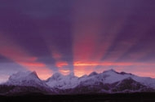

PRESENTATIONS:

IPCC Special Report on 1.5 Degrees, NDCs and Cryosphere:
Pathways for Both High Urgency and Ambition
Can Parties Act in Time to Prevent Cryospheric Destabilization?
Wednesday December 12, 16:45-18:15

Kindly find presentations at the link:

https://www.dropbox.com/home/NDCs%2C%20Cryosphere%20and%20SR1.5%20Side%20Event

Thank you for your interest!

Organized by Climate Analytics, International Cryosphere Climate Initiative (ICCI) and Climate Policy Center. Questions/follow-up: Pam Pearson, +46-70-57 522 57, pam@iccinet.org and Ela Smith, Climate Analytics, +49 152 56124061, ela.smth@climateanalytics.org

