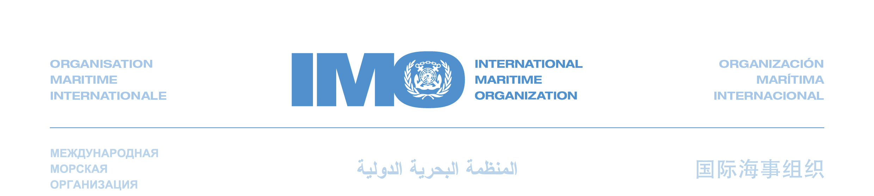
Note by the International Maritime Organization
to the twelfth session of the Ad-hoc Working Group on Long-Term Cooperative Action under the Convention (AWG-LCA)

Agenda item 3 – Preparation of an outcome to be presented to the Conference of the Parties for adoption at its sixteenth session to enable the full, effective and sustained implementation of the Convention through long-term cooperative action now, up to and beyond 2012

Outcome of the sixty-first session of IMO’s Marine Environment Protection Committee Further progress made on technical, operational and market-based measures

5 October 2010

The Marine Environment Protection Committee (MEPC) of the International Maritime Organization (IMO), meeting for its 61st session in London, made further progress in developing measures to improve the energy efficiency of ships, in order to reduce greenhouse gas (GHG) emissions from international maritime transport.

Although international maritime transport is the most energy efficient mode of mass transport and only a modest contributor to global CO₂ emissions (2.7% in 2007) while carrying 90% of world trade, a global approach for further improvements in energy efficiency and emission reduction is needed as sea transport is predicted to continue growing significantly in line with world trade. IMO’s work on enhanced energy efficiency and GHG emission control has three distinct building blocks and the Organization has over several years developed technical and operational reduction measures that will when fully implemented significantly improve the maritime sector’s carbon footprint. The third building block is the market-based mechanisms where IMO currently is working in accordance with a work plan culminating in 2011.

Technical and operational measures

Having considered means by which technical and operational measures could be introduced in the Organization’s regulatory regime, the Committee noted the desire of some States party to MARPOL Annex VI – Regulations for the prevention of air pollution from ships to request the Secretary-General to circulate proposed amendments to that Annex, to make mandatory, for new ships, the Energy Efficiency Design Index (EEDI) and the Ship Energy Efficiency Management Plan (SEEMP)), both of which have been previously disseminated for voluntary use. The circulated draft amendments would then be considered by the Committee’s next session with a view to adoption under MARPOL Annex VI. The Committee also noted, however, that some other States did not support the circulation of such amendments.

Although decisions as to how to proceed with the next step of IMO’s climate change strategy were not reached by consensus, nevertheless the Committee made noteworthy progress on all three elements of its GHG work, namely technical, operational and market-based measures, and it is expected that further substantial progress will continue to be made at its next meeting in July next year.

The EEDI will establish a minimum energy efficiency requirement for new ships depending on ship type and size and is a robust mechanism to increase the energy efficiency of ships step-wise for many decades to come. The EEDI is a non-prescriptive, performance-based mechanism that leaves the choice of technologies to use in a specific ship design to the industry. As long as the required energy-efficiency level is attained, ship designers and builders would be free to use the most cost-efficient solutions for the ship to comply with the regulations. The reduction level in the first phase is set to 10% and will be tightened every five years to keep pace with technological developments of new efficiency and reduction measures. IMO has set reduction rates until the period 2025 to 2030 when a 30% reduction is mandated for most ship types calculated from a baseline representing the average efficiency for ships built between 1999 and 2009.The EEDI is developed for the larger and most energy intensive segments of the world merchant fleet and will embrace 72% of emissions from new ships covering the following ship types: oil and gas tankers, bulk carriers, general cargo and container ships. For ship types not covered by the current formula, suitable formulas will be developed in the future addressing the largest emitters first.

The SEEMP establishes a mechanism for a shipping company and/or a ship to improve the energy efficiency of ship operations. The SEEMP provides an approach for monitoring ship and fleet efficiency performance over time using the Energy Efficiency Operational Indicator (EEOI) as a monitoring tool and serves as a benchmark tool. The SEEMP urges the ship owner and operator at each stage of the plan to consider new technologies and practices when seeking to optimize the performance of a ship. The Second IMO GHG Study 2009 indicates that a 20% reduction on a tonne-mile basis by mainly operational measures is possible and would be cost-effective even with higher fuel prices than those currently experienced. The SEEMP will assist the shipping industry in achieving this potential.

Market-based measures

The Committee also held an extensive debate on how to progress the development of suitable market-based measures (MBM) for international shipping, following the submission of a comprehensive report by an Expert Group which carried a feasibility study and impact assessment of several possible market-based measures submitted by governments and observer organizations.

The scope of the work of the Expert Group was to evaluate the various proposals on possible MBMs, with the aim of assessing the extent to which they could assist in reducing GHG emissions from international shipping, giving priority to the maritime sectors of developing countries, least developed countries (LDCs) and Small Island Developing States (SIDS). The MBM proposals under review ranged from a contribution or levy on all CO₂ emissions from international shipping or only from those ships not meeting the EEDI requirement, via emission trading systems, to schemes based on a ship’s actual efficiency, both by design (EEDI) and operation (EEOI).

The Committee agreed Terms of Reference for an intersessional meeting of the Working Group on GHG Emissions from Ships, to be held in March 2011, tasking the group with providing an opinion on the compelling need and purpose of MBMs as a possible mechanism to reduce GHG emissions from international shipping. The meeting is also tasked to further evaluating the proposed MBMs considered by the Expert Group, including the impact of the proposed MBMs on, among others, international trade, the maritime sector of developing countries, as well as the corresponding environmental benefits. A report from the intersessional group will be submitted to MEPC 62 in July 2011 enabling the Committee to make further progress in accordance with its work plan.

________

