Philippines: Mainstreaming Climate Change in National and Local Development Planning to Establish Climate Resilient Communities

TITLE: PHILIPPINES: MAINSTREAMING CLIMATE CHANGE IN NATIONAL AND LOCAL DEVELOPMENT PLANNING TO ESTABLISH CLIMATE RESILIENT COMMUNITIES
DATE: 02 DECEMBER 2011 (FRIDAY)
TIME: 18:30—20:00
VENUE: Apies River, ICC, Durban, South Africa
PART I: Time: 18:30 – 19:00
PRESENTATION ON ENABLING COMMUNITIES TO MITIGATE & ADAPT TO CLIMATE CHANGE IN THE PHILIPPINES:THE ECOTOWN FRAMEWORK
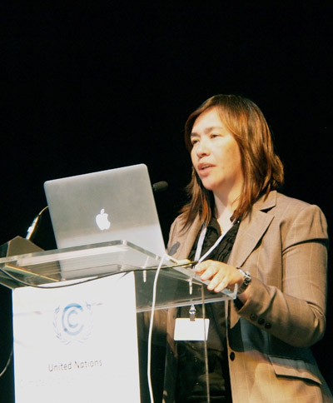
Download Powerpoint presentation at: http://www.climate.gov.ph/phocadownload/COP%2017%20Philippines/NCCAPcop17ecotown.pdf
The Philippine government has begun to mainstream climate change in national and local level. The side event will feature the Eco-town framework where ecosystem-based management approach and sustainable financing mechanism (Payment for Ecosystem Services) is used to establish climate resilient communities.
Speaker: H.E. MARY ANN LUCILLE L. SERING, Secretary and Vice-Chair, Climate Change Commission, Philippines (CCC) (National Focal Point)
PART II: TIME: 19:00 – 19:30
SHOWCASING CONCERTED EFFORTS IN MAINSTREAMING CLIMATE CHANGE ADAPTATION IN DEVELOPMENT PLANNING
Download Powerpoint presentation at: http://www.climate.gov.ph/phocadownload/COP%2017%20Philippines/MDGFcop17presentation.pdf
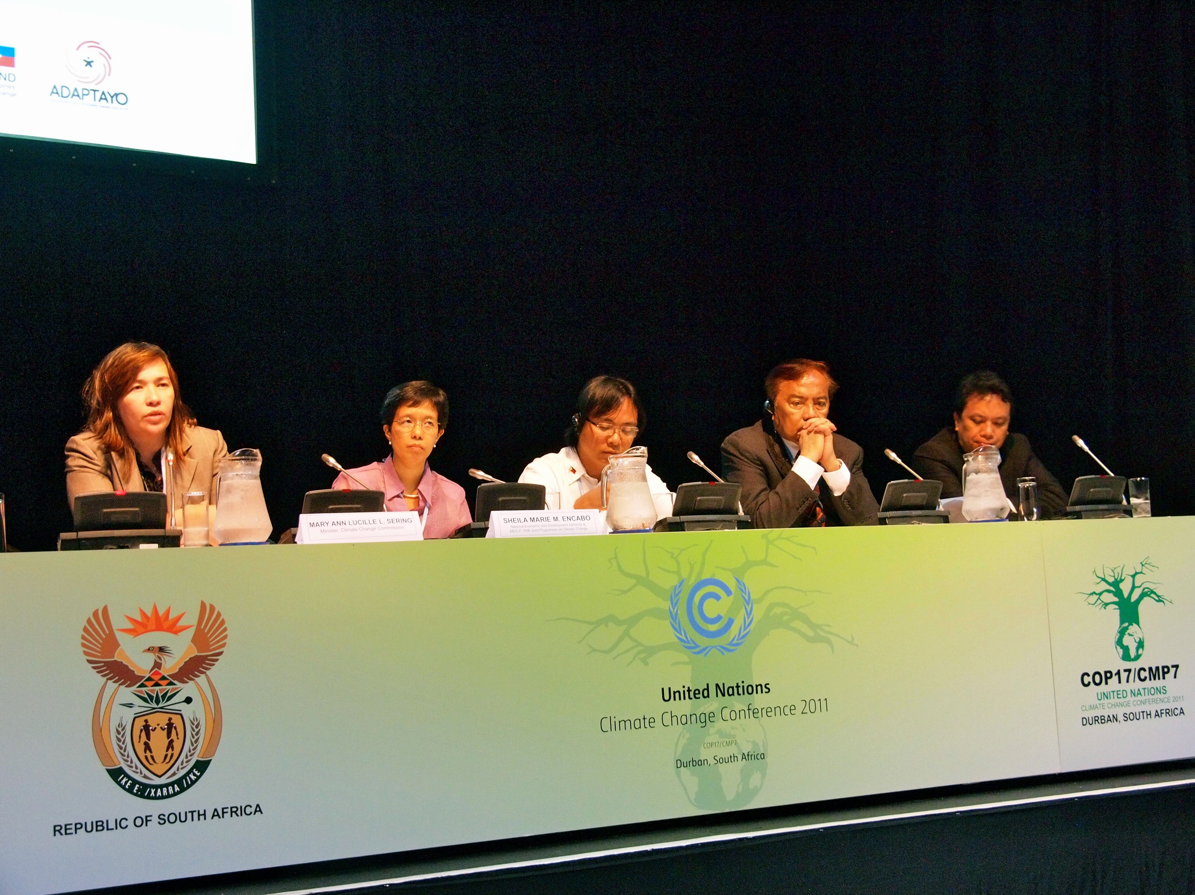
The MDG-F 1656 Joint Programme on Strengthening the Philippines’ Institutional Capacity to Adapt to Climate Change aims to influence key development and institutions of the Philippine government by integrating climate change adaptation as one of the critical issues that pose as a serious threat to the country in achieving its MDG targets. The second part of the Philippines’ side-event showcases the concerted efforts of key stakeholders in mainstreaming climate change adaptation in national, sectoral and local planning and regulatory processes.
Speaker: DIRECTOR SHEILA MARIE E. ENCABO, Programme Coordinator of the Millenium Development Goals – Funds (MDG-F) 1656 Joint Programme on Climate Change, National Economic and Development Authority (NEDA), Philippines
Secretary Mary Ann Lucille Sering, CCC; Director Sheila Encabo, NEDA; Commissioner Naderev Sano, CCC; Commissioner Heherson Alvarez, CCC; and Secretary Neric Acosta, Presidential Adviser on Environment at the Side Event, COP 17/CMP 7, Durban, South Africa

