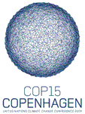
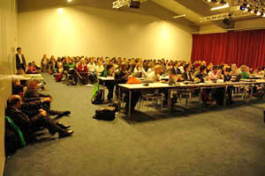
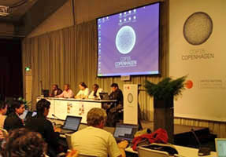

INFORSE-WECF Side Event at UNFCCC COP15
United Nations Climate Change Conference
Monday, December 14, 2009
Bella Center, Niels Bohr Room, Copenhagen, Denmark
INFORSE and WECF at UNFCCC COP15
See presentations and pictures at the Side Event:
INFORSE’s web site:
http://www.inforse.org/europe/conf09_COP15_side_INFORSE-WECF_14_dec_Bella.htm
WECF website:
http://www.wecf.eu/english/articles/2009/12/inforse-wecfevent.php
See pictures from the INFORSE exhibition at
http://www.inforse.org/europe/conf09_COP15_INFORSE-exhibition-Bella-pictures.html
See INFORSE participation at UNFCCC COP15:
http://www.inforse.org/europe/conf09_COP15.htm

best wishes

INFORSE and WECF

