Alon Carmel



Alon Carmel is a senior economist at the UK Office of Climate Change (OCC). He currently leads work on modelling of future carbon markets and carbon finance. Prior to this he coordinated the analytical work for the Department for Transport feeding into the Stern Review, 2006 UK Climate Change Programme Review (CCPR) and the 2007 Energy White Paper. Alon has a background in the economics of urban development and transport and has worked in development NGOs in Jerusalem and Beijing.

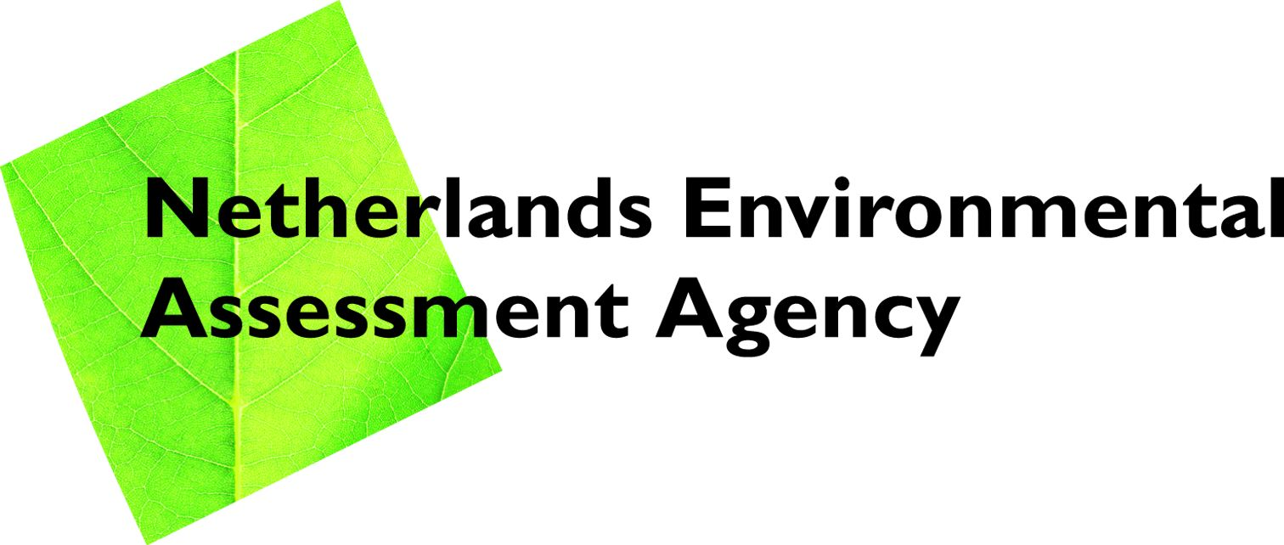 | 
www.mnp.nl | www.occ.gov.uk

