Side event agenda

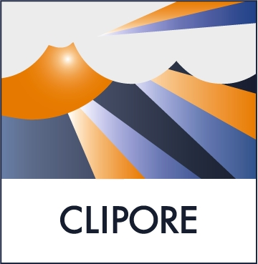 | European Climate Platform (ECP)  An Initiative by Mistra’s Climate Policy Research Programme (CLIPORE) and the Centre for European Policy Studies (CEPS) | 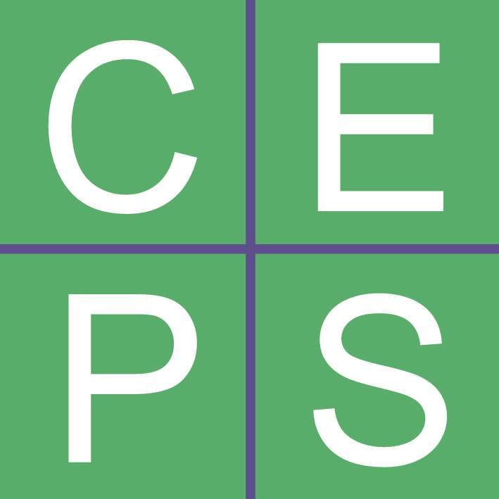

Side event at the UNFCCC COP/MOP, Montreal, Canada

IMPROVING THE FUNCTIONING OF THE CDM

Agenda

Tuesday 6th of December 2005; 18:00-19:30

Venue: Palais des Congrès de Montréal, Room: Three Rivers

18:00 Introduction by the Chair: Bo Kjellén, Former Chief Climate Negotiator, Sweden; Stockholm Environment Institute; Tyndall Centre &
Presentation by Christian Egenhofer, Senior Research Fellow CEPS, on the ECP Report: Improving the Clean Development Mechanism

18:10 Keynote Speaker I: Werner Wutscher, Secretary General, Federal Ministry for Agriculture, Forestry, Environment and Water Management, Austria (incoming EU Presidency)

18:25 Keynote Speaker II: Marthinus van Schalkwyk, Minister of Environmental Affairs & Tourism, Republic of South Africa

18:40 Questions and Answers

19:00 Panel Discussion with:
- Jürgen Salay, climate change unit, European Commission
- Dirk Forrister, Managing Director, Natsource

19:30 Cocktail

For further information on the ECP please have a look at: http://www.ceps.be/Article.php?article_id=484

