Royal Government of Bhutan presents
Enhancing Gross National Happiness
through Climate Change Adaptation Projects in Bhutan

Date & Time: Friday, 11 December, 2009 18:15 - 19:45
Venue: Dan Turell Room (Bella Center), Copenhagen, Denmark

Program

1 Opening Remarks
His Excellency Dasho Nado Rinchhen (Deputy Minister, National Environment Commission, Bhutan)

- Potential CDM Rural Electrification to Displace GHG Emission by Replacing
the Existing Usage of Fossil and Non Renewable Biomass Fuels, Leading to
Enhanced GNH in Bhutan
- Rural Electrification for Clean Energy, Better Living and Sustainable Growth
Mr. Karma P. Dorji (National Project Manager, Department of Energy)
Mr. Suresh Nepal (General Manager, Bhutan Power Corporation Limited)
(2) JICA’s Support for CDM
Mr. Shinya Ejima (Director General, Japan International Cooperation Agency (JICA))

- National Adaptation Program of Action to Reduce Climate Change-Induced Risks
and Vulnerabilities from Glacial Lake Outburst Floods in Bhutan
Mr. Ugyen Wangda (Chief Geologist, Department of Geology and Mines)

Light meal will be served.

This event presents how Bhutan is making concerted efforts to provide universal access to clean energy using climate friendly technologies and adaptation measures to reduce imminent threats of GLOFs, thereby enhancing National Happiness, which in turn, contributes to Global Happiness.

Oragnized by Department of Energy and Department of Geology and Mines (Ministry of Economic Affairs: (www.moea.gov.bt))
Bhutan Power Corporation Ltd. : www.bpc.bt


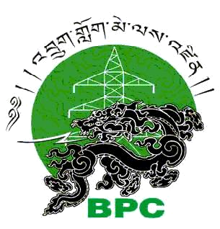
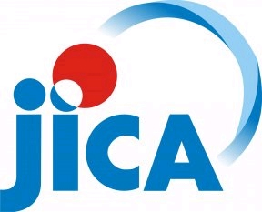
National Environment Commission : www.nec.gov.bt
Supported by

