HERITAGE CONSERVATION AND The SUSTAINABLE DEVELOPMENT GOALS

44 (0)20 7824 7157
20 Grosvenor Gardens, London SW1W 0DH, UK



Foreword by Dame Fiona Reynolds, Chair of INTO

Everyone is talking about sustainable development. And indeed it’s hard to argue against a concept that seeks to balance efforts to improve quality of life with social, economic and environmental issues.

What is hard is to know is what good sustainable development looks like.

When the member states of the United Nations set out their agenda to end poverty, promote peace, share wealth and protect the planet in 2015, they rooted it in seventeen objectives. The Sustainable Development Goals (SDGs) provide powerful aspiration for improving our world – laying out where we collectively need to go and how to get there.

Cultural heritage, though, gets scant mention in the SDGs: just a brief reference in Goal 11.4 to “strengthen efforts to protect and safeguard the world’s cultural and natural heritage". We think it can contribute much more, which is why we wanted to share our INTO member organisations experiences in working toward the achievement of the SDGs.

This report shows very practically how the National Trust family across poorer and richer countries alike is taking action to end poverty, promote peace, share wealth and protect the planet. From Australia to Zimbabwe our INTO member organisations are working to create beautiful cities, to protect the countryside whilst still producing enough food, caring for our inheritance rather than striving for unsustainable levels of growth.

But the fight is not yet won. Over the last century we have lost a vast richness of nature and much of the diversity of our landscape; we have degraded our soils and natural resources and we have let our precious heritage decay or – worse – be sacrificed. And in spite of huge efforts, nature and the beauty of the wider countryside are in a worse state than when the conservation movement set out to protect them. Add to this the looming pressures of climate change and it is clear we need to do things differently.

The SDGs call for us all: governments; businesses; civil society and the general public to work together to build a better future for everyone. With INTO members contributing to 14 out of the 17 goals, we think we can say that the protection of our cultural landscape, and all that that entails, has an important role to play in the future of our planet. Heritage is indeed a ‘pillar of sustainability’.

John Muir, the Scottish-American naturalist and preservationist, had the words for it: “not blind opposition to progress, but opposition to blind progress”. It’s a fight to which we all need to belong.

Introduction

Towards the end of the nineteenth century, organisations were beginning to be formed across the world with the aim of conserving fast-disappearing natural and cultural heritage.

The Society of the Preservation of Norwegian Ancient Monuments (Fortidsminneforeningen) was established in 1844 by artists who "discovered" Norway's cultural heritage during academic excursions to rural districts and valleys, for example. The Trustees of Reservations in Massachusetts became the US’s first private non-profit conservation organisation in 1890 and the National Trust of England, Wales and Northern Ireland (National Trust) was founded in 1895.

Since then the National Trust movement has grown to include a range of countries from Australia, Bermuda, Canada and Fiji through Korea, Malta and New Zealand to Taiwan, the United States and Zimbabwe.

Each organisation is different, but they share similar goals, legal constitutions and structures, and for around 40 years have been coming together under the umbrella of the International Conference of National Trusts (ICNT) to share information and best practice, to develop solutions to common problems and to show solidarity with other members of the movement.
It was at the 10th ICNT in Edinburgh that delegates agreed the need to establish a global federation to coordinate activity between conferences and so the International National Trusts Organisation, INTO, was launched at the 12th ICNT in Delhi in December 2007.
INTO, (www.intoorg.org), is an umbrella body for National and Heritage Trusts globally, united by their common interest in the conservation and enjoyment of our shared heritage – built and natural, tangible and intangible. It currently has over 70-member organisations of which 11 are based in the Pacific region.

The organisation brings people together to exchange information, develop and promote best practice, and work to effect change. INTO’s mission is to “promote the conservation and enhancement of the heritage of all nations for the benefit of the people of the world and future generations”.

The present position
The 21st century is a time when built and natural heritage all over the world is under increasing threat from environmental decay, climate change, apathy leading to neglect, and conflict. Against this background is a growing awareness and recognition of the value of collaborative international action.

The National Trust approach is viewed by many as an important model to the charitable and voluntary organisations that have been established to combat these threats. And as established Trusts we have an opportunity, if not a duty, to collaborate with our sister organisations around the world.

To date, international collaboration on heritage conservation has focused primarily on sites of universal value. This is important, but there is a critical need to better protect and preserve both tangible and intangible heritage of national, regional, and local significance, and especially to integrate heritage conservation into international, national and local programmes for sustainable development. Heritage-focused NGOs within individual countries (National Trusts and similar organisations) can and do play a key role – in partnership with national and local governments – in facilitating and promoting this type of heritage conservation.

As a global non-governmental organisation with close ties to the United Nations (UN), INTO has engaged with the topic of sustainable development since its establishment and has highlighted the vital role of cultural heritage in the sustainable development process.

INTO members have a wider portfolio of interests beyond preserving built and natural heritage. The ownership of property, as is the case with many of the members, often allows for practices relating, for example, to sustainable tourism, clean water, renewable energy, sustainable agriculture, poverty eradication, education etc., all of which contribute directly to the Sustainable Development Goals (SDGs).
The SDGs, otherwise known as the Global Goals, are a universal call to action to end poverty, protect the planet and ensure that all people enjoy peace and prosperity.
The 17 goals are interconnected – often the key to success on one will involve tackling issues more commonly associated with another. They all have targets and indicators with the aim to achieve these by 2030
It was with that in mind, and in keeping with the framework of the SDGs adopted by the UN in September 2015, that INTO recently carried out a survey amongst its membership to find examples of where heritage conservation in its many facets is contributing to the relevant SDGs. And the results were surprising in that no less than 14 of the 17 Goals proved to be relevant to heritage conservation showing that it is indeed a ‘pillar of sustainability’

This paper enlarges on the role played by INTO and its members in achieving the SDGs and provides relevant case studies.

The relevant Goals

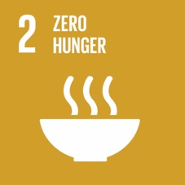
GOAL 2: NO HUNGER

Goal 2 of the SDGs calls for ending hunger, achieving food security, improving nutrition and promoting sustainable agriculture by 2030. As the world’s population continues to grow, increasing food production to meet this challenge puts a tremendous amount of pressure on natural resources. To meet this task, we need to be moving towards more sustainable food production systems and resilient agricultural practices.

Programs should integrate cultural factors, such as traditional knowledge and practices that contribute to the sustainable use of natural resources. These practices can be based on the use of diverse crops, plants and animals as well as an understanding of the local environment. Many of INTO’s members are currently planting traditional plants (heritage stocks) in their communities as well as promoting sustainable farming practices in conjunction with genetic preservation of heritage livestock species.

- The Nabogiono Farm (National Trust of Fiji) located on Taveuni Island, is a semi-subsistence farm and established agritourism venture. The farm shares knowledge of local agricultural produce, medicinal plants and biodiversity with communities, and emphasises on the importance of conserving these natural resources for the future.

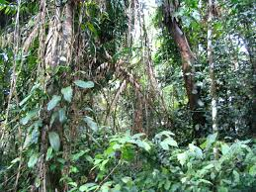
Nabogiono Farm (National Trust Fiji)

- Tesouros de Galicia (Spain) works to promote sustainable agri-business properties in Galicia that are environmentally responsible, either for energy efficiency, ecological management of natural resources and production, or conservation of native breeds or typical products.
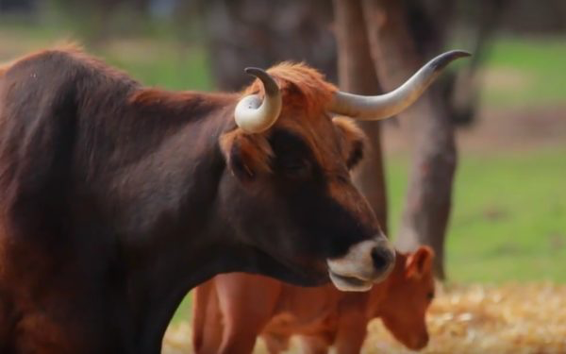
‘Biocoop’ Verin, Galicia (INTO FARMS)

- The Nehill Brothers Farm (National Trust of Australia) in Victoria has used sustainable farming practices since 1874. It focuses on traditional farming techniques and genetic breeding of livestock, which were once common throughout rural Australia, such as the Large Black Pig and Wiltshire Horn Sheep.
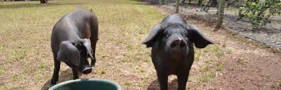
Black Pigs (nationaltrust.org.au)

The preservation of traditional breeds and heirloom species is important for cultural reasons as well as reducing the dangers associated with narrowing the genetic base. The loss of genes influencing adaption ability and disease resistance could have dire consequences for a species.

Education is a key component of sustainable agriculture, especially the role of imparting traditional knowledge to younger generations. La Rochelle, a property owned by the National Trust Zimbabwe, is establishing an agricultural training centre of excellence that will offer courses in sustainable organic farming for small scale farmers in southern and central Africa.

The role of traditional farming techniques and traditional breeds and heirloom species is invaluable in creating sustainable agricultural systems for future generations. These traditional practices are being implemented at INTO’s members’ sites world-wide.

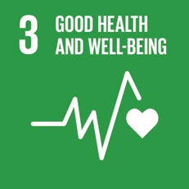
SDG 3: GOOD HEALTH & WELL BEING

This goal’s objective is to ensure health and well-being for all. The concept of good health and well-being has been defined by the World Health Organization as a “state of complete physical, mental and social well-being and not merely the absence of disease or infirmity.”
The impact of ‘place’ on health is well recognized. A sense of place is a unique collection of qualities and characteristics – visual, cultural, social and environmental – that provide meaning to a location. Studies have shown that “healthy places make people feel comfortable and at ease, increasing social interaction and reducing antisocial behaviour, isolation and stress”. Well-designed cities can promote health, reduce stress, increase social interactions; while poorly designed cities can create unhealthy environments, crime, dangerous traffic and can impact a person’s motivation for exercise.

Our members believe that the preservation of open space is essential to a healthy lifestyle. Bodenfreiheit in Austria, acquires land for open space because they believe that the preservation of free space serves three major objectives: well-being and leisure, ecological quality and diversity, and sustainable food production. The Bermuda National Trust has developed community gardens to encourage community-based activities.

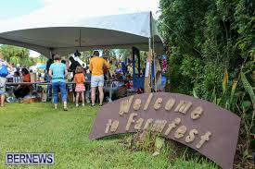
Bermuda National Trust

Studies have also shown that people have an intangible connection and emotional attachment to places and communities. The National Trust recently conducted a neurophysiological research study that revealed for the first time that meaningful places generate a significant response in areas of the brain associated with positive emotions. It found that people experience intense feelings of well-being, contentment and belonging from places that evoke positive memories, much more than tangible objects such as photographs or wedding rings. This study solidifies the need to preserve these meaningful places for people to reap the health benefits now and for future generations.

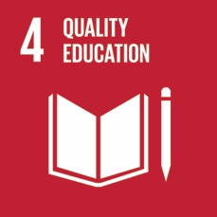
SDG 4: EDUCATION

Education has been recognized as a critical factor in addressing environmental and sustainability issues and ensuring well-being. This SDG aims to ensure that all have equal access to education and opportunities to improve relevant skills for increased employment prospects. Additionally, this goal’s objective is to ensure that students of all ages gain the necessary knowledge and skills needed to promote sustainable development through programmes which promote sustainable lifestyles, human rights, gender equality, promotion of a culture of peace and non-violence, global citizenship and appreciation of cultural diversity and of culture’s contribution to sustainable development.

A quality education is the underpinning to improving people’s lives and sustainable development. Several of our INTO members have integrated a natural and cultural approach into their respective educational systems. The An Taisce Green School, a program operated and co-ordinated by the National Trust of Ireland is a student led program that integrates environmental and sustainability issues as part of the curriculum for primary and secondary schools across the country.

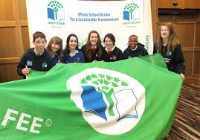
An Taisce Green Schools

The National Trust for the Cayman Islands provides content to the Cayman Islands Education Department to ensure that preservation of natural resources and places of historic significance are cited in the national curriculum and made available to educators. The Japan National Trust has a Trust Youth Centre aimed at engaging students from universities in Japan and abroad in promoting natural resource and heritage conservation in Japan. Students are encouraged to attend seminars, exhibitions and events as well as network with environmental and heritage professionals.

Other members have educational programs on specific topics, such as the Montserrat National Trust program on the digitalisation of endangered archives of Montserrat’s history, where students learn about the process of archiving documents as well as the history of the Island. St. Helena National Trust has a program for the protection of endangered invertebrates that are part of the ecosystem of the Island. The Bermuda National Trust has developed teacher resource guides for several of their historic sites that are tied to the Bermuda educational curriculum.

Incorporating intangible cultural heritage into an educational curriculum is a fundamental component to a sustainable future as it provides living examples of education as well as being the most important vehicle for cultural diversity. INTO along with the Cross-Cultural Foundation of Uganda (CCFU), National Trust Zimbabwe, and the Sierra Leone National Trust sponsored the Schools Cultural Heritage Competition held in their respective countries. This competition emboldens the younger generation to serve as ‘Heritage Champions’ and encourages children to take responsibility and to develop a better understanding and appreciation of the diverse tangible and intangible cultural heritage across the continent. Entries covered areas from traditional pottery, to the importance of cattle, mat making, and ceremonial dances.
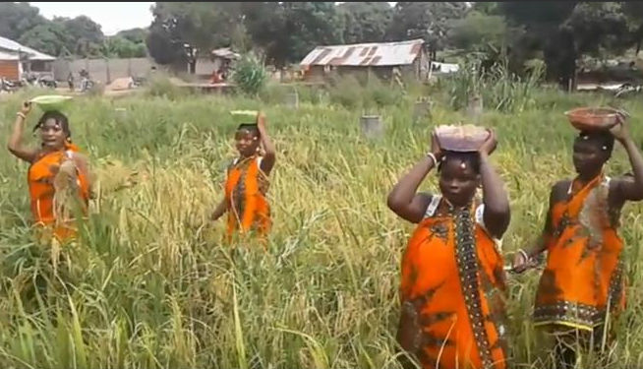
‘Song and dance for planting: With Agriculture, Food Sufficiency is Assured’ by Henry Fergusson Junior Secondary School (INTO)

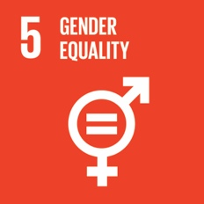
SDG 5: GENDER EQUALITY

Women and girls continue to face discrimination across economic, social and political spheres. It is important to recognize the role that culture plays in terms of gender equality. SDG 5 aims to end all forms of gender discrimination and ensure women’s full and effective participation and equal opportunities for leadership at all levels of decision-making. It is important to recognize the role that culture has played in terms of gender equality. Many cultural practices are carried out by women, especially in developing countries where the majority of those employed in the cultural sector are women.

The Cross-Cultural Foundation of Uganda (CCFU) prepared a report on Women Culture & Rights in Acholi. The report looked at the concerns about the “marginalisation and oppression of women” in Uganda since it gained independence from Britain in the 1960s and how it was perceived that patriarchy, culture and traditions were often reinforcing gender inequality and the subjugation of women and girls. However, what the research found was that prior to Uganda independence, culturally defined womens’ and girls’ rights existed under traditional Acholi culture and were protected. These values, norms and expectations related to gender and community have been passed on from generation to generation upholding women’s dignity in society. Since the 1960’s these culturally-defined rights have changed (or adapted) while others have ceased for various reasons, including war, western forms of education and religion.

The report discusses how these culturally-defined rights and current laws can be used to enhance women’s empowerment today and educate the younger generation on these rights and traditions. The CCFU has published two additional handbooks on using Acholi culture to promote women’s rights and empowerment: “My Rights as a Woman or Girl – What does Acholi culture say?” and “Promoting Women’s Rights as Defined by Acholi Culture – A cultural leaders’ handbook” . These handbooks highlight ways to use culture to strengthen the realization of women and girls’ rights.

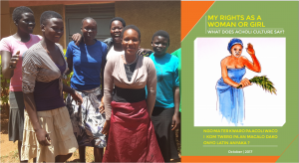
Cross-Cultural Foundation of Uganda

As culturally-defined values, norms and expectations are shaped, empowerment of women, perhaps through traditional roles that women have played, should be strongly encouraged and should provide women and girls a voice that shows the important role of women and girls in cultural life. Heritage organisations, such as INTO’s members, are critical in helping women increase their stature within the community.

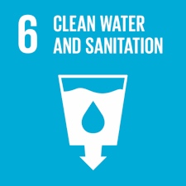
SDG 6: ENSURE ACCESS TO CLEAN WATER AND SANITATION FOR ALL

This goal’s objectives are to ensure availability of safe and affordable drinking water as well as improvement of water quality and protection of water-related ecosystems through sustainable management of water. It is important to recognize traditional knowledge and practices concerning water management and how they contribute to equitable access to clean water and sustainable water use, especially in the area of agriculture.

It has long been established that local communities, through traditional knowledge, have been able to shape sustainable water management practices. The Indonesian Heritage Trust has worked determinedly to protect the traditional agricultural social system named the Subak, which has been recognized as UNESCO World Cultural Heritage of Cultural Landscape Site since 2012. For over 1,000 years, Subak has been used as a traditional Balinese system for water irrigation management.

This cooperative farming system uses a traditional method of regulating water management/irrigation of rice fields and represents a historical understanding of the agricultural ecosystem in Bali, including how to deal with pest management. The water management system is under the authority of the priests in water temples that practice traditional Balinese philosophy of Tri Hita Karana, meaning the three causes of well-being/happiness. This philosophical approach brings together the realms of the spirit the human world and nature. This traditional practice of democratic and egalitarian farming has enabled the Balinese to become the most prolific rice growers in the region. Unfortunately, these Subaks are under continued threat due to increased urbanization and a growing tourism trade. In 2016, the Indonesian Heritage Trust, offered a Field School entitled “Towards Sustainable Cultural Landscape of Subak System”. Students participated finding sustainable approaches to protect this vulnerable landscape.

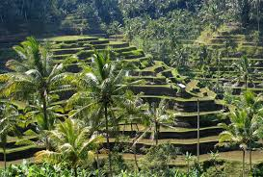
Subak System

Other INTO members, such as the Slovakia National Trust’s former director, Martin Kovac, an expert in water resource management, works with INTO and its members on the impact of water management on cultural heritage sites. He advises the National Trusts on topics ranging from water shortage, flood and drought risks, and how to regenerate damaged landscapes and water cycles impacted by climate change as well as disaster risk recovery.

It is imperative that local cultural policies and environmental sustainability, including the sustainable use of water resources be incorporated into governmental policies. As we have shown through the Subak system, traditional practices concerning water management can contribute to equitable access to sustainable water use. Without this local traditional knowledge base, we may see some of these unique heritage sites disappear. The work that INTO and its members provide in advocating for the protection and continued use of these traditional systems of water management is crucial for the development of sustainable solutions to address many water-related challenges.

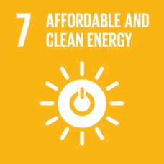
SDG 7: AFFORDABLE AND CLEAN ENERGY

Goal 7 of the SDGs calls for universal access to affordable, reliable and modern energy, substantially increase the share of renewal energy in the global energy mix and double the global rate of improvement in energy efficiency.

Members of INTO are leading the charge in the area of renewable energy and in promoting energy conservation for heritage sites. The National Trust has pledged to source 50 percent of its energy needs from renewable resources by 2020. In fact, at Hafod y Llan, a sheep and cattle farm in Wales, the National Trust is operating a hydroelectric plant that will not only provide enough energy for the entire farm but is expected to generate enough electricity to power around 445 homes.

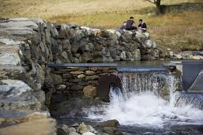
Hafod y Llan (National Trust)

Educating the public on awareness of renewable and sustainable energy, in particular for use in the conservation and preservation of historical and cultural buildings and homes is essential. The Montserrat National Trust is using solar panels to provide energy to pump collected rain water to irrigate its Botanic Garden and through this project is running a series of workshops for local farmers and landscapers to inform them of the uses of renewable energy in the field.

Working collaboratively to combat the impacts of climate change and rising energy costs, the National Trust’s Fit for the Future Network, brings together more than 80 of the UK’s largest charities and land-owning organisations to educate each other on the clear benefits of becoming more environmentally sustainable and energy efficient.

The adaptive reuse of heritage buildings is an essential component of sustainable development. It provides tremendous environmental benefits, combined with energy savings and avoids the wastefulness of demolition and reconstruction. “The greenest building is the one already built.” In 2009, the National Trust for Historic Preservation in the United States (NTHP) created the Preservation Green Lab to advance research on the value that older buildings bring to their communities and to establish policies that makes it easier to reuse and green older and historic buildings. The goal of the Preservation Green Lab is to minimize carbon impacts from the built environment by retrofitting and reusing older buildings while still maintaining their historic character.

The efficient use of resources – energy savings, energy efficient technologies and measures as well as the use of renewable energy sources are essential for sustainability. INTO members have shown that heritage buildings and cultural resources are part of the future and contribute to the long-term sustainable development. The key for heritage organisations is creating sustainable solutions that work in harmony with natural and historic heritage.

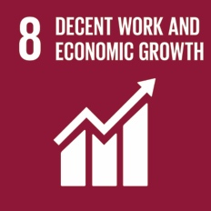
SDG 8: PROMOTE INCLUSIVE AND SUSTAINABLE ECONOMIC GROWTH, EMPLOYMENT AND DECENT WORK FOR ALL

SDG 8 finds that an increase in labour productivity, a reduction in the unemployment rate, especially for young people, and improved access to financial services and benefits, are essential components of sustained and inclusive economic growth. Heritage conservation is considered an asset in terms of economic development. “Both tangible and intangible heritage can and do contribute to equity, inclusion, liveability, sustainability, creativity and economic development.” Dozens of studies conducted on the economics of preservation have consistently found that heritage conservation is good for the economy. Heritage conservation:

- Creates jobs,
- Increases property values,
- Provides a boost for heritage tourism through adaptive reuse of heritage assets,
- Reduces environmental impact by less materials in landfills, and
- Increases the revitalization of downtown areas.
The Main Street program of the National Trust for Historic Preservation is one of the most successful cost-effective programs of economic development. Main Street America has been helping revitalise older and historic commercial districts for more than 35 years. Since 1980s, the Main Street program has generated $74.73 Billion USD for reinvestment, 276,790 buildings have been rehabilitated, 614,716 jobs have been created and 138,303 businesses have started. Preservation of older places can have tremendous economic benefits and should be used as a powerful and forward-looking tool for making places more inclusive, resilient, safe and sustainable.

With rapid urbanization cities with valuable historic cores and heritage assets sometimes struggle to modernize without losing their uniqueness. The National Trust in Tasmania in collaboration with the University of Tasmania, is working to develop a program which identifies and measures the economic and social benefits of investing in heritage conservation. Investing in heritage conservation can lead to urban liveability, attracting talent, and providing an enabling environment for job creation.

Tourism is one of the fastest-growing sectors of the world economy of which heritage tourism accounts for 40 percent. Many heritage sites are receiving huge influx of visitors causing a degradation of the site and visitor experience and can lead to management difficulties. Managing heritage resources, by involving local communities can attract tourism investment in a sustainable way.

Many countries are trying to seize this opportunity by implementing tourism-oriented policies and programs. The Australian National Trusts have developed a national framework for heritage tourism including a “discussion paper for government” to consider for the development of a national policy and investment. Other members are forming partnerships with other leading cultural and tourism organisations. For example, the Bermuda National Trust is partnering with other heritage, art and tourism organisations to encourage visitors to discover Bermuda’s heritage beyond the beaches. Some of our members are working at the more local level, such as the Saint Lucia National Trust. The Saint Lucia National Trust is investing in the protection of the Mankote Mangrove, the largest mangrove in the Eastern Caribbean. The work involves protection and enhancement of the health of the mangrove as well as providing livelihood support for local communities that depend on the area. Saint Lucia National Trust is providing training and equipment for tour operators in the area.

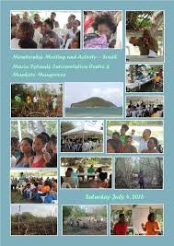
St. Lucia National Trust

Sustainable heritage tourism and heritage conservation are important as they have a positive economic and social impact, establish and reinforce identity and help build an image. Preservation of tangible and intangible heritage of an area also serves as an instrument in facilitating harmony and understanding among people. INTO and its members are in the forefront of promoting sustainable economic growth and through investments in heritage preservation, revitalisation of historic districts, and heritage tourism, employment opportunities will proliferate.

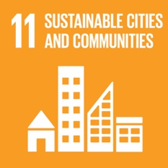
SDG 11 MAKE CITIES AND HUMAN SETTLEMENTS INCLUSIVE, SAFE, RESILIENT AND SUSTAINABLE

Cultural heritage has a crucial role to play in SDG 11 as it is the main goal dedicated to sustainable development in cities. The goal aims, inter alia, to improve access to safe, inclusive and accessible green and public spaces and to strengthen efforts to protect and safeguard the world’s cultural and natural heritage.

Cities and communities are essential for the well-being and quality of life as they serve as hubs for economic and social development and innovation. A vision for sustainable cities has never been more important than today as more than half of the world’s population lives in cities and the trend is expected to continue with more than two-thirds of the world living in an urban environment by the year 2050. “Well planned and managed cities can drive sustainable development”.
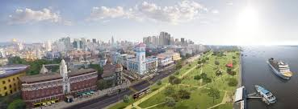
Yangon Heritage Trust

Heritage cities in developing nations currently face intensified urban problems as a result of rapid population growth, economic development and commercialisation. Many of INTO’s members are working to promote liveable cities. The Yangon Heritage Trust works with an international advisory group of urban planners, conservationist, and architects to help facilitate dialogue with local experts and interested parties to promote and integrate Yangon’s unique urban heritage into one of Asia’s most liveable cities.

Following the communist revolution, Shanghai began a frenzy of demolition and new construction. The Ruan Yisan Heritage Foundation was created to support and promote urban heritage conservation in China. They work directly with the government to carry out surveys of older historic districts and neighbourhoods. They strive to protect neighbourhoods/areas that are more liveable and community-oriented key to sustainability.

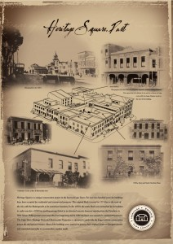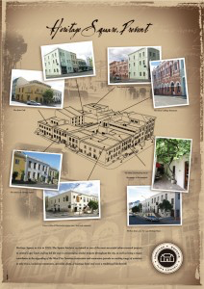
Heritage Square Past and Now (Cape Town Heritage Trust)

The Cape Town Heritage Trust works with developers and conservationists to restore and preserve the city’s outstanding assets. It undertook one of the largest restoration projects in the inner city, a group of eighteenth century town houses, and restored them into a hotel, restaurants, retail stores, offices and operating blacksmith. This is a great example of how good conservation and successful commercial developments are not mutually exclusive.

In Malaysia, new townships on the edge of many historic cities are exposed to severe pressure of commercialisation, poor design and cultural uniformity that has faded away their uniqueness. The Badan Warisan Malaysia (BWM) works towards restoration of and adaptive reuse of many of these sites. Their aim is to revitalize historic structures while maintaining and promoting the sense of place and the role that traditional knowledge-based systems play in sustainable development.

As discussed in SDG 7 and 8, the National Trust for Historic Preservation’s Green Lab’s and Main Street America program are great resources for promoting historic preservation and building reuse to a growing interest in sustainability. Through their research, they advocate and help establish legal frameworks for adaptive reuse to be included in sustainability and resilience planning in cities across the United States.

Creating strong heritage and natural resource conservations laws will ensure these resources are protected in the future. The National Trust Cayman Islands works directly with local government to make sustainable development choices moving forward and helped to create the country’s first National Conservation Law.

Inventories and statutory lists of local tangible and intangible natural and cultural heritage are critical tools for the management of these resources. They are a key component of cultural management plans and critical in order to know, protect and preserve what is found in a specific area. These inventories and list are the underpinning for establishing mechanisms for protection. The Saint Lucia National Trust has designed a “System Plan of Protected Areas” with a list of buildings of architectural and/or historic significance and areas of natural importance. The National Trust Cayman Islands has created a Heritage Register for both important historical sites and natural areas to keep a better inventory and safeguard these key sites.

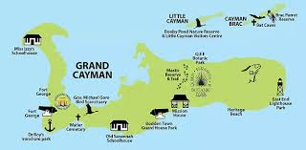
National Trust Cayman Islands

“Urban areas must be ‘rehumanized’, both in terms of scale and in enhancing a sense of belonging. Systematic, comprehensive and culturally sensitive urban development models are required to promote inclusive processes that facilitate access, representation and participation in culture.” The need for urban areas that are sustainable can create hope, jobs and growth. These areas can create stronger social cohesion and general human development. Adopting measures to protect and safeguard tangible and intangible cultural and natural heritage in an urban environment is critical. INTO and its members advocate for stronger regulations and laws, collaborate with key stakeholders such as governments, developers, environmentalists, those with traditional knowledge base, and other interested parties to realise the goal of sustainable cities and communities.

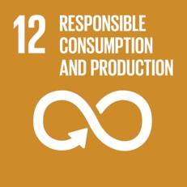
SDG 12: RESPONSIBLE CONSUMPTION AND PRODUCTION

‘Doing more and better with less’ is the aim of SDG 12. Responsible consumption and production is about growing our economies by reducing resource use, degradation, and pollution while increasing the quality of life in the process. Current global consumption and production patterns are unsustainable. Efficiency gains and technological advances alone will not be sufficient to bring global consumption to a sustainable level. It is therefore imperative that consumers adopt more sustainable consumption patterns, making use of goods and services that respond to basic needs and bring a better quality of life, while, at the same time, minimizing the use of natural resources, environmental pollutants, and waste, so as not to jeopardize the needs of future generations. Consumers must be more sustainable in their choices and use of products and services.

Food and drink have the highest levels of ecological impact per dollar spent. In terms of absolute consumption and production, food has the most significant impact. Food produced locally usually has lower ‘food miles’ and therefore less emissions and energy attributed to it from paddock production to the consumer consumption. Buying local produce also strengthens local food chains and supports farming communities. A great example for healthy eating and local produce are found in Quinta da Pedra Branca in Portugal. The farm has a “Bio-Nice” campaign which engages people who share an enthusiasm for food with high nutritional value, unique flavour, and is produced without fertilizers and pesticides.

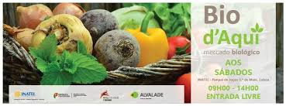
Bio -Nice (Quinta da Pedra Branca)

Another component of SDG 12 is the development and implementation of tools to monitor sustainable development impacts for sustainable tourism that creates jobs and promotes local culture and products. The Grenada National Trust and the Organization of American States (OAS) worked on implementing a model to help develop viable and responsible heritage tourism economies throughout the Caribbean. The model focuses on encouraging protection and promotion of tangible and intangible sustainable heritage among communities that now receive few benefits from the regional tourism industry through endorsement of local tourism products and services that safeguard heritage resources and communicate their value to all audiences.

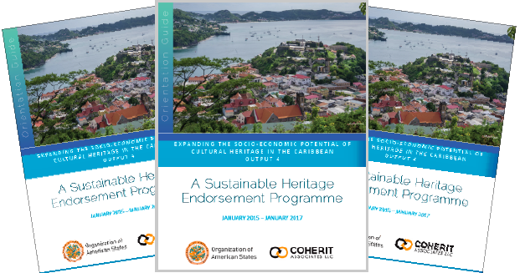
Studies have shown that consumers are interested and willing to pay more for sustainable products that are geared towards environmental protection and would benefit local communities. For example, in England the Lake District Tourism and Conservation Partnership (now the Lake District Foundation) was founded in 1993 by the National Trust, Cumbria Tourist Board and the Lake District National Park Authority to help fund the beautiful landscapes in the region. These landscapes were the main reason for tourism in the area. This partnership worked with the local tourist industry (hoteliers, shops and businesses) to set up a “Visitor Payback” scheme whereby all the revenue received goes to environmental works carried out by the various conservation bodies.

Tourism-related activities need to show due respect for the safeguarding of intangible and tangible cultural and natural heritage. Tourism must be managed collaboratively with clear strategies and guidelines and include all key stakeholders. Heritage organisations, as key stakeholders, play a strategic role in sustainable cultural tourism by working with local communities and guiding sustainable behaviour in tourism activities. Sustainable consumption and production patterns are central to sustainable tourism.

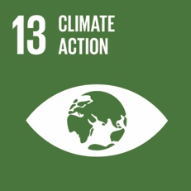
SDG 13: CLIMATE CHANGE

The target here is to improve education, awareness-raising & human & institutional capacity on climate change mitigation, adaption, impact reduction & early warnings.

INTO has been an active participant in climate change debates since COP 15 in Copenhagen, promoting the need to take strong and decisive action to address climate change and its impacts on heritage through both mitigation strategies that reduce the effects of climate change and adaptation strategies to cope with its unavoidable consequences.

At COP 17 in Durban we took the focus of INTO’s climate change campaigning a few steps further by specifically drawing out the failure of the international deliberations of the UN and national governments to acknowledge sufficiently the implications of climate change for the sustainability of culture. And at COP 18 in Doha we managed to ensure that cultural heritage, and in particular the intangible cultural heritage, was included in formulating compensation for non-economic Loss and Damage.

Climate change has the capacity to substantially undermine the integrity of the world’s cultures, altering most, if not all, and destroying many. INTO determined that it could not stand by and witness this impact occurring as the destruction of culture is a fundamental breach of the principle of intergenerational equity, in that a culture destroyed or diminished within the time of the current generation will deprive members of future generations of their right to their cultural inheritance. This principle has been confirmed in many UNESCO Conventions.

We say that if the global community acts too slowly in response to climate change, or acts insufficiently, the cultural legacy for those that follow the current generation will be irreparably diminished.
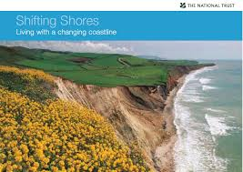
Coastall Impact (National Trust)

INTO and its members have the capacity to demonstrate that cultural heritage holds not only the record of past successes and failures to adapt to climate change but also the record of successful ways of minimising greenhouse gas emissions, thereby showing how climate change may be mitigated. Our perspective of resource conservation involving soil, energy, water and other natural components of our biosphere can demonstrate that a wise and balanced approach to sustainable land management is achievable. Throughout the National Trust movement, there are many exemplary management approaches that convey a strong, practical and positive message as shown throughout this paper.

Most recently, at the biennial International Conference of National Trusts held in Bali in September 2017, the Indonesian Heritage Trust formulated the Gianyar Declaration. This highlights the role that heritage organisations across the globe should be taking in terms of mitigation and adaptation and goes on to describe our duties.

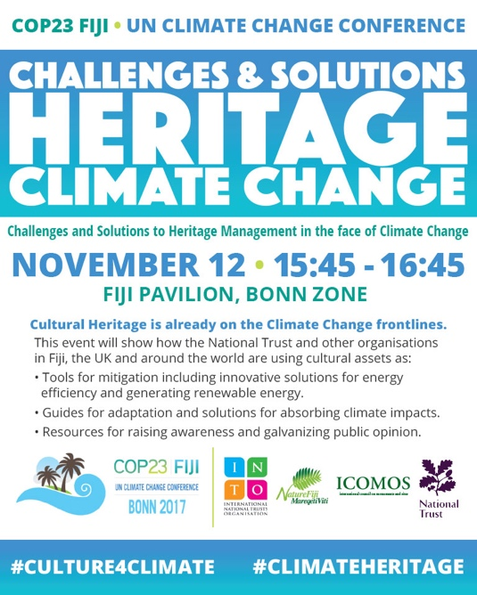

For the last 3 COPs, in Paris, Marrakech and Bonn, INTO has worked in partnership with ICOMOS and UNESCO promoting the need for more account to be taken of the principles espoused above.
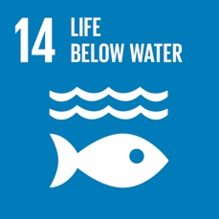
SDG 14: LIFE BELOW WATER

Human actions have caused many threats to marine life and ocean sustainability. Protection of marine species and support for the people who depend on oceans is critical.

INTO was brought in to support its two members in Taiwan, the Taiwan Environmental Information Association and the Taiwan National Trust, as well as other environmental associations, in opposing the proposed construction of a petro-chemical factory on 4500 ha of coastal wetland on the west coast at Dachen, the biodiversity of which was exceptional.
Just offshore of the site in question was the last remaining habitat for the few, critically endangered (IUCN Red List) Pink Dolphin that still survive. It was also an area where the local oyster fishermen plied their trade using ox-drawn wooden carts (the last remaining site in Taiwan where they are used) to access their oyster beds.

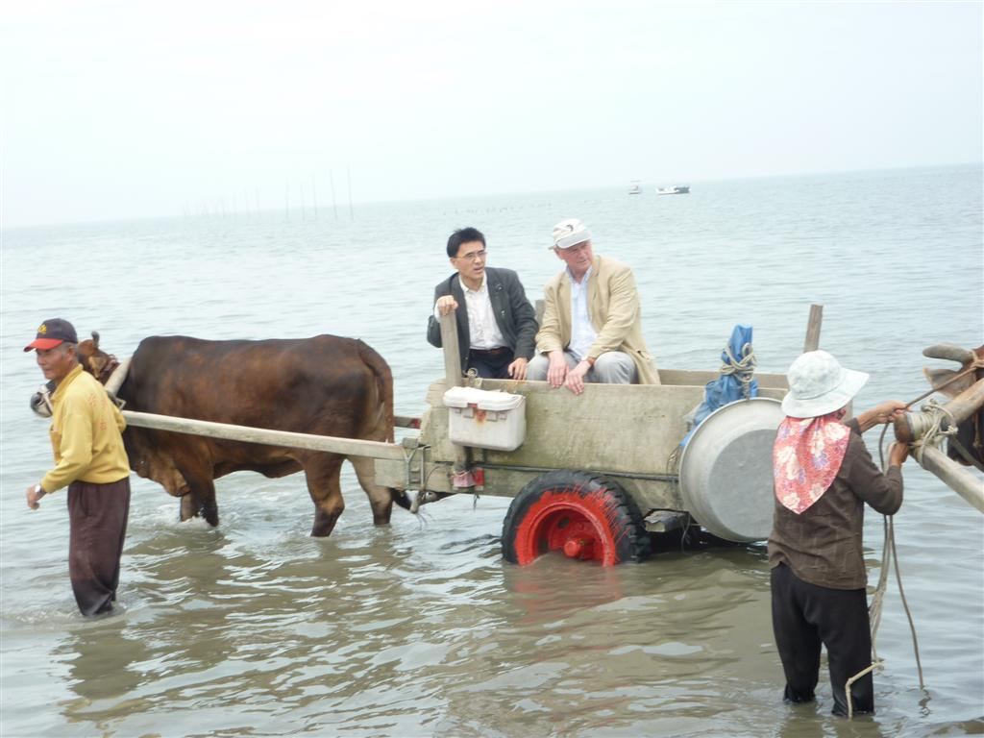
(INTO)

With the assistance of INTO’s Director of Advocacy, these organisations and other conservation groups, were able to convince the President of Taiwan that the site held extraordinary value to the pink dolphins and other marine life as well as to the oyster fisherman’s livelihood and should be protected. The project was successfully abandoned a year later.
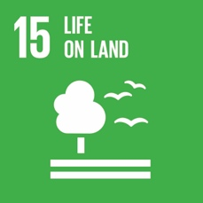
SDG 15: LIFE ON LAND

SDG 15 seeks to ensure the protection, restoration and sustainable use of terrestrial and inland freshwater ecosystems, including forests, wetlands, mountains and drylands as well as combating desertification and stopping and reversing land degradation and loss of biodiversity.

Terrestrial ecosystems provide many benefits to society, including clean air and water, natural resources, recreation, biodiversity conservation, and protection and mitigation from natural disasters and climate change. However, today these natural resources are declining, ecosystems are stressed, and biodiversity is being lost across the globe. There are many causes that lead to deforestation and severe forest degradation including agriculture, unsuitable forest management, infrastructure projects, natural disasters and climate change.

Human-caused deforestation and desertification pose major challenges to sustainable development. INTO members are at the forefront of sustainably managing deforestation, biodiversity loss and ecosystem protection. In particular, many organisations are working with local communities and traditional landowners to protect and restore biodiversity and contribute to environmental sustainability.

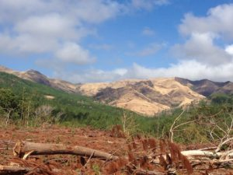
Burned land. National Trust Fiji

The National Trust of Fiji is working to combat deforestation and desertification of their land. More than half the lands in the Fiji Islands are forested. Some lands have been extremely degraded from constant burning, poor soil quality and abandoned agricultural land. The National Trust of Fiji in partnership with the Ministry of Agriculture and the Ministry of Forests is currently working on the implementation of the Action Against Desertification Project. They will be collecting information from targeted communities and stakeholders that will lead to restoring forests in areas of Fiji through sustainable land management and land use planning.

The African Union of Conservationists (AUC) in an effort to combat forest degradation in Uganda is using a more participatory and innovative approach that requires involvement of a broad spectrum of stakeholders. The Collaborative Forest Management plan is a collaboration between government, interested organisations, community groups and other stakeholders where they share roles, responsibilities and benefits for the purpose of sustainably managing a local or central forest reserve. Involving local communities in the design and implementation of management plans is essential to help them move into roles where they themselves are regulating and policing forest reserves.

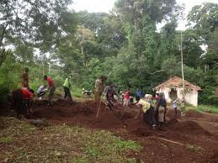
African Union of Conservationists

Natural disasters also have devastating impacts on natural resources, especially in the Caribbean. Since 1999, the National Parks Trust of the British Virgin Islands undertook a mangrove replanting programme across the southern coast in Tortola. Unfortunately, after the catastrophic hurricane season of 2017, the majority of these mangrove stands were destroyed. To prevent this from reoccurring, the National Parks Trust is currently working with volunteers to pioneer other techniques, such as planting within concrete blocks, in order to replant mangroves across the British Virgin Islands.

Biodiversity is the foundation of healthy, functioning ecosystems upon which all life depends, including animals, plants and people on earth and makes a key contribution to sustainable development. The integration of ecosystems and biodiversity values into national and local planning is essential. Biodiversity in the Pacific islands has been hit particularly hard with the introduction of invasive species and habitat loss. Fiji has 164 known amphibian species, approximately 29 percent are endemic and approximately 15 percent are threatened. One of the critically endangered species is the Fiji Crested Iguana, found only on a few Fijian islands. Working with traditional landowners (Mataqali Vuvaivi of Yanuya Village) and other key stakeholders, the National Trust of Fiji is protecting and restoring the tiny island of Manuriki, home to these endangered species. Fijian Bats, its only native mammal, are also critically endangered. Currently, the National Trust of Fiji is working on plans for the restoration and rehabilitation of these native species by compiling inventories of their numbers, acquiring critical habitats and running an awareness program - educating landowners and the public on best efforts to protect these species.

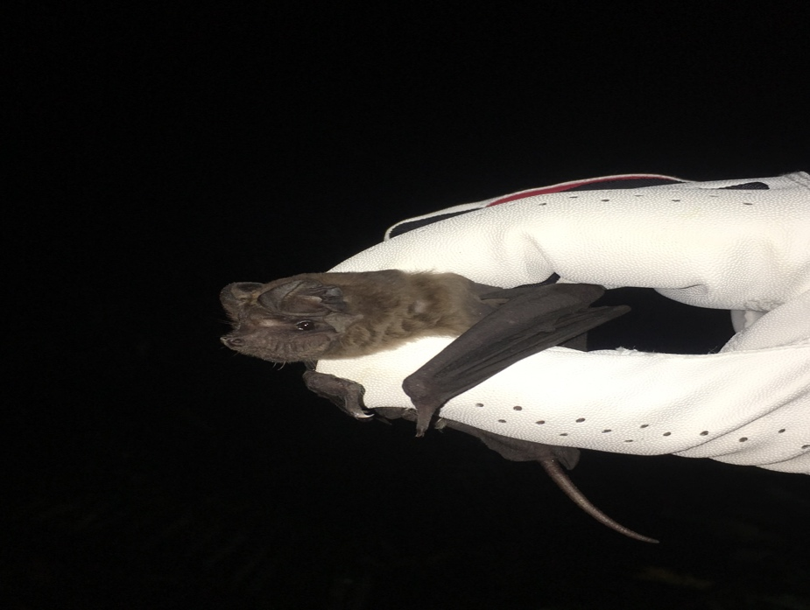
Fijian Bats (National Trust Fiji)

Similar to Fiji, on Dog Island in Anguilla, degradation of native species of birds and native plants have been devastated by invasive non-native species. The Anguilla National Trust began the Dog Island Restoration Project to restore the island by eradicating the non-native species and thereby creating the invaluable opportunity for re-colonization with other rare indigenous species. Today, Dog Island has become the largest island to be cleared of rats and restored in the Eastern Caribbean.

The Bermuda National Trust is also working on a Conservation Management Plan for two islands located in Ely’s Harbour, Palm Island and Morgan’s Island where invasive species have taken hold. These islands form a valuable habitat, detached from the main island and have healthy populations of endemic species. Research is being done to implement an invasive species removal plan.

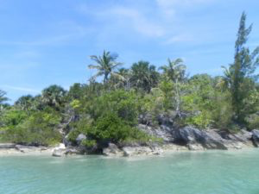
Bermuda National Trust

Working with local and traditional knowledge offers an alternative view and relationship to nature and the environment. INTO and its members work with indigenous and local communities as they better understand the local environments and are able to provide valuable insights into conservation, restoration and use of terrestrial ecosystems that support sustainable management of land and its resources. The contribution of local and traditional communities is invaluable to protect biodiversity and environmental sustainability.

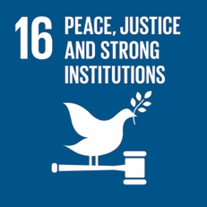
SDG 16: PEACE, JUSTICE AND STRONG INSTITUTIONS

INTO and its members are committed to promoting respect for cultural diversity and facilitating cultural understanding and peace. The National Trusts in Australia in both Western Australia and Victoria have major programs underway which include working directly with Aboriginal communities in the conservation and interpretation of heritage areas and have developed national guidelines for Aboriginal Interpretation on Trust places.

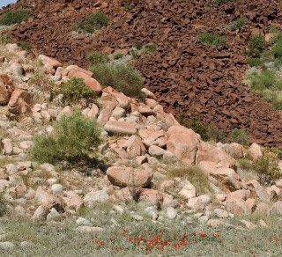
Archaeology Report (National Trust Western Australia)

Maori heritage is central to New Zealand’s unique identity and is New Zealand’s heritage. Heritage New Zealand works to promote Maori heritage and to protect tangible and intangible property associated with the Maori people. The Maori Heritage Council works collaboratively with Heritage New Zealand to help promote the Maori culture and consciousness by encouraging an understanding of its values beyond being thought of as purely Maori culture but rather a culture belonging to all of New Zealanders.

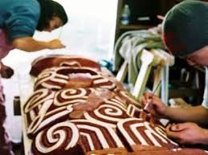
Heritage New Zealand

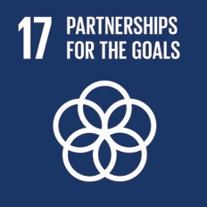
SDG 17: Global Partnership for Sustainable Development

INTO as an organisation has partnered with many relevant international organisations to promote the need for heritage conservation (UNESCO, ICOMOS, IUCN, Europa Nostra); sustainable tourism (World Travel and Tourism Council, UNWTO); sustainable consumption and production (UNEP), sustaining local communities (Global Ecovillage Network); climate change and cultural heritage (UNFCCC)

Within its own organisation and in support of its members INTO has introduced a small grants programme helping them to build capacity and so enabling them to address relevant sustainable development challenges.

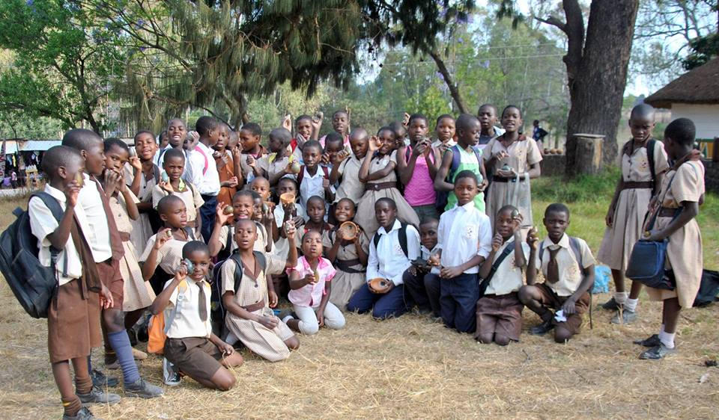
National Trust Zimbabwe (INTO Small Grants recipient)

Every other year INTO with the host member organises the International Conference of National Trusts which many heritage organisations attend, exchanging best practice, networking, and above all learning about the challenges of heritage conservation.

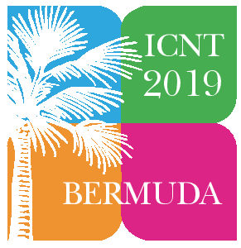
INTO Conference March 2019

INTO is currently developing a Technical Assistance Programme (TAP-INTO) bringing together all our capacity building services.

Conclusion

This paper gives a snapshot of some of the work that INTO and its members are doing which contributes to the achievement of the SDGs. Of the 17 Goals, 14 are directly relevant to heritage conservation and many of those are interconnected.

Too often culture and cultural heritage are omitted from debates on, for example, climate change and sustainability. In the latter case the three pillars normally referred to are social, economic and environmental.

We believe that this paper makes the case for there to be a fourth pillar, namely ‘cultural’, so enhancing the principle that heritage conservation is very definitely a pillar of sustainability.

The world will need about 50 percent more food by 2030; to produce enough food sustainably is a global challenge. A New Global Partnership: Eradicate Poverty and Transform Economies Through Sustainable Development – The Report of the High-Level Panel of Eminent Persons on the Post 2015 Development Agenda (United Nations 2013).
http://naturefiji.org/profile/national-trust-of-fiji
http://www.tesourosdegalicia.com
http://www.nationaltrust.org.au
https://larochellecentre.com
Preamble to the Constitution of the World Health Organization as adopted by the International Health Conference, New York, 19-22 June,1946; signed on 22 July 1946 by the representatives of 61 States (Official Records of the World Health Organization, no. 2, p. 100) and entered into force on 7 April 1948.
Hernandez, L. and Blazer, D. (2006). Genes, behavior, and the social environment. Washington, DC: National Academies Press, Chapter 2.
International Journal of Humanities and Social Sciences, The Concept of Place and Sense of Place in Architectural Studies, World Academy of Science, Engineering and Technology, Vol:5, No. 8, 2011.
Public Health and Landscape, Creating healthy places. Landscape Institution Position Statement, November 2013, pp 14, 22.
Ibid.
Bodenfreiheit Austria. http://www.bodenfreiheit.at
The Bermuda National Trust. https://www.bnt.bm/
National Trust report, Places That Make Us, 2017. Available at: https://www.nationaltrust.org.uk/
ICSU, ISSC (2015): Review of the Sustainable Development Goals: The Science Perspective. Paris: International Council for Science (ICSU). Available at: https://www.icsu.org/cms/2017/05/SDG-Report.pdf
https://greenschol sireland.org
National Trust for the Cayman Islands. www.nationaltrust.org.ky
Japan National Trust. http://www.national-trust.or.jp/english/englishindex.htm
Montserrat National Trust. http://montserratnationaltrust.ms/
St. Helena National Trust. http://www.sthelenaisland.info/st-helena-national-trust/
3000 students take part in a three-stage learning process with the BNT in social studies and science both in museums and nature reserves. Additionally, the BNT carries out a wide series of talks/seminars on local island culture. https://www.bnt.bm
Ibid.
http://intoorg.org/30236
Ibid.
Ibid.
The Cross-Cultural Foundation of Uganda, Women, Culture & Rights in Acholi, 2017. Available at: https://ccfublog.wordpress.com/
Ibid. at 4.
Ibid. at 3.
Ibid. at 6.
Ibid. at 27.
Ibid. at 28.
http://crossculturalfoundation.or.ug/wp-content/uploads/2017/11/My-rights-as-a-woman-or-girl.pdf
The International Council for Science. (2002). Science, traditional knowledge and Sustainable Development. Available at: https://www.icsu.org/publications/ reports-and-reviews/science-traditional-knowledge
Centre U. (2018). Cultural Landscape of Bali Province: the Subak System as a Manifestation of the Tri Hita Karana Philosophy. [online] Whc.unesco.org. Available at: http://whc.unesco.org/en/list/1194
Ibid.
Anand Krishna, Tri Hita Karana: Ancient Balinese Wisdom for Neo Humans, Anand Ashram Foundation, 2008
Towards Sustainable Cultural Landscape of Subak System, Bali Internship Field School for Subak, BIFSS 2016. Available at: http://www.balikuna.org/download/BIFSS%202016%20Proceeding%20final.pdf
https://www.nationaltrust.org.uk/lists/our-guide-to-renewable-energy
National Trust (2018). Turning Water into a conservation win. [online]. Available at: https://www.nationaltrust.org.uk/features/turning-water-into-a-conservation-win
Montserrat National Trust. http://montserratnationaltrust.ms/
National Trust (2018). Fit for the Future Network [online]. Available at: https://www.nationaltrust.org.uk/features/fit-for-the-future-network ; See also www.fftf.org.uk
Clark, D. (2018). Adapting an Older Building for a New Use. [online] Buildings.com. Available at: https://www.buildings.com/article-details/articleid/5837/title/adapting-an-older-building-for-a-new-use
NTHP 2018. Green Stories [online]. Available at: https://savingplaces.org/story-categories/green-stories?page=4#.WxAgWVOFOu4
NTHP 2018. PRESERVATION GREENLAB [online]. Available at: https://savingplaces.org/preservation-green-lab#.Ww__c1OFOu4
Ibid.
UN Economic and Social Council (2017). Report of the Secretary-General, Progress towards the Sustainable Development Goals, E/2017/66 [online]. Available at: http://www.un.org/ga/search/view_doc.asp?symbol=E/2017/66&Lang=E
Rypkema, D. 2005, The Economics of Historic Preservation: A Community Leader’s Guide, National Trust for Historic Preservation, USA; and Guido Licciardi and Rana Amirtahmasebi, Eds., 2012. The Economics of Uniqueness. Washington, DC: The World Bank.
Rypkema, D. (2018). Heritage Conservation as Sustainable Development: The Historic Preservation Movement’s Road to Habitat 3. [online]. USICOMOS.org. Available at : http://www.usicomos.org/heritage-conservation-as-sustainable-development-the-historic-preservation-movements-road-to-habitat-3/
Place Economics (2011). Measuring the Economics of Preservation: Recent Findings. A report prepared for the Advisory Council on Historic Preservation. Available at: http://www.preserveamerica.gov/docs/final-popular-report6-7-11.pdf
Ibid.
Ibid.
https://www.mainstreet.org/home
National Trust Tasmania. https://www.nationaltrust.org.au/tas/
Guido Licciardi and Rana Amirtahmasebi, Eds., 2012. The Economics of Uniqueness. Washington, DC: The World Bank.
Jyoti Hosagrahar, The UNESCO Courier, Many Voice, One World, Culture: at the heart of SDGs, April – June 2017.
Ibid.
Ibid.
National Trust Australia. www.nationaltrust.org.au
Heritage Bermuda. www.heritagebermuda.com
Saint Lucia National Trust. www.slunatrust.org
United Nations, Department of Economic and Social Affairs, Population Division, World Urbanization Prospects: The 2014 Revision, Highlights (ST/ESA/SER.A/352), New York, 2014
Aijun, Y. (2018). Well-planned and Managed Cities can drive Sustainable Development. UN agency chief. [online] UN News. Available at: https://news.un.org/en/2018/02/1002181.
www.yangonheritagetrust.org
Levin, D. (2018). In Shanghai, Preserving Buildings Takes Works. [online]. NYTimes.com. Available at: https://www.nytimes.com/2010/05/02/arts/design/02shanghai.html
Ruan Yisan Heritage Foundation. http://www.ryshf.org/
Ibid.
Cape Town Heritage Trust. www.heritage.org.za
Ibid.
Alias, Shah Ali, and Keen Wai (November 2010). New Urbanism and township developments in Malaysia. Centre for Building and Urban Studies (Malaysia). Available at: https://umexpert.um.edu.my/file/publication/00006042_62755.pdf
Badan Warisan Malaysia. https://badanwarisanmalaysia.org
Preservation Green Lab. https://savingplaces.org/preservation-green-lab#.WxUvoFOFOu4
National Trust Cayman Islands. www.nationaltrust.org.ky
Saint Lucia National Trust. https://www.slunatrust.org
National Trust Cayman Islands. www.nationaltrust.org.ky
UNESCO (2016). Culture, Urban, Future: Global Report on Culture for Sustainable Urban Development. [online]. Paris. Available at: https://www.bnt.bm
Living Planet Report, World Wide Fund for Nature (WWF), 2004. Available at: http://assets.panda.org/downloads/lpr2004.pdf
Ibid.
WWF-UK, One Planet Business, 2006. [online]. Available at: http://wwf.panda.org/knowledge_hub/all_publications/living_planet_report_timeline/
Ibid.
Quinta da Pedra Branca. https://quintadapedrabranca.pt/
Organization of American States. http://www.oas.org/en/sedi/desd/ct/cultural.asp
World Tourism Organization (UNWTO) and Organization of American States (OAS), 2018. Tourism and the Sustainable Development Goals – Good Practices in the Americas. [online]. UNWTO, Madrid. Available at: https://www.e-unwto.org/doi/pdf/10.18111/9789284419685
Lakes District Foundation. www.lakedistrictfoundation.org
Molesworth, Prof. Simon R., 2014, INTO’s Climate Change Action, An Taisce, Summer, p.14.
Ibid.
Ibid.
Ibid.
Gianyar Declaration, 2017. (online). Available at: https://intoorg.org/wp-content/uploads/2017/09/GIANYAR-RECOMMENDATION.pdf
Food and Agriculture Organisation of the United Naitons. Sustainable Development Goals. [online]. Available at: http://www.fao.org/sustainable-development-goals/goals/goal-15/en/
World Wildlife Fund (2018). Deforestation Causes. [online]. Available at: http://wwf.panda.org/our_work/forests/deforestation_causes/
Ibid.
Food and Agricultural Organisation of the United Nations (FAO). 2010. Global Forest Resource Assessment. Country Report Fiji. [online]. FAO, Rome. Available at: http://www.fao.org/docrep/013/i1757e/i1757e.pdf
National Trust of Fiji. https://naturefiji.org/project/action-desertification-project-aad-fao/
Daveta, M. Technical Workshop on Great Green Wall and Dryland Restoration Fiji Action Against Desertification. Fiji Forestry Department [online]. Available at: http://www.fao.org/3/a-az758e.pdf
Turyahabwe, N. & Agea, J. & Tweheyo, M. & Tumwebaze, S. (2012). Collaborative Forest Management in Uganda: Benefits, Implementation Challenges and Future Directions. 10.5772/28906. [online] Available at: https://www.researchgate.net/publication/224830124_Collaborative_Forest_Management_in_Uganda_Benefits_Implementation_Challenges_and_Future_Directions
Ibid.
National Parks Trust of the Virgin Islands. http://www.bvinationalparkstrust.org/
UNECE.org (2018). Regional Forum on Sustainable Development for the UNECE Region. Geneva. [online]. Available at: https://www.unece.org/fileadmin/DAM/RCM_Website/Concept_note_SDG15_2.pdf
Fijisun.com.fj. (2010). Pacific islands biodiversity under threat, experts warns. Fiji Sun. [online] Available at: http://fijisun.com.fj/2010/05/13/pacific-islands-biodiversity-under-threat-expert-warns/
International National Trusts Organisation (2015). Re-introduction of Fiji Crested Iguanas. [online]. Available at: https://intoorg.org/encyclopedia/re-introduction-of-fiji-crested-iguanas
National Trust of Fiji. Bats of Fiji. https://naturefiji.org/project/bats-of-fiji/
The Anguilla National Trust. http://www.axanationaltrust.com/
The Bermuda National Trust. http://www.bnt.bm

