2011 Annual Report and Accounts

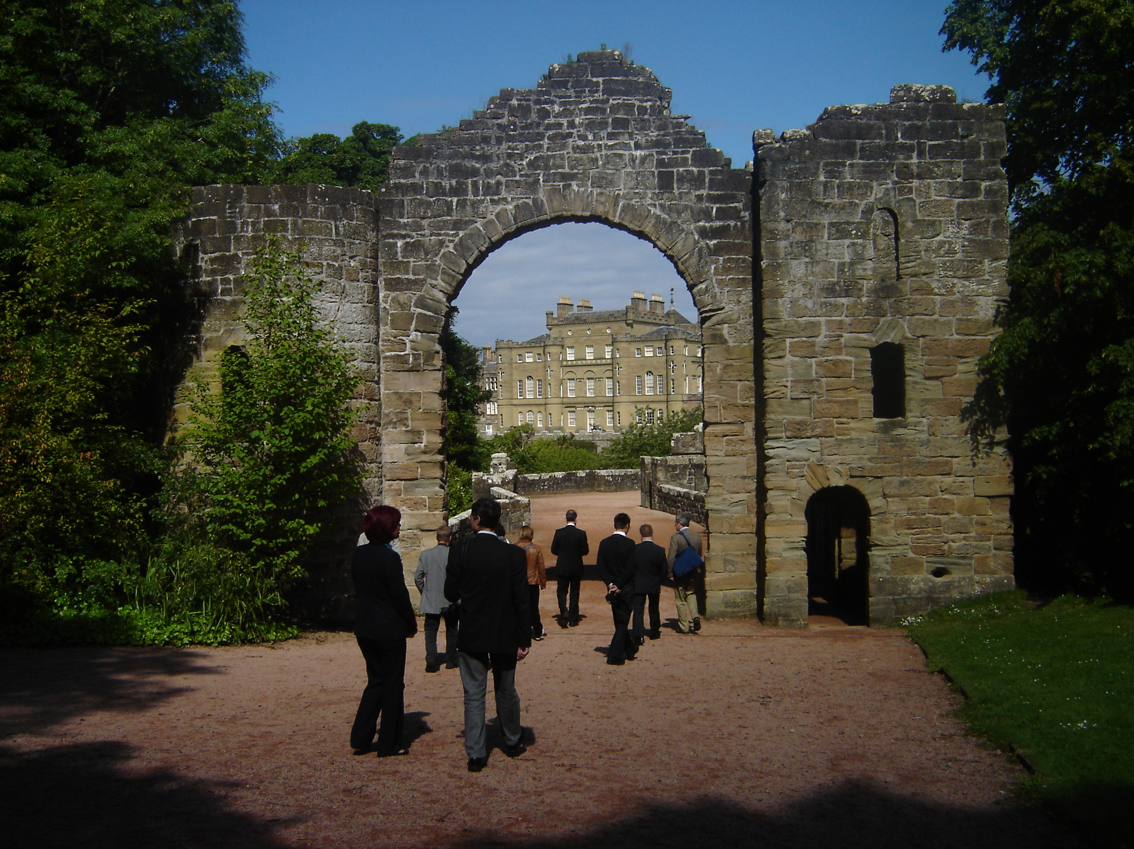


Message from the INTO Chairman

Connecting People, Places and Stories was the theme of our Conference in 2011 and serves as a good description of our wider work programme that goes much deeper than the heritage conservation National Trusts are (rightly) famous for, underlining the public benefit that INTO brings.

The 14th International Conference of National Trusts (ICNT) in Victoria, Canada, strengthened ties between the National Trusts of the world and enabled us to share experiences in increasing engagement and dealing with change – economic, political, social and technical, as well as environmental. I was delighted that our concerns about sustainability and the effects of climate change on the world’s cultures were integrated into the ‘Victoria Declaration on Climate Change’, which I then had the honour of advocating at the UN talks in Durban, known as COP 17.

Currently comprising more than sixty member organisations from over fifty nations, the global voice of INTO represents over six million individual members and supporters, and an extended constituency of many tens of millions more people who demonstrate their support through visitation, expenditure, philanthropy and participation.

Geoffrey Read and Oliver Maurice, joined me in representing INTO at COP 17, where we increased our presence from previous years with a stand and side event raising awareness of the impacts of climate change on National Trusts and gaining wider backing of the Victoria Declaration. We could not have achieved this without local support from the South African National Heritage Trust as well as the contribution of Luke Strachan, our youth volunteer.

Another highlight for me this year was the Central European Project which, funded by INTO Amicus member Rodney Davidson AO OBE, brought heritage practitioners from the Czech Republic, Hungary, Poland and Slovakia to the UK to experience different approaches to heritage management, in particular community engagement. I had the pleasure of joining the team in the North of England and saw for myself the benefit of such an intensive and focussed study visit, which we hope to repeat in other regions. In June, in the presence of HRH The Prince of Wales, a wonderful reception took place at Clarence House to celebrate INTO reaching 50 member organisations. A workshop, instigated by HRH, then took place immediately following the reception, to which HRH contributed and I chaired, involving 24 of our INTO people reporting on their worldwide work and outlining future proposals.

Capacity building and external advocacy have therefore taken centre stage in 2011 but we have also been reviewing our own structure and strategy. We have undertaken a mid-term review of Strategy 2.0 INTO The Future, which will see us focussing on five key areas next year, namely good governance, membership services, programmes and projects, financial sustainability and advocacy.

Lastly, I would like to thank all our committed volunteers, supporters and Secretariat personnel for their hard work and dedication, in particular my fellow trustees and Executive Committee members. But really INTO is nothing without its member organisations and as we move into 2012, I see our network becoming an even stronger coalition of organisations with a shared mission and vision for the future of heritage worldwide.
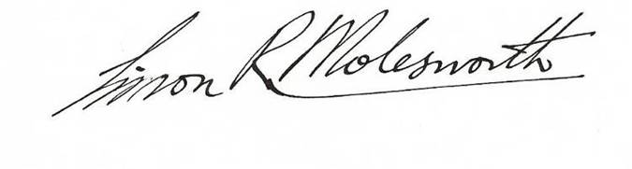

Simon R. Molesworth AM, QC
Chairman of the INTO Executive Committee

Contents
 | Page
Message from the INTO Chairman | 2
Contents | 3
Achievements and Performance | 4
Organisational development | 4
Policy and advocacy | 5
Fundraising and awareness | 7
Membership services | 8
Our Members | 9
Report of the Trustees for the year ending 31 December 2011 | 11
Trustees | 11
Structure, governance and management | 11
Appointment of Trustees | 12
Organisation | 12
Executive Committee members | 13
Risk management | 13
Objectives and activities | 13
Statement of Financial Activities for the year ended 31 December 2010 | 14
Balance sheet – 31 December 2010 | 14
Notes to the Financial Statements for the year ended 31 December 2010 | 14
Thanks | 16

Cover picture: Participants on INTO’s Central European Project visiting Culzean Castle, owned and managed by the National Trust for Scotland.

The International National Trusts Organisation (INTO) is a non-profit organisation registered as a
limited company in England and Wales (No 06718966) and a registered charity (No 1128224).
Our registered office is 32 Queen Anne’s Gate, London SW1H 9AB, UK.

Achievements and Performance

INTO is a global coalition of National Trusts and like organisations, united by their common interest in the conservation and enjoyment of our shared heritage - built and natural, tangible and intangible. Our charitable object is to ‘promote the conservation and enhancement of the heritage of all nations for the benefit of the people of the world and future generations’.

INTO’s strategic vision in 2011 remained to ‘make the National Trust movement greater than the sum of its parts by providing a global focal point through which the movement, from every corner of the earth, comes together and works together’. This report describes progress on our 2011 priorities: organisational development and building the capacity of the Secretariat; policy and advocacy; fundraising and membership services, and outlines our revised Strategy 2.2.

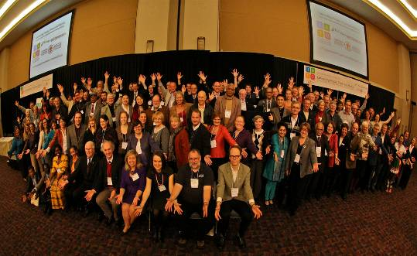
1. Organisational Development
The 14th International Conference of National Trusts brought together 300 delegates from 36 countries in Victoria, British Columbia, from 12-15 October 2011. In her closing remarks, Catherine Leonard said “As we explored new strategies for heritage conservation in a changing world, we had the opportunity to share our experiences, to listen to committed voices and to feel that the things that concern us are basically the same. We heard that the most important things are not necessarily the objects, stories or places that we look after, but people. And we have explored a new paradigm of ‘looking after with people rather than for people’.”

The evolution of INTO as the focal point for the global National Trust movement progressed tremendously through this conference and the participation of so many Trusts from developing nations, generously supported by the Getty Foundation, played a large part in this success.

Delegates left Victoria energised and committed to begin applying what they had learned to their own circumstances, and looking forward to the next conference in Entebbe, Uganda, in
October 2013.

Delegates at the 14th ICNT, Victoria, Canada

Since we embarked on Strategy 2.0 INTO The Future, an incredible amount has been achieved by the INTO Executive Committee working closely with the Secretariat team. In the light of changes affecting our member organisations over the past two years however, and a realisation that the growth we had hoped for for INTO would be slower in coming, we have revised our objectives for the next two years.

Strategy 2.2 (2012-2015) provides a clear focus on strategic priorities and is a direct response to the recommendations arising from the independent review undertaken in 2011. The accompanying action plan will enable us to advance our ambitions at a steady and realistic pace.

Careful evaluation and fresh thinking have enabled us to set out five objectives covering:

- The administration of INTO;
- Excellence in membership services;
- Programmes and projects;
- Financial sustainability; and
- What is unique and special about the National Trust approach.

We have also undertaken a brief membership survey as part of the process for preparing the new INTO Directory, which will be published for the first time in 2012 following discussions in Victoria. The Executive have prioritised communication in the new strategy and we plan to conduct more regular feedback sessions with the INTO membership.
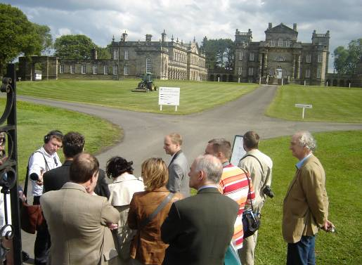
The Secretariat has been restructured to accommodate more volunteers and to be a more comfortable fit with the new strategy.
As an outcome of INTO’s participation in the visit of HRH The Prince of Wales to the region in March 2010, INTO ran its Central European Project in June 2011. Seven representatives from heritage organisations in Slovakia, the Czech Republic, Hungary and Poland spent time exploring with their British counterparts different approaches to finding a viable future for historic buildings by balancing conservation community outreach and financial return.

The project was generously funded by INTO’s first Amicus member, Rodney Davidson, a veteran of previous ICNTs and great advocate of the value of international collaboration.

Putting aside significant differences in legal frameworks, sources of support and cultural discontinuity, our delegates reflected on the need to create more volunteer opportunities and increase visitor numbers; the capacity of heritage to generate employment and how to
persuade the ‘experts’ that commercial and
more ‘mass appeal’ activities can still
respect historic values.

CEP delegates at Seaton Delaval Hall

The National Trust of England, Wales and Northern Ireland (NTEWNI) continues to host the INTO Secretariat and we remain hugely grateful for its ongoing support and additional contributions.

Prior to the International Conference of National Trusts, we undertook some vital constitutional reforms, which were then approved unanimously by the membership in Victoria. Our Chairman is also leading work to establish the INTO Foundation and has secured pro bono legal advice from the firm Wrigleys.

2011 has seen a steady growth in membership and we have been encouraging existing ‘National Trusts’ to join INTO, particularly those in the Commonwealth where the concept is well-known, whilst reaching out to other relevant groups and organisations.

2. POLICY AND ADVOCACY

INTO’s policy work falls into two categories: assisting member organisations with national advocacy efforts in their own countries, and bringing together the National Trusts of the world to speak with one voice on global issues.

INTO lent its support to the Taiwan Environmental Information Association (TEIA) campaign opposing the construction of a petro-chemical factory on the unique Dachen Wetlands.

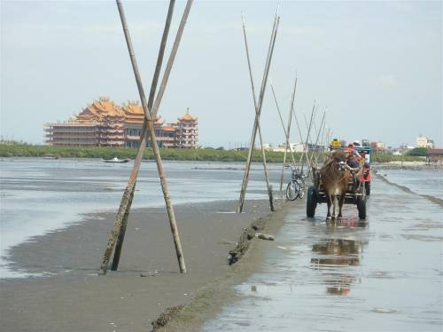
Dachen Wetlands, Taiwan

We were thrilled when the President of Taiwan stepped in at the last minute and called on his government to reject the proposal, thereby saving the 4,000 ha ecological site for future generations. INTO was likewise involved in the CCFU’s (Cross-Cultural Foundation of Uganda) petitioning of its government to save the National Museum of Uganda, which as a result was granted a reprieve in 2011. INTO has also contributed to discussions with senior civil servants, the St Helena National Trust and other ngos about how to minimise the impact of the planned airport on the island.
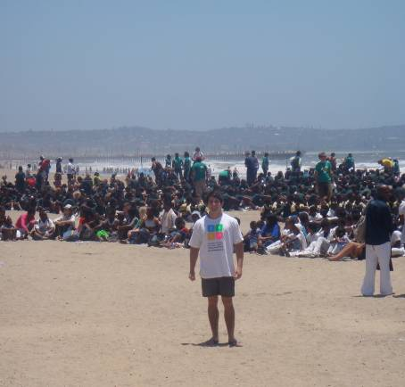
At a regional advocacy level, Marcus Gilleard (NTEWNI) represented INTO Europe on the EU’s Working Group on Green Infrastructure. INTO Europe met several times by teleconference in 2011 and agreed to focus on a small number of priorities including working with Europa Nostra on policy issues, helping establish National Trusts where they do not currently exist and knowledge sharing. Our Chairman and representatives of several INTO member organisations also met during the Europa Nostra Congress in Amsterdam in June.
Luke Strachan, our youth volunteer at COP 17

Oliver Maurice was invited to attend the UNEP Global Partnership for Sustainable Tourism in January and INTO continues to feed into this grouping. We have also worked closely with Global Climate Change Alliance (GCCA), of which we are now members.
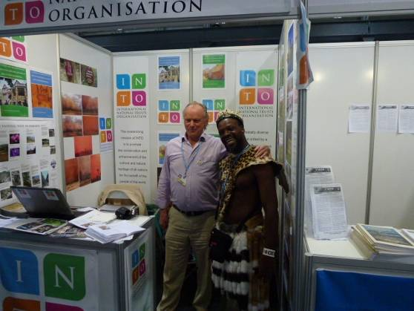
Catherine Leonard presented the outcomes of the Central European Project at the 1st Heritage Forum of Central Europe in Poland in July, spreading the word about INTO and making connections with heritage groups in the Visegrad countries.
Reflecting on his participation at COP17, Oliver Maurice said “While the outcome of the high level talks left much to be desired once again, INTO's presence made a real impression and working with a team of volunteers from the newly formed South African National Heritage Trust and Luke Strachan from Michael House School in Durban, we welcomed 325 people from 83 different countries to the INTO stand, of which 133 signed the Victoria Declaration. Many also expressed interest in joining INTO and already some of these have been followed up.

Thanks to Greenpeace offering space and refreshments in their tent on the beach, we also held a well attended lecture evening, which - added to the 9 television, videotape and newspaper interviews Simon and I gave in Durban - helped raise INTO’s profile and that of the South African National Heritage Trust.”

Oliver greets a visitor to the INTO stand

In October, delegates at the INTO Conference in Canada endorsed the Victoria Declaration on Climate Change, which had been drafted by our Chairman in recognition that culture was under-represented in the debate.

At the end of the year, INTO sent a small delegation of volunteers, armed with the Victoria Declaration, to Durban where delegates from 193 countries met for the 17th Conference of the Parties to the United Nations Framework Convention on Climate Change (known as COP 17).

The aim was to raise awareness of INTO’s work and the impacts of climate change on culture, to sign up new members and to support the burgeoning South African National Heritage Trust (SANHT). Volunteers from the SANHT helped run the INTO booth and side event, kindly hosted by Greenpeace, and Luke Strachan, a Durban schoolboy who also volunteered his time, participated in some of the additional youth activities.
3. FUNDRAISING AND AWARENESS

As 2011 was a conference year, most of our fundraising effort focussed on this and we can report some significant successes. We were thrilled to learn at the very end of 2010 that INTO was to be awarded a grant of $75,000 from the Getty Foundation to enable delegates from developing countries to attend the Victoria Conference. With the help of the National Trust for Historic Preservation, we also built a partnership with the American Express Foundation which gave $25,000 towards the conference keynote leadership panel session. The Prince Claus Fund generously gave funding support to several delegates, for which we are also very grateful.
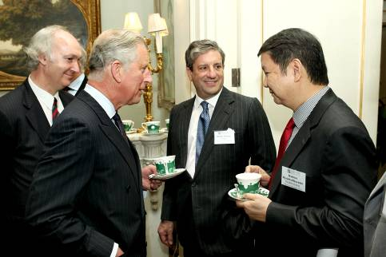
We celebrated the end of the Central European Project on 22 June with a very special tea party at Clarence House, the London home of HRH The Prince of Wales. It was a super opportunity to mark the fact that INTO had reached fifty member organisations, celebrate our achievements thus far and discuss plans for the future with our members, partners and opinion formers. The event finished with a round table conversation led by His Royal Highness that sought to develop a sense of common cause through discussing the unique role National Trusts can play in community engagement, mitigating against and adapting to climate
change, linking the built and natural
environments and sustainable tourism.

HRH The Prince of Wales meeting INTO members
© Paul Burns

Thanks to the NTEWNI, we were able to employ a consultant, Alex Youel, to help us develop information materials, identify and approach potential partners, build up a guest list for our special event at Clarence House and ensure the smooth running on the day.

At the INTO Conference in Canada in October we decided to launch a Small Grants Programme. A small injection of funds at the beginning of a project, particularly for smaller community heritage groups, often gets things moving or can help attract other grants and gifts. We are now embracing the challenge of finding funds for the pilot programme in 2012.

Also in October, representatives of INTO member organisations and the Secretariat joined ‘Quest’, a special fundraising workshop in Canada run by Jim Lord, which gave all those concerned some food for thought and strategies for the future.

In terms of awareness-raising, the major events for INTO in 2011 (our party at Clarence House in the presence of HRH The Prince of Wales, the INTO conference in Victoria and our presence in Durban) are discussed elsewhere in this report.
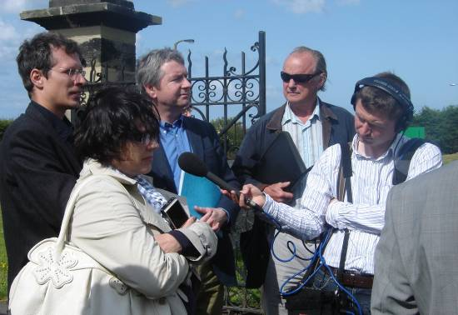
Other examples of outreach include BBC producer, Alasdair Cross, interviewing INTO personnel and participants on the Central European Project for a programme about INTO and its work in 2012.

Part of INTO’s core purpose is to help establish National Trusts where they do not currently exist and we have been supporting groups in countries such as Czech Republic, Hong Kong and Portugal amongst others.
Interviewing CEP participants
INTO continued to reach out to other international and umbrella bodies in 2011 including meetings with ICOMOS, the International Institute for Conservation, the Global Heritage Fund, BUILD and UNESCO. We also have a growing number of facebook fans and plans to further extend public awareness of INTO and its work in 2012.
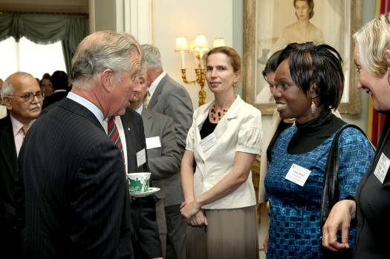
HRH The Prince of Wales meeting INTO members and supporters at Clarence House © Paul Burns

4. MEMBERSHIP SERVICES

Our membership is central to everything that INTO does and we were thrilled to be able to celebrate reaching fifty members in 2011. That number continued to grow over the year and as we head into 2012, we have reached - and surpassed - the sixty mark. Developing excellent membership services and programmes is therefore vital.

The International Conference of National Trusts (ICNT) is an on-going membership service and it is always such a thrill when the members of INTO come together on a biennial basis to share best practice and to speak in one voice on matters of common concern. We are delighted that the next ICNT will be hosted by the Cross-Cultural Foundation of Uganda in Entebbe from 30 September to 4 October 2013.

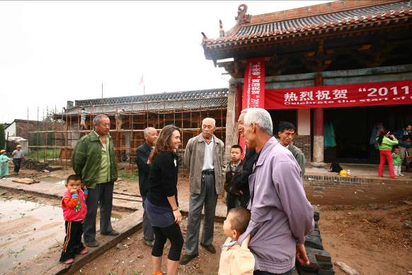
In a new initiative this year, Liz Ferguson, one of our new Secretariat volunteers, has compiled a Membership Directory and at the same time took a straw poll of membership satisfaction, which we will follow up on in 2012.
In 2011 INTO launched its overseas working holidays pilot in collaboration with several member organisations. Opportunities include constructing a shelter in a pristine Canadian forest run by The Land Conservancy of British Columbia, becoming a tour guide in the historic Liptovský Hrádok castle run by the National Trust of Slovakia, or renovating an ancient mill in the heart of the French countryside with Union Rempart.

The scheme, which rolls out in 2012, brings young people together to work on practical, community based conservation projects and we plan to extend its range next year.

2011 joint French and Chinese workcamp in Pingyao

Following the highly successful working holiday exchange between INTO members Union Rempart in France and the Ruan Yisan Heritage Foundation in China (which resulted from the two organisations meeting at the Dublin ICNT in 2009), we have launched a scheme to promote the working holidays of other INTO member organisations with the help of the NTEWNI.

We have also helped source specific assistance for organisations such as the Zimbabwe National Trust, which needed help planning how to secure the future of one of its sites, the Bermuda National Trust with the preparation of a strategic plan, the National Trust of Slovakia with advice on the vernacular heritage restoration, and the South African National Trust with potential donors.

In 2011 INTO said goodbye to some old friends: Sue Cassell, who had been so instrumental in the establishment of INTO; Jeanine Perryck who had represented the Gelderland Trust since 2008 and Colin Griffiths who retired from his role as Honorary Director of Policy Development.
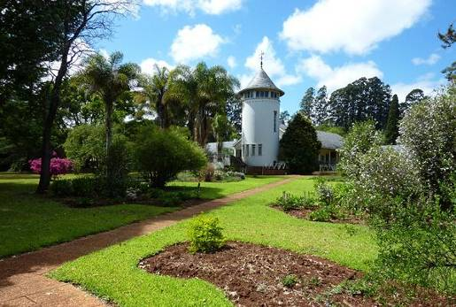
Karen Dickin, NTEWNI, helped the National Trust of Zimbabwe develop a management plan for their flagship property, La Rochelle in the Eastern Highlands. “Left to the people of Zimbabwe in 1967” she writes, “the estate is now rather worse for wear. But amongst local Trust supporters there is a deep love of the place and bags of hope and enthusiasm that things can only get better.

One of the key areas of the management plan is to attract schools and local visitors but even a simple thing like labelling the specimen trees is a chore as there are no engraving machines available in Zimbabwe, even if they could afford one. I am now galvanising the National Trust gardening community to see how we might support them going forward, including
engraving labels. Longer term, INTO hopes to help develop a professional garden
conservation plan.”
NTZ property, La Rochelle
We welcomed some new faces in 2011 as well: Marcus Gilleard, with a background in international conservation policy, took over from Sue Cassell at the NTEWNI; Maggie Morgan joined the Secretariat as Honorary Director of Strategy and Development having stepped down from her role as a senior manager with the NTEWNI; Julie Thompson, a recruitment expert, joined the team as Volunteer Placements Manager; and Liz Ferguson, a management consultant, has also been volunteering as a Project Manager.

There are other volunteers who have helped the INTO Secretariat along the way this year alongside our existing team of Oliver and Geoffrey, to whom we are enormously grateful for their gift of time and expertise. We hope to grow the team still more next year as INTO goes from strength to strength!

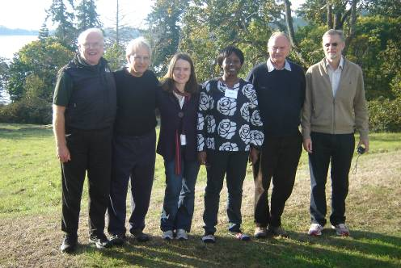
We were all very saddened by Susan D Neumann’s death in 2011. Many of us had the privilege and honour of working with Susan over the years and it was wonderful to spend time with her at the International Conference of National Trusts in Ireland in 2009, to which she had dedicated so much. Like all of those whose lives she touched, we miss Susan greatly.
INTO members and Secretariat at the ‘Quest’ workshop

Our Members

INTO achieves its mission through cooperation, coordination and comradeship between the international community of National Trusts, the development of best conservation practices, increasing the capacity of individual organisations, establishing Trusts where they do not presently exist, and advocacy in the interests of heritage.

Our members are “independent, non-governmental, charitable, educational, not-for-profit, membership-based or like organisations that have as a principal purpose the conservation, enhancement, or promotion of cultural or natural heritage”.
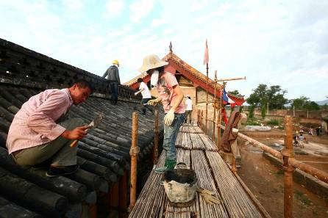
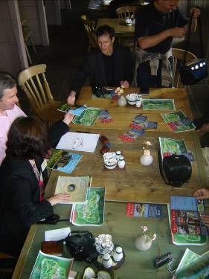
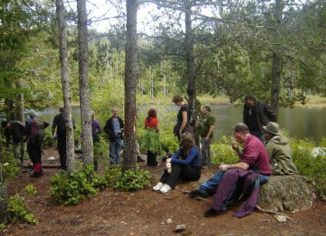
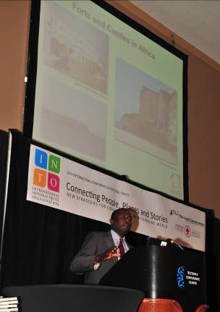
At the end of 2011, INTO had 56 member organisations:

Europe
Europa Nostra (Associate)
The Falkland Islands Museum and National Trust
Conservatoire du Littoral (Associate)
Fondation du Patrimoine (Associate)
Union Rempart, France
The National Trust of Monuments for Hungary (Associate)
Landscapes Ages Museums Association, Hungary (Associate)

The National Trust for Ireland: An Taisce
The National Trust of Italy: Fondo per l’Ambiente Italiano (Associate)
The National Trust for Jersey
The National Trust of Malta: Din l-Art Helwa
Gelderland Trust for Historic Houses and Natural Landscape
Pro Patrimonio, The National Trust of Romania
International Centre for the Roerichs (Russia)
National Center for Heritage Trusteeship (Russia)
St Helena National Trust
National Trust of Slovakia
National Trust (England, Wales and Northern Ireland)
National Trust for Scotland
North of England Civic Trust (Associate)

Asia
Ruan Yisan Heritage Foundation (China)
Beijing Cultural Heritage Protection Center
Calcutta Tercentenary Trust (Associate)
The Indian National Trust for Art and Cultural Heritage
Indian Trust for Rural Heritage and Development
Indonesian Heritage Trust
Amenity 2000 Society in Japan (Associate)
Korean National Trust for Cultural Heritage (Associate)
The National Trust of Korea
Badan Warisan Malaysia (Heritage of Malaysia Trust)
Sri Lanka National Trust
Badwan Warisan Sumatra Heritage Trust (Associate)
Taiwan Environmental Information Association (TEIA)
Taiwan National Trust (Associate)

The Americas, including the Caribbean

The Bermuda National Trust
Heritage Canada
The Land Conservancy, BC, Canada
National Trust for the Cayman Islands
Montserrat National Trust
The National Trust for Historic Preservation, USA
St Lucia National Trust

Photo credits from top: CEP briefing at Paxton House, Scotland; Workcamp in Pingyao, China; George Abunga addresses ICNT plenary, Canada; ICNT site visit to Sooke Hills

Oceania and Australasia

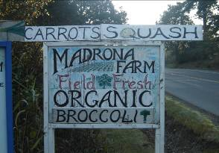
The Australian Council of National Trusts
The National Trust of Australia (Australian Capital Territory)
The National Trust of Australia (Northern Territory)
National Trust of South Australia
The National Trust of Fiji
New Zealand Historic Places Trust (Associate)
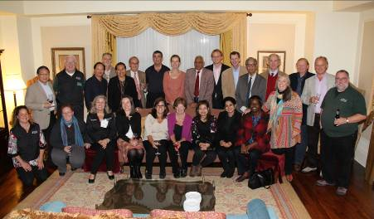

Africa and the Middle East

Addis Woubet, Ethiopia
Africana Research Centre AFREC, Nigeria (Associate)
Cape of Good Hope Living Heritage (Associate)
Conservation Trust, South Africa (Associate)
Swaziland National Trust Commission
Trust for African Rock Art (TARA)
Cross Cultural Foundation of Uganda
Zanzibar Stone Town Heritage Society
Photo credits: TLC’s Madrona Farm and INTO members at ICNT.
The National Trust of Zimbabwe

We aim to ensure that our decision-making process is a democratic one and to make the most of our members’ specific skills and enthusiasm. We welcome and value their involvement in INTO’s activity.

Report of the Trustees for the year ending 31 December 2011

The Trustees (who are also the Directors for the purposes of company law) are pleased to present their annual report together with the consolidated financial statements of the charity for the year ending 31 December 2011 which are also prepared to meet the requirements for a Directors' Report and Accounts for Companies Act purposes. The Trustees who served during the period are as follows:

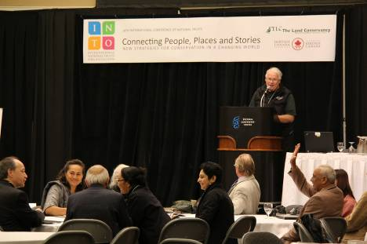
SK Misra
2011 INTO Congress, Victoria, Canada
Simon Molesworth (Chairman)
Simon Murray (Secretary)
David J Brown
Michaela Kubikova
Martin Scicluna
William Turner (Vice Chairman)
Robin Yarrow

None of our Trustees receive remuneration or other benefit from their work with INTO.

Structure, governance and management
INTO is a company limited by guarantee (No 06718966) governed by its Memorandum and Articles of Association, registered on 7 October 2008, and referenced by the INTO Charter, endorsed in Delhi on 3 December 2007. These documents are available on the INTO website. It is registered as a charity with the Charity Commission (No 1128224). The members of the company are the Trustees as detailed on page 2 of the Memorandum of Association. In the event of the charity being wound up, the liability in respect of the guarantee is limited to £1 per member of the company.
The INTO member organisations listed on pages 10 and 11 are part of the wider advisory body known as the INTO Charter Organisation, which meets every two years in person, appoints the INTO Executive Committee members and is governed by the INTO Charter.
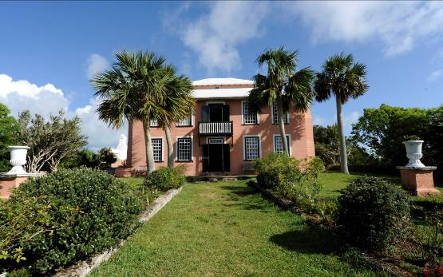
Following the launch of the UK Friends of the Bermuda National Trust, which coincided with our INTO Executive meeting in London in October 2010, a twinning arrangement between the Bermuda National Trust’s Verdmont and the NTEWNI’s Fenton House has now been established.

The aim is to strengthen relations between the two Trusts; to develop inter-organisation training and exchange of staff; and to build two-way cultural tourism to National Trust properties in both countries through the sharing of information at each property, special lectures and events, publicity and articles in each others magazines and local media, as well as contact with travel agencies to develop tourism opportunities.

The formal launch of the twinning will take place in May 2012 and we believe it will provide a model plan and structure for future INTO twinnings and mentorings.

Verdmont, Bermuda National Trust
The Directors consider that the company is entitled to exemption from the requirement to have an audit under the provisions of section 477 of the Companies Act 2006 ("the Act") and members have not required the company to obtain an audit for the year in question in accordance with section 476 of the Act. The Directors acknowledge their responsibility for ensuring that the company keeps accounting records which comply with section 386 of the Act and for preparing financial statements which give a true and fair view of the state of affairs of the company as at 31 December 2011 and of its surplus for the period then ended in accordance with the requirements of sections 394 and 395 of the Act and which otherwise comply with the requirements of the Companies Act 2006 relating to the financial statements so far as applicable to the company.

Appointment of Trustees
As set out in its Articles, the INTO Charity seeks and considers, but is not bound to follow, advice and recommendations that might be received from the INTO Charter Executive Committee regarding persons considered to be desirable candidates to be appointed a Director.

Organisation
The INTO Trustees meet annually in person. They are supported and advised by the INTO Charter Executive Committee, representing the INTO Congress. The Executive Committee and Secretariat meet regularly by teleconference (and once a year in person), thus making optimal use of virtual technologies and enabling our worldwide interests and membership to participate in a regular and cost-effective manner. These meetings are chaired by Simon Molesworth.

There are also ad-hoc sub-committees covering subjects such as the INTO Conference and Membership which also meet on a regular basis. The NTEWNI was appointed host of the INTO Secretariat and employs a Head of the INTO Secretariat who manages the day-to-day operations of the charity. To facilitate effective operations, the Head of the INTO Secretariat delegates activity to a team of volunteer directors for operational matters:

Colin Griffiths, Director of Policy Development – until October 2011

Oliver Maurice, Director of Membership
Maggie Morgan, Director of Strategy and Development – from October 2011
Geoffrey Read, Director of Special Projects
James Wadsworth, Treasurer

INTO Charter Executive Committee (in addition to the Trustees, listed on page 11)
Emily Drani (Cross-Cultural Foundation of Uganda)
John Ducie (An Taisce The National Trust for Ireland)
LK Gupta (Indian National Trust for Art and Cultural Heritage)
Catrini Pratihari Kubontubuh (Indonesian Heritage Trust)

Jeanine Perryck (The Gelderland Trust) – until October 2011
Bishnu Tulsie (Saint Lucia National Trust) – from October 2011
Sang Koo Yun (National Trust of Korea)

Mr SK Misra is not currently a member of the Executive Committee but is a Trustee and holds the position of Emeritus Vice-Chairman.

Risk Management
The Trustees confirm that the major risks to which INTO is exposed have been reviewed and systems established to manage these.

Objectives and Activities
INTO brings people together to share information, best practices and inspiration, to strengthen existing organisations towards the achievement of their objectives and to empower communities seeking to develop new Trust-like organisations where hitherto a voice for heritage did not exist. Our network connects and encourages organisations all around the world and gives leverage to the vision and aspirations of individual Trusts on the global stage and provides a forum for the advancement of intercultural understanding and the development of civil society.

In shaping our objectives and planning our activities for the year, the Trustees have considered the Charity Commission’s guidance on public benefit. The financial statements have been prepared in accordance with the requirements of the special provisions relating to companies subject to the small companies regime within Part 15 of the Companies Act 2006; the Charities Act 1993; the applicable Accounting Standards in the United Kingdom; the revised statement of Recommended Practice (‘SORP 2005’), ‘Accounting and Reporting by Charities’, published in March 2005; and in accordance with the Financial Reporting Standard for Smaller Entities (effective April 2008). The principal accounting policies of the charity are set out below.

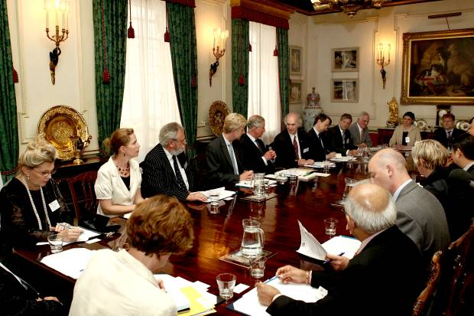
The financial statements that follow were approved by the Trustees on 30 August 2012 and signed on their behalf by Simon R. Molesworth, AM, QC, Chairman of INTO.



Simon Murray
INTO Secretary

INTO members participating in a round table discussion at Clarence House, 22 June 2011 © Paul Burns

Statement of Financial Activities for the year ended 31 December 2011

 |  | 2011 | 2011 | 2011 | 2010
Note |  | Unrestricted General Funds | Restricted Funds | Total Funds | Unrestricted General Funds
Incoming resources
Subscriptions received | 1 | 25,813 | - | 25,813 | 23,773
Grants |  | 2,300 | - | 2,300 | 2,300
Donations | 3 | 320 | 74,272 | 74,592 | 3,889
Total incoming resources |  | 28,433 | 74,272 | 102,705 | 29,962
Resources expended
Special conferences and projects | 4 | - | 74,272 | 74,272 | -
Cost of generating funds and governance | 4 | 26,091 | - | 26,091 | 29,375
 |  | 26,091 | 74,272 | 100,363 | 29,375
Net income |  | £2,342 | - | £2,242 | £587

There are no recognised gains and losses other than as stated above. All of the results above relate to continuing activities.

Balance sheet - 31 December 2011 | Note | 2011 | 2010
Current assets
Debtors - receivable within one year |  | 5,020 | 6,949
Cash at bank |  | 20,245 | 29,164
 |  | 25,265 | 36,113
Creditors - amounts falling due within one year | 7 | 20,594 | 33,784
Net current assets |  | £4,671 | £2,329
Reserves
Unrestricted General Fund | 8 | £4,671 | £2,329

Notes to the Financial Statements for the year ended 31 December 2011

- Basis of accounting

The financial statements have been prepared under the historical cost convention.

Accounting period covered by report

This report deals with the financial activities of INTO for the year ended 31 December 2011.

Incoming resources
All incoming resources are included in the Statement of Financial Activities when the Charity is legally entitled to the income and the amount can be quantified with reasonable accuracy.

Resources expended
Expenditure is included on an accruals basis, inclusive of any Value Added Tax which cannot be recovered, and is recognised when there is a legal or constructive obligation to pay.
  - Cost of generating funds includes costs of generating voluntary income
  - Governance costs are those incurred in connection with the administration of the charity and compliance with constitutional and statutory requirements.

Funds
Unrestricted funds are those funds for use at the discretion of the trustees in furtherance of the general objectives of the Charity. Restricted funds are to be used in accordance with specific restrictions imposed by donors or which have been raised by the Charity for particular purposes.

Foreign exchange
Assets and liabilities held in foreign currency are translated to sterling at the exchange rate ruling at the year-end. Income and expenditure in foreign currency are translated to sterling at the standard rate for the year.

- Cash flow statement
The size of the charity is such that it is not required to present a cash flow statement.

- Donations
Restricted donations comprise £11,932 received in advance in 2010 from Mr Rodney Davidson to fund the Central European Cross-Border Collaboration Project which was held in June 2011, along with £46,755 from the Getty Foundation and £15,585 from the American Express Foundation to support delegates attending the International Conference of National Trusts held in Victoria, Canada, in October 2011. The expenditure related to these three donations is disclosed as restricted resources expended in note 4.

- Total resources expended 2011 2010

Unrestricted Funds
Promotion costs | 720 | 818
Meeting, communication and travel costs | 4,616 | 8,369
Insurance | 1,781 | 1,860
Salary and expenses | 18,596 | 17,932
Loss on exchange | 160 | 15
Bank interest and charges | 218 | 381
 | 26,091 | 29,375
Restricted Funds
Central European Cross-Border Collaboration Project (CEP) | 11,932 | -
International Conference of National Trusts (ICNT) | 62,340 | -
 | 74,272 | -

£100,363 £29,375
- Staff numbers and costs
There was 1 employee during the period.
Salary | 16,312 | 14,661
Social Security costs | 1,265 | 1,134
Reimbursable expenses | 1,019 | 2,137

£18,596 £17,932
- Taxation
The Organisation has no liability to corporation tax in the period.

- Creditors - amounts falling due within one year
Amount owing to The National Trust of England, Wales and Northern Ireland to reimburse salary and other costs incurred on behalf of INTO | 18,377 | 14,439
Amount received in advance from Mr Rodney Davidson in connection with an event taking place in 2011 | - | 11,932
Other creditors | 2,217 | 7,413
£4,671

£20,594 £33,784
- Reserves
At 1 January 2011 | 2,329
Net income for the year | 2,342

Thanks

Our achievements this year would not have been possible without the generous support of countless people across the globe. Many thanks to our international array of members, supporters and volunteers already mentioned in this report, particularly our Trustees, Executive Committee, Amicus members, Secretariat team and member organisations. INTO would like to extend special thanks to:

- The Getty Foundation for generously providing international travel grants for the ICNT
- The American Express Foundation for sponsoring the keynote panel session at ICNT
- Rodney Davidson AO OBE for funding the Central European Cross-Border Conservation Capacity Building Project
- The National Trust of England, Wales, and Northern Ireland for generously providing the INTO Headquarters in London and for additional support to the INTO Secretariat
- The National Trust for Historic Preservation for its continued hosting of the INTO website and for managing credit card donations to INTO
- The Australian Council of National Trusts for contributing towards our Chair’s costs, assisting with Australian donations to INTO and supporting the production of materials for COP 17
- The Land Conservancy of British Columbia, the Heritage Canada Foundation and all their Canadian partners for hosting the 14th ICNT
- La Trobe University for financing Simon Molesworth’s attendance at COP 17
- Messrs Maurice and Read for covering their own airfares to Durban
- John Smithson for generously donating air miles
- June Taboroff and Graham Bell for their work on the Central European Project
- Irena Edwards for advising on the Czech Republic and Peter Mitchell for Slovakia
- Europa Nostra for welcoming the INTO Europe group in June
- TLC for hosting the INTO Executive Committee Meeting at Abkhazi Garden, for holding the Amicus event and supporting INTO involvement in the Quest Workshop
- Malcolm Lynch of Wrigleys for kindly providing pro bono legal assistance
- The Rector of Michaelhouse School and Luke Strachan for volunteering at COP 17
- The International Cultural Centre in Krakow for funding Catherine Leonard’s attendance at the 1st Heritage Forum of Central Europe
- Hannah Eastman for her work with the Amenity 2000 Society in Japan
- Greenpeace for hosting the INTO COP 17 side event and Anthony Hamilton Russell for providing liquid refreshment
- Jill and Graham Cox for hosting the INTO team in Durban
- Vicky Grange for keeping the INTO office running

and all the delightful, interesting and kind-hearted people we have met along the way.

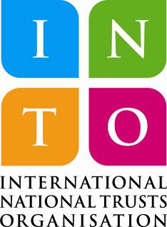
Contact us:

INTO Secretariat
32 Queen Anne’s Gate
London
SW1H 9AB
United Kingdom

Website: www.internationaltrusts.org
Email: into@nationaltrust.org.uk
Tel: +44 (0) 20 7799 4578

