


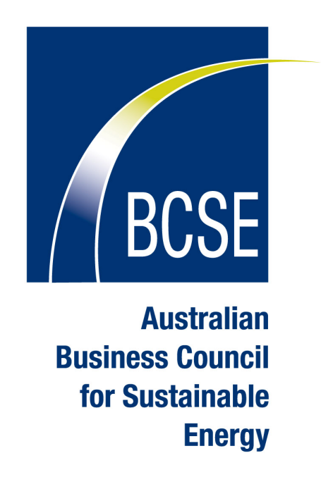

U.S. Business Council for
Sustainable Energy

SIDE EVENT AGENDA
Twelfth Conference of the Parties to the UNFCCC/Second Meeting of the Parties to the Kyoto Protocol

Nairobi, Kenya

EVENT TITLE: Business Views on Market-Based Approaches Post-2012

THEMES: This program will analyze and provide business and delegate perspectives on post-2012 policy issues, responding to the set of questions that the co-facilitators of the dialogue on long-term cooperative action has released on market-based approaches to
global emission reduction.

DATE/TIME/LOCATION: Friday, November 10, 15:15 – 16:45, African Blackwood

Opening | James Wolf, Head Delegate, U.S. Business Council for Sustainable Energy
Overview of the Dialogue Workshop Questions under consideration, next steps for dialogue process | Jan Adams, Ambassador for the Environment to Australia
BCSEs Coalition Overview  Experiences and value with market-based approaches and general recommendations on CDM, JI and Post-2012 | Lisa Jacobson, U.S. Business Council for Sustainable Energy
Business Views Post-2012  Key findings of “Business Views on International Climate and Energy Policy” | Kirsty Hamilton, U.K. Business Council for Sustainable Energy
Company Perspective  Value of market-based approaches, what the market needs going forward and what businesses are looking for from the UNFCCC process | Francesca Cerchia, Econergy International
Respondents  What is the value of market-based approaches? How can they be improved? What signals are need from the UNFCCC process and when? What other decisions will impact markets post-2012? | Richard Wise, Australian Business Council for Sustainable Energy  Jim Wolf, American Standard/Trane  William Greene, Point Carbon
Question & Answer Session

Closing Remarks

