Emperor penguin population variability in a region subject to climate warming

Emperor penguin population variability in a region subject to climate warming

Information Paper submitted by the United Kingdom and ASOC
Summary
In this paper the United Kingdom and ASOC present data showing levels of inter-annual variability in emperor penguin population numbers across the Antarctic Peninsula and Weddell Sea. Precautionary spatial protection would best be located in those places where refugia from climate change are most likely to exist, that is, in the high latitude Weddell Sea.
Introduction
Over the latter part of the twentieth century, the Antarctic Peninsula has been amongst the most rapidly warming parts of our planet. This has major consequences, not only for the physical environment, but also for those species and communities that use the Peninsula during different parts of their life cycle.
For emperor penguins, direct colony observations and population counts are particularly difficult as they breed in the winter when conditions are particularly harsh. Consequently, the first whole population estimate for the species occurred only recently and relied upon the use of satellite remote sensing (ATCMXXXVI - WP10; Fretwell et al., 2012).
To date, only a single emperor penguin breeding site (located on the Dion Islands, Marguerite Bay) is thought to have been largely vacated as a consequence of rapidly declining sea ice. However, more information on colony population trajectories is needed if appropriate protection and conservation measure are to be put in place.
This Information Paper reports on a collaborative study between the British Antarctic Survey and WWF that explored the population size of 16 colonies of emperor penguin situated in the quadrant between 0ᵒ and 90ᵒ W (Figure 1). The population estimates for each colony were derived using hi-resolution satellite imagery over the period 2009 to 2016. Our goal was to explore whether there were regional patterns that are consistent across large areas, or whether colonies numbers appeared to fluctuate independently, regardless of patterns at adjacent colonies.
Results and Discussion
Most of the emperor penguin colonies in the study area had between a few hundred and a few thousand breeding pairs, with an average colony size of fewer than 5,000 pairs. All colonies counted were highly variable from year to year and there was no common inter-annual patterns of change across all sites. Therefore, over such a short timeframe (2009-2016), determination of population trends was unlikely to be robust.
In future, we will use the dataset to investigate how relatedness between groups of colonies is affected by environmental patterns and processes. Local sea-ice characteristics may also govern individual colony patterns and processes, as this will impact upon whether adults need to cross extensive regions of seasonal sea ice when they leave for, or return from, foraging, or whether colonies fail because sea ice forms late, or breaks out early before chicks fledge.
Recent evidence suggests that emperor penguins have virtually no barriers to mating, allowing gene flow around the continent. The population in the sector between 0ᵒ and 90ᵒ W should, therefore, be considered in this wider context. It is plausible that colonies located to the west of the Antarctic Peninsula are separate from the Weddell Sea colonies, but this has yet to be confirmed. If the ATCM/CEP is to consider any form of spatial protection for emperor penguins, this broader perspective should be considered. Precautionary spatial protection, if deemed appropriate, would best be located in those places where refugia from climate change are most likely to exist, that is, in the high latitude Weddell Sea.
Supporting references
Fretwell PT, Larue MA, Morin P, Kooyman GL, Wienecke B, Ratcliffe N, Fox AJ, Fleming AH, Porter C & Trathan PN (2012) An Emperor Penguin population estimate: The first global, synoptic survey of a species from space. PLoS ONE 7: e33751.

Trathan, P.N., Fretwell, P.T., Stonehouse, B (2011) First recorded loss of an emperor penguin colony in the recent period of Antarctic regional warming: implications for other colonies. PLoS ONE 6: e14738.

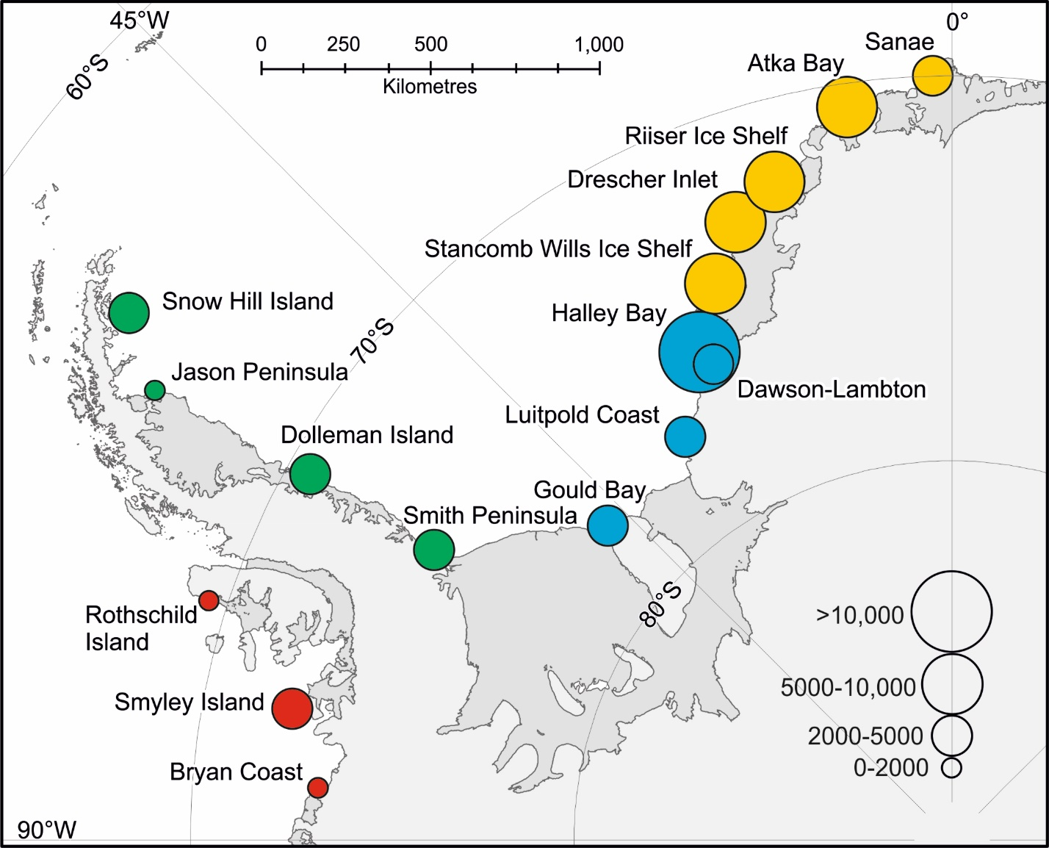
Figure 1. Location of emperor penguin breeding sites between 0ᵒ and 90ᵒ W.

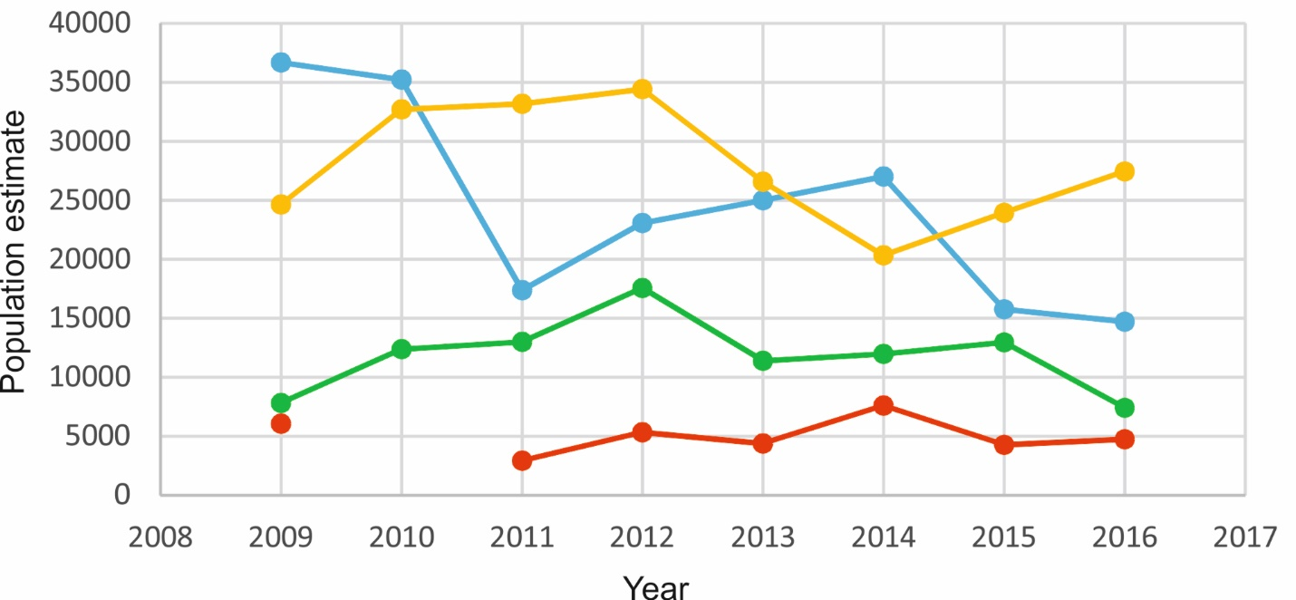
Figure 2. Inter-annual population change for the four groups colour coded in Figure 1; Bellingshausen (red), eastern Antarctic Peninsula (green), high latitude Weddell Sea (bleu) and eastern Weddell Sea (yellow).

