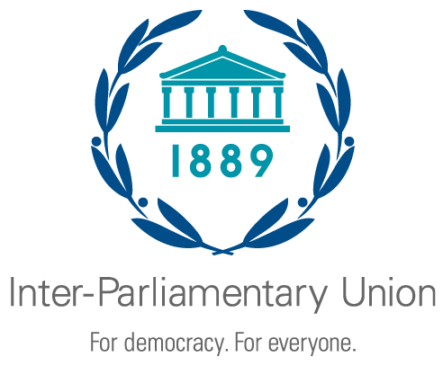


UNFCCC side event at COP24 in Katowice, Poland

Legislating on climate change:
An assessment of experiences and impacts of climate and energy laws

Tuesday 11 December 2018, 1:15–2:45pm
Room Wisla

To aid implementation of national climate policies this event will feature new studies on the impact of climate laws in Mexico and the UK and share the experiences from Latin America and other regions in designing and implementing climate and energy transition legislation.

Keynote address
- Ms Carolina Schmidt, Minister of the Environment, Chile
Thematic presentations
Developing and implementing climate change laws: The experience of the UK and Mexico
- Dr Alina Averchenkova, Distinguished Policy Fellow, Grantham Research Institute on Climate Change and the Environment, London School of Economics and Political Science
Developments on climate change legislation in Latin America
- Prof Pilar Moraga, Center for Climate and Resilience Research (CR2), Centro de Derecho Ambiental, Law School, University of Chile
Panellists
- Hon Mai Mahmoud Ebrahim, Member of Pan African Parliament
- Mr Fernando Virgilio Macedo, Member of Parliament, Portugal
- Ms Valvanera Ulargui, Director General, Climate Change Office, Spain
Moderator
- Ms Carolina Urmeneta, Ministry of Environment, Chile

Please note that the panel will be conducted in English only.

Organisers
The Inter-Parliamentary Union (IPU) is the world organisation of parliaments, a global forum for parliamentary dialogue, cooperation and action. Created in 1889, it advances democracy and assists parliaments and parliamentarians throughout the world to fulfil their mandates.
The Grantham Research Institute on Climate Change and the Environment was established by the London School of Economics and Political Science in 2008 for policy-relevant research and training, bringing together international expertise on economics, finance, geography, the environment, international development and political economy.
The Center for Climate Science and Resilience (CR2) brings together researchers from different disciplines of the natural and social sciences who study how climate change impacts ecosystems and Chilean society.
For further information, please contact: Dr Alina Averchenkova, Grantham Research Institute: a.averchenkova@lse.ac.uk

