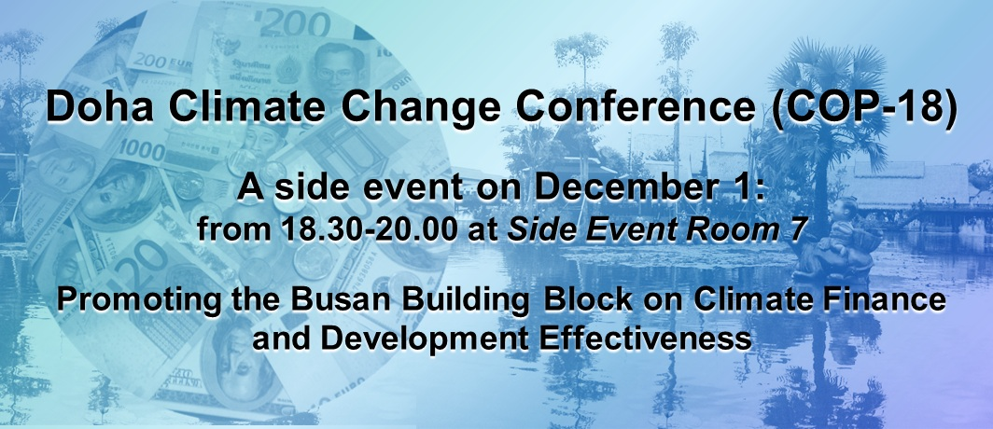

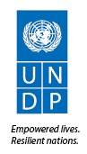
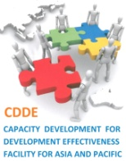
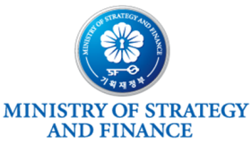

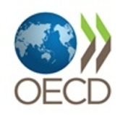



At the Fourth High Level Forum on Aid Effectiveness in Busan (2011) a high level panel moderated by UNDP Administrator, Helen Clark, reached consensus that international climate finance should be channeled through and aligned with country led strategies and systems. At this time, partners launched the Busan Building Block (BBB) on Climate Change Finance and Development Effectiveness.
Twenty seven countries and institutions are officially supporting this partnership with the purpose of promoting coherence and collaboration across the climate change and development communities at all levels. A fundamental premise is that climate change and development are intrinsically linked and that climate finance should be informed by the experience of past efforts to improve the effectiveness of aid to promote development.
A year on from Busan there is a need to report back on early results of the partnership and enhance the added value that it can bring through further dialogue and consultation.
Please visit: www.climatefinance-developmenteffectiveness.org
Objectives of the Side Event:
- To raise awareness, promote further dialogue and strengthen engagement to achieve the goals of BBB on Climate Change Finance and Development Effectiveness

- To present the early results of studies and actions aiming to implement the goals of the BBB on Climate Change Finance and Development Effectiveness

- To discuss the challenges, opportunities and lessons learnt in linking climate finance and development effectiveness goals, and to seek ideas from all stakeholders on how further strengthen the partnership.
Target audience:
All partner country government officials (Ministries of finance, environment, climate change, planning), representatives from civil society, development partners and climate change finance practitioners.
(Please see event agenda at back)

AGENDA
Saturday 1st December 2012
Side Event Room 7 (seven)
Promoting the Busan Building Block on
Climate Finance and Development Effectiveness
Time | Description
18.30-18.35 | Welcoming Remarks by SHIM SEOP, Vice President of Korea Eximbank
18.35-19:15 | Presentations (8 minutes each)  Chair: Yannick Glemarec, Director for Environmental Finance, UNDP  - Overview of initiatives related to climate finance and development effectiveness – Jan Corfee-Morlot, Team Leader, OECD-DCD  - CSO reflections on the climate finance architecture and development effectiveness – Antonio Tujan Jr., IBON International Director  - Climate Public Expenditure and Institutional Reviews: Approach and Lessons Learned – Pradeep Kurukulasuriya, Senior Technical Adviser, Climate Change Adaptation, UNDP  - Establishment of the Green Climate Fund in Korea and the increasing role of Korea in the BBB-CCF – LEE, Seong Won, Director of Development Cooperation Division, Korean Ministry of Strategy and Finance
19:15-19:35 | Panel Discussion (7 minutes each)  Chair: Yannick Glemarec, Director for Environmental Finance, UNDP  - Donor harmonisation for development effectiveness and climate finance:  the Vietnam Experience – CHANG, Young Hoon, Director General of EDCF Planning Office, Korea Eximbank *EDCF: Economic Development Cooperation Fund  - Commentary from a national government perspective – Vice-Minister Naderev Sano, Philippines Climate Change Commission  - Commentary from a national government perspective
19.35-20.00 | Open Discussion (25 minutes)  Chair: Yannick Glemarec, Director for Environmental Finance, UNDP  - Concluding remarks
RSVP to: Ms. Jinny Lee at jylee@koreaexim.go.kr ; Ms. Tetet Lauron at tlauron@iboninternational.org

This event is co-organised by the Korean Ministry of Strategy and Finance and IBON,
with the support of Korea Eximbank, Better Aid, OECD, UNDP and the CDDE Facility

