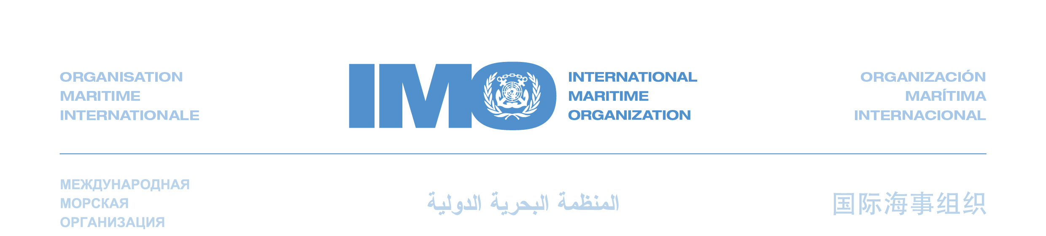
SIDE EVENT

International Shipping and Climate Change

Wednesday, 6 October - from 13:00 to 14:30

Room 2

All participants at the United Nations Climate Change Talks are cordially invited and warmly welcomed to participate and actively partake in a side-event on international maritime transport and greenhouse gas emissions.

A panel of international experts will engage in a comprehensive analysis of a future control regime for greenhouse gas emissions from international shipping.

Greenhouse gas emission from international shipping is modest (2.7% in 2007) but steadily growing apace with globalization and world trade. IMO’s work on enhanced energy efficiency and emission control has three distinct building blocks and the Organization has developed technical and operational measures with the aim of making them mandatory by 2011. The third building block is the market-based measures where IMO has established an Expert Group to undertake a feasibility study and impact assessment of ten possible mechanisms. The scope of the Expert Group is to evaluate the proposals potential of reducing GHG emissions from international shipping, their possible impacts on trade and development as well as on the shipping and maritime sectors, giving priority to the maritime sectors of developing countries.

Programme

Presentations on the ongoing work within IMO to develop and enact a global comprehensive regulatory framework to promote energy efficiency and control greenhouse gas emissions in the international shipping sector

Expert Panel with representatives from maritime nations, the shipping industry and environmental organizations

Discussion – Questions and Answers – Panel and Audience interaction

IMO’s vision is to eliminate all adverse environmental impacts from ships by developing effective regulations that apply universally to all ships

