

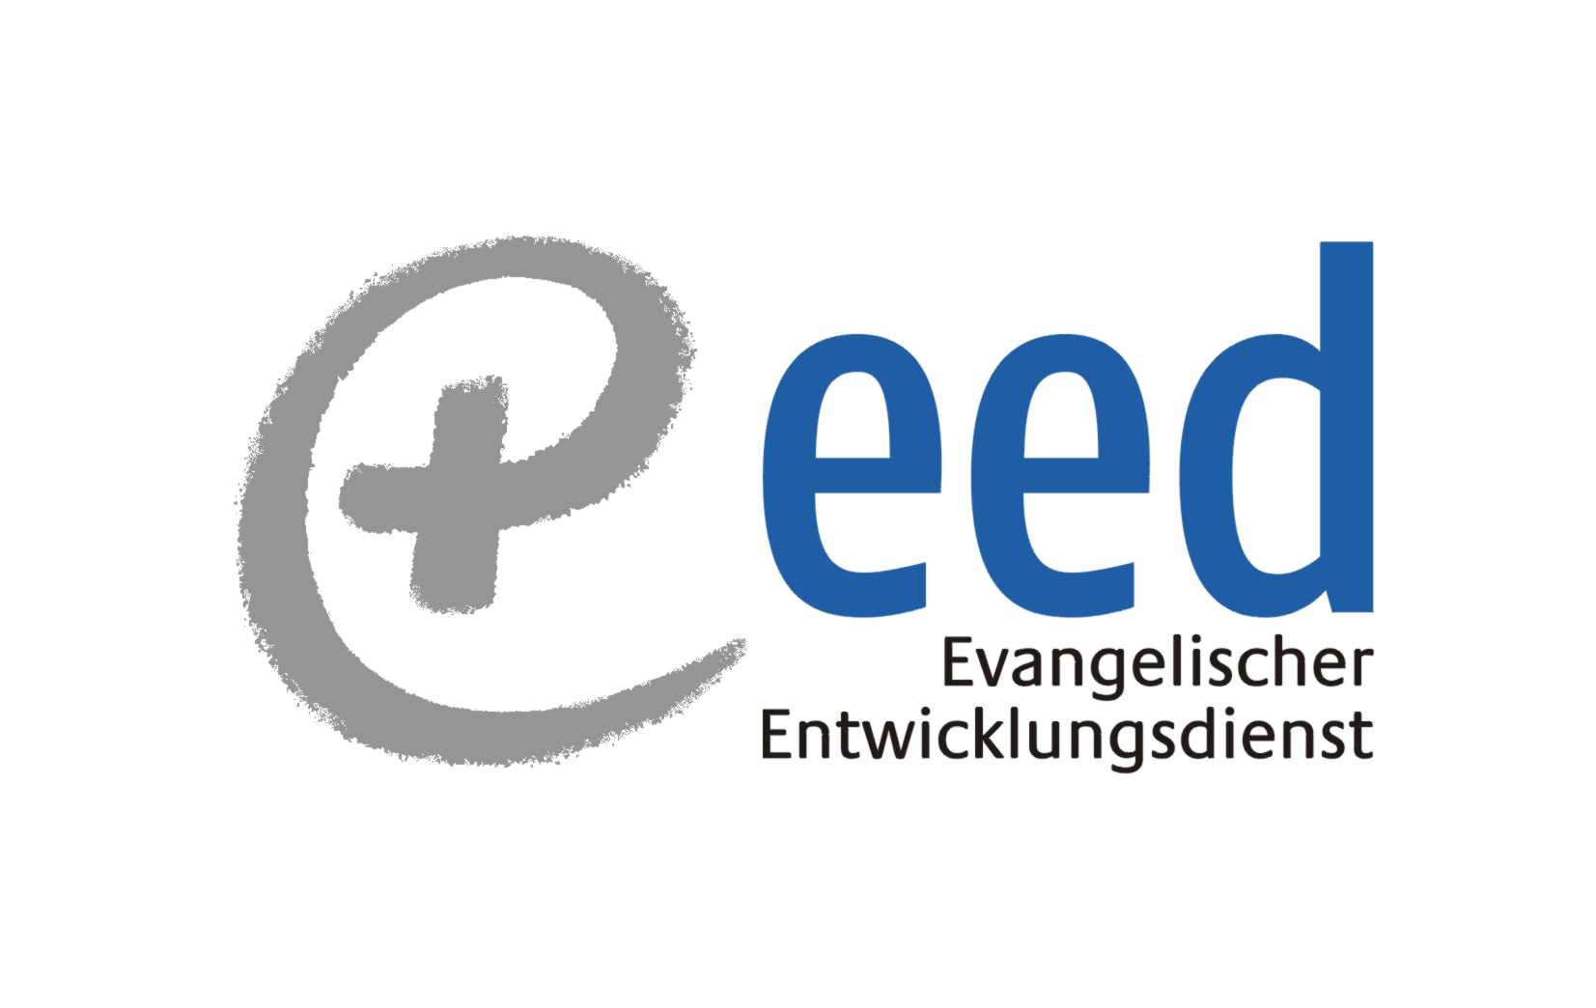
EED-INECC Side Event
COP 17 / CMP 7 29th November, 2011

Towards A Low Emissions Economy – Pro Poor and Gender Responsive Adaptation and Mitigation – Experiences from India and Bangladesh

Ms. Ajita Tiwari Padhi, INECC: Make Market and Maintain - Tribal Women Entrepreneurship on Solar
Film: http://www.youtube.com/watch?v=mqZBGLRzjLk&feature=related
Mr. Siddharth D’Souza, LAYA: My energy my life – ‘cluster approach’ to energy security
Film: http://www.youtube.com/watch?v=YOmq5ib_2p4
Dr. Sheila Benjamin, SCINDEA: Less carbon more food – low carbon farming initiatives
Film: http://www.youtube.com/user/ineccvideos#p/u/7/2KOKs2CawRY
Mr. Jahangir H. Masum, CDP: Transforming Marginalized Women to Climate Leaders
Presentation: http://www.cdpbd.org
Dr. Nafisa Goga D’Souza, LAYA/INECC: Concluding Remarks

