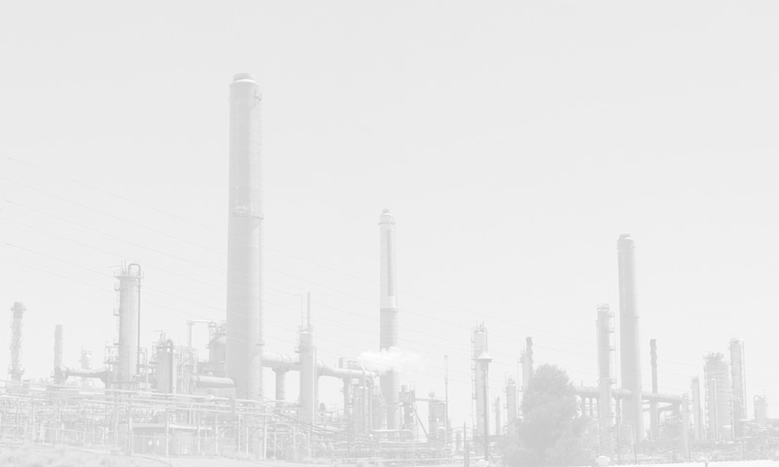


Building New Capacities in Central and Eastern Europe

COP 12 Side Event
Monday, 6 November 2006,
13:15-14:45 Room Acacia

1. “Workshop on fulfilling the monitoring and reporting requirements under the UNFCCC and the Kyoto Protocol: main findings”

Part 1 – Speaker: Mr. Larry Macfaul, Environment Researcher, Environment Programme, the Verification Research, Training and Information Centre (VERTIC)

Part 2 – Speaker: Ms. Maria Khovanskaya, Project Manager, Climate Change Programme, the Regional Environmental Center for Central and Eastern Europe (REC)

2. “Green Investment Scheme in Romania: lessons learnt and road ahead”,

Speaker: Mr. Vlad Trusca Head of Department, State Control on Climate Impact, Ministry of Natural Resources and Environmental Protection, Romania

