

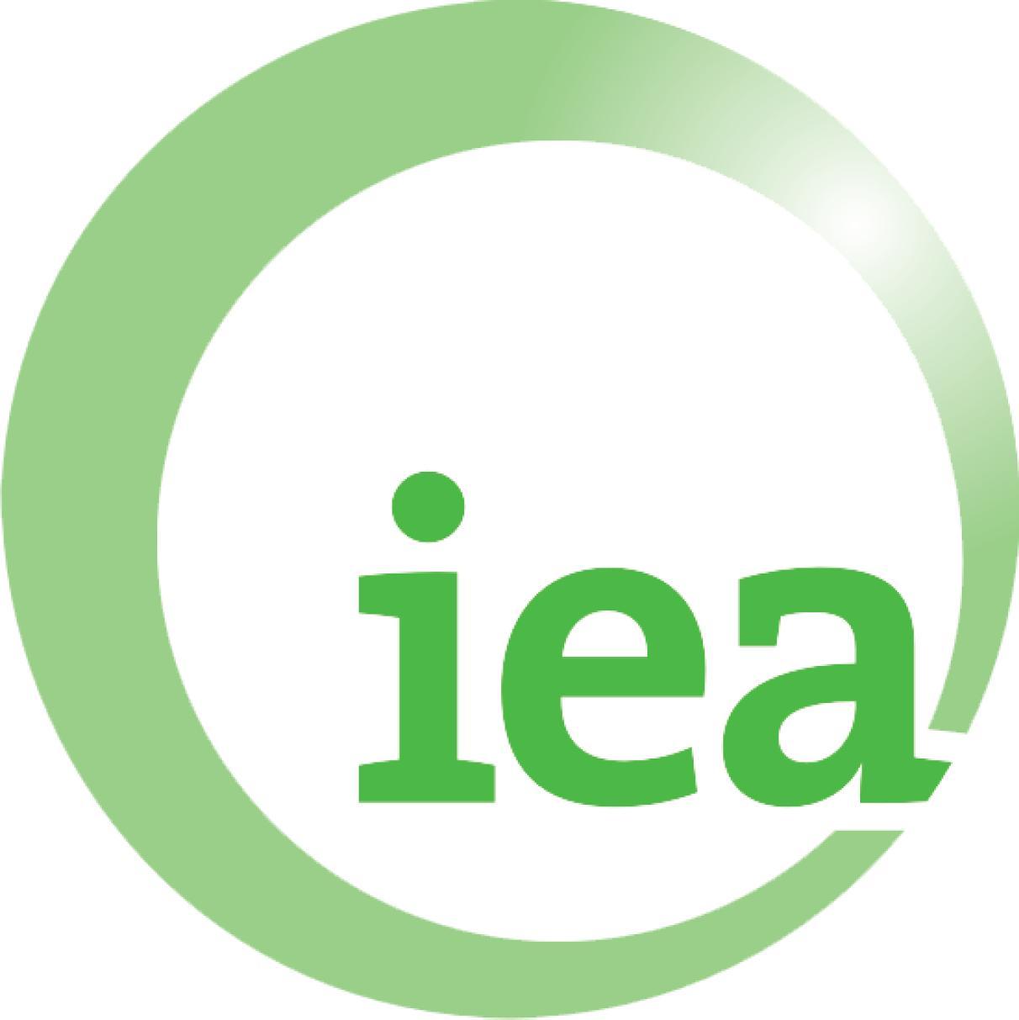
Side Event
Keeping Track: Emissions Unit Accounting After 2012
OECD/IEA Climate Change Expert Group
Tuesday 14th June 2011, 13:15-14:45, SOLAR
(side event slot kindly provided by Croatia)

Refreshments will be provided
Facilitator: Richard Baron, IEA
Andrew Prag
OECD
Duan Maosheng
Tsinghua University, China
Paul Bodnar / Kate Larsen
United States delegation
Pete Erickson
Stockholm Environment institute
Kim Carnahan
International Emissions Trading Association
Followed by general discussion

www.oecd.org/env/cc/ccxg

