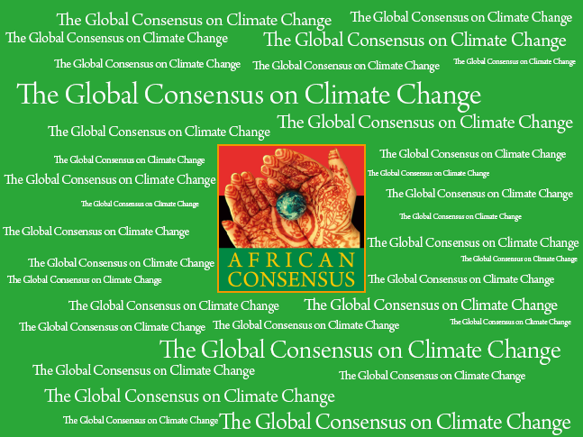

For Immediate Release

African Consensus Calls for:

Global Consensus on Climate Change

Durban, South Africa - The African Consensus, an alliance of African and globally-minded social activists, civil society and the private sector will come together to determine the lowest common denominator points that need to be achieved in Durban at an event on Nov. 29.

This grouping is holding the country negotiators to account to achieve a Global Consensus on Climate Change (GCCC) articulated in new fresh language that sets a positive tone.

It is expected that key nation negotiators will meet them at the table in Durban at a side event to be held on 8:15 p.m. on Nov. 29. China’s negotiation team may be prepared to receive the GCCC document, in an unusual display of openness to civil society.

GCCC activists are asking for three main outcomes from Durban that are in the framework of COP17:

- Uphold, expand and improve the incentive mechanisms under the current Kyoto Protocol to spur use and development of appropriate technologies and approaches for GHG mitigation and adaptation and enhance sustainable development.
- Promote incentive mechanisms for mitigation and adaptation that have a high environmental and social integrity, which are capable of attracting investment using public infrastructure and policies, channeled through entities such as the Green Climate Fund.
- Establish a climate registry under UNFCCC to coordinate and facilitate donor and private financial resources, which help meet developing country needs.

In addition, the GCCC is calling for two additional action points outside of COP17:

- Eliminate subsidies supporting fossil fuel production and consumption for industry bearing in mind poverty alleviation issues.
- Establish debt swaps for climate change mitigation and adaptation for underdeveloped regions such as Africa and Least Developed Countries.

Outcomes within the mandate of COP17 have been detailed out further in a checklist system that the GCCC grouping will check in the middle of the negotiations and report back on.

African Consensus was selected to lead the GCCC because COP17 is being held in Africa. African Consensus is a network of NGOs and social people’s action movement from across the African Continent. It calls for: 1) protection of ethnic diversity, 2) through sustainable social enterprises, 3) and call for business to contribute to community development and protection of the environment. The African Consensus Declaration was adopted by the African Commission for Human and Peoples Rights NGO Forum on April 28th, 2011.

The Global Consensus on Climate Change (GCCC) document was drafted by representatives from: African Consensus, Himalayan Consensus, and the Climate Markets and Investment Association.

Didier Awadi, West African celebrity rapper, and leader of African Consensus says: “The African Consensus is taking the lead on this event because COP17 is held in Africa, and our continent suffers from climate change. Desertification increases each year, our coasts submerged by higher tidewater flooding. Our people do not want to suffer any more. Action is needed now! I am pleased that civil society is joining forces with us calling for negotiators to breakthrough at this round.”

Laurence Brahm, global activist and Founder of Himalayan Consensus added, “We are seeking a minimum common denominator of points that can be agreed by three stakeholders together - government, private sector and civil society. By agreeing on action for these basic points we are calling for a breakthrough in the annual stalemate at UNFCC talks. We must recognize that climate change is the single biggest threat to our planet’s security. We are calling upon key negotiators to agree to a coalition on the willing to fight climate change.”

Steven Gray, representative from Climate Markets and Investment Association says, "It is important to recognize that there are fundamental action points that civil society, the private sector and many governments agree on. Our private sector members are calling for these negotiations to deliver strong policy frameworks that 1) support sustained capital deployment through innovative mechanisms; and 2) builds from the gained experience in order to scale up new and additional capital deployment from the private sector to support the investments required for a stable climate."

To learn more about “Call to Action,” visit www.himalayanconsensus.org or email laurencebrahm@himalayanconsensus.org.

End

