Seas the Future
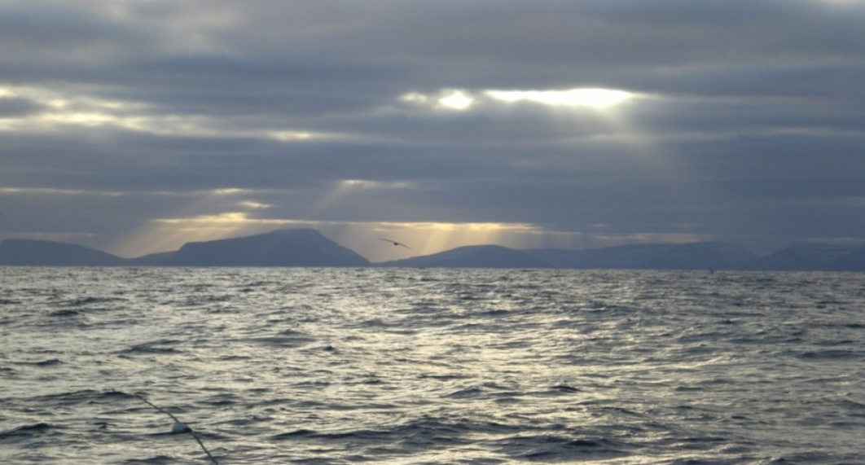

Enhancing North Atlantic & global partnerships
on oceans issues in a changing climate

The Government of the Faroe Islands welcomes COP 15 participants and the media to Seas the Future, one of Denmark’s official COP 15 Side Events. Building on existing initiatives to ensure a strong focus on the importance of oceans for global climate and sustainable development, ministers from the North Atlantic, Southeast Asia, South Pacific and Caribbean regions will discuss the particular challenges they face as island and coastal nations in a changing climate.

The Side Event will be opened by Mr Kaj Leo Johannesen, Prime Minister of the Faroe Islands and chaired by Ms Annika Olsen, Minister for Environment and Climate Policy, Faroe Islands.

Participating ministers:
Dr Fadel Muhammad, Minister of Marine Affairs and Fisheries, Indonesia,
Vidar Ulriksen, State Secretary for Fisheries & Coastal Affairs, Norway,
Gordon Darcy Lilo, Minister for Environment, Conservation & Meteorology, Solomon Islands
Svandís Svavarsdóttir, Minister for the Environment, Iceland
Michael Church, Minister for the Environment, Grenada

Seas the Future will also feature the following brief presentations:
- The role of the North Atlantic in the global climate by Professor Bogi Hansen of the Faroe Marine Research Institute, awarded the Nordic Nature and Environment Prize in 2006
- Statement from Oceans Day, Monday 14 December at the European Environment Agency in Copenhagen, organised by the Global Forum on Oceans, Coasts & Islands
- The FAO Global Partnership on Climate, Fisheries and Aquaculture: Ms Cassandra de Young, Fishery Policy Analyst, Economics and Policy Division

*Participation is on a first-come-first-serve basis. *Refreshments will be served after the event.

