


GUANGYUAN
Sichuan, China
欠发达地区的低碳发展
Low-Carbon Development in the Less Developed Areas

低碳广元 生态城市
Guangyuan , a low carbon and ecological city

广元市人民政府
People's Government of Guangyuan Municipality
01 基本情况
Basic Information
■ 广元概况
Overview
广元，古称利州，地处中国四川盆周北部山区、嘉陵江上游、川陕甘三省结合部，幅员面积1.63万平方公里，总人口 314万。广元是连片贫困地区，2010年农村人均纯收人不足1196元的贫困人口达42.7 万人，占农民总数的17.6°/。，分别比全国、全省高14.8个和12.7个百分点。还有11万人居住在无生存条件的石山区，10万人是生活条件很差的水库淹没区移民，随着扶贫标准的提高，贫困人口还将会增加。全市地区生产总值达到321.87亿元，人均生产总值达到12313元，约为1859美元，仅为全国人均生产总值的41.5%。城镇居民可支配收人12509元，农民人均纯收人4036元，约为1889美元和609美元，分别相当于美国2010年居民收入的4%和1.3%，英国2010年居民收入的4.9%和1.6%，日本2010年居民收入的4.5%和1.4%。
Guangyuan, named Lizhou in ancient time, is located in the mountains of northern China's Sichuan Basin, the upper reaches of the Jialing River and the junction areas of Sichuan, Shaanxi and Gansu provinces, covering an area of 16,300 square kilometers, with a total population of 3.14 million. Guangyuan consists of contiguous poor areas, and a population of 427,000 with per capita net income of less than 1,196 yuan living in poverty in the year of 2010, accounting for 17.6% of the total peasant population, which are respectively 14.8 and 12.7 percentage points higher, compared with the national and provincial level. A population of 110,000 lives in rocky mountainous areas without basic living conditions, and a population of 100,000 resettlers from reservoir inundation areas also live under very poor living conditions. With the improvement of poverty alleviation standards, the population living in poverty will continue to increase. Guangyuan's GDP reaches 32.187 billion yuan, and the per capita GDP reaches 12,313 yuan (or about $1,859), which only accounts for 41.5% of the national per capita GDP. The disposable income of urban residents is 12,509 yuan, and the net income of peasants 4,036 yuan respectively (or about $ 1,889 and $609 respectively), which are equivalent to 4% and 1.3% of U.S. residents' annual income in 2010, 4.9% and 1.6% of British residents’ annual income in 2010 and 4.5% and 1.4% of Japan residents' annual income in 2010.
■ 低碳理念的提出及形成
Proposal finalization of low-carbon concept
中国把坚持科学发展观，贯彻节约资源和保护环境作为基本国策， 把可持续发展作为经济社会发展的重要目标，发展低碳经济，建设低碳社会已经成为我国的战略重点和全民教育重要方向。四川省“十二五”提出了实行控制温室气体排放制，推进低碳新兴产业发展，开展低碳城市试点工作，推进低碳建筑、低碳交通、低碳社区建设，加强适应气候变化能力建设。
China has been adhering to the scientific outlook on development, implementing resource conservation and environmental protection as fundamental national policy and sustainable development as an important economic and social development objective, as a result, development of a low-carbon economy and a low-carbon society has become an important strategic focus of China and the direction of EFA. The "12th Five Year Plan" of Sichuan Province has proposed to implement the system of controlling greenhouse gas emissions, to promote the development of new low-carbon industries, to carry out the experimental work of low-carbon city, to promote the construction of low-carbon buildings, low-carbon transportation and low-carbon community, so as to strengthen the capacity to adapt to the climate change.
2010年1月，市委书记罗强在北京“低碳中国论坛首届年会”发表演讲。
In January 2010, Luo Qiang, Secretary of the CPC Guangyuan Municipal Committee, gave a speech at the "The First Annual Meeting of Low-carbon China Forum" in Beijing.
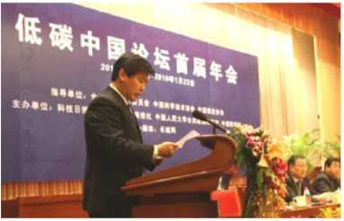
2009年8月，市长马华（右一）、中国社科院可持续发展研究中心主任潘家华（中）、世界自然基金会代表Oliver.Rapf为“低碳重建与企业发展（中国•广元）国际论坛”启幕。
Ma Hua , the City Mayor (1st from right), Pan Jiahua (in the center), Director of the Center for Sustainable Development of the Chinese Academy of Social Sciences and Oliver Rapf, Representative from the World Wild Fund for Nature unveiled the curtain for "International Forum on Low-carbon Reconstruction and Enterprise Development (Guangyuan, China) " in August 2009.
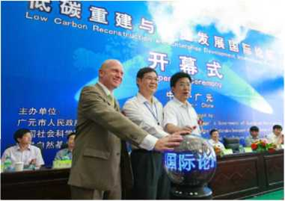
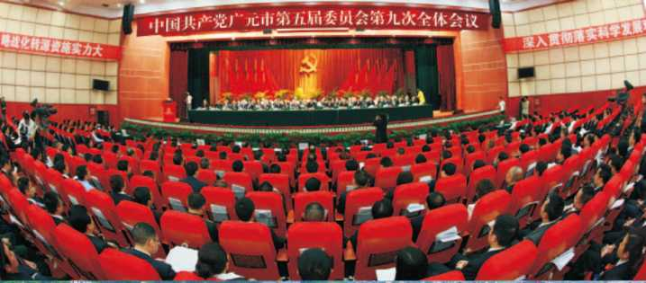
广元市坚持以科学发展观为指导，按照“加快发展、科学发展、又好又快发展”的总体取向，以人为本、尊重自然、因地制宜、统筹兼顾，以实施转化战略为突破口，以能源结构低碳化，产业发展低碳化和增加碳汇为主线，创新发展清洁能源，积极推动低碳经济发展，努力建设资源节约型、环境友好型社会，把光源建成中国西部发展低碳示范城市。
Guangyuan has been adhering to the scientific outlook on development, based upon the overall approach of "accelerated development, scientific development, sound and rapid development," and that of people-oriented development, respect for nature, adaptation to local conditions and integrated strategy of coordination, to implement the conversion strategy as the breakthrough point, and to keep the low-carbonization of energy mix, low-carbon industrialized development and carbon sequestration increase as the main line, so as to actively promote the development of clean energy innovation, to build a resource-saving and environment-friendly society, and to build Guangyuan into a model city of low-carbon development in West China.
02 能源结构低碳化
Low-carbonization of Energy Mix
广元天然气、风能、水能、太阳能、地热能等清洁能源资源富集。天然气探明储量达3610亿立方米，是四川省天然气综合利用重点发展地区和重点支持区域。已建成沼气池29.6万口。全市的清洁能源比例达20%，节能减排从能源结构低碳化的角度可拓展更大空间。全市林业用地面积占幅员面积的61.9%，被誉为"天然氧吧"和嘉陵江上游的天然生态屏障，碳汇优势十分明显。
Guangyuan boasts abundant reserves of natural gas, wind energy, hydropower, solar energy, geothermal and other clean energy resources. The proven natural gas reserves in Guangyuan reach 361 billion cubic meters, which makes the city one of the priority development areas and key support areas for the integrated utilization of natural gas in Sichuan Province. With 296,000 biogas digesters built already, the clean energy proportion of the city reaches 20%, while energy conservation from the perspective of low-carbonization of energy mix can be expanded to an even bigger picture. The forest land in Guangyuan covers 61.9% of the total area of the city, which presents quite obvious carbon sequestration advantages, as the "natural oxygen bar" and the natural ecological barrier of the upstream Jialing River.
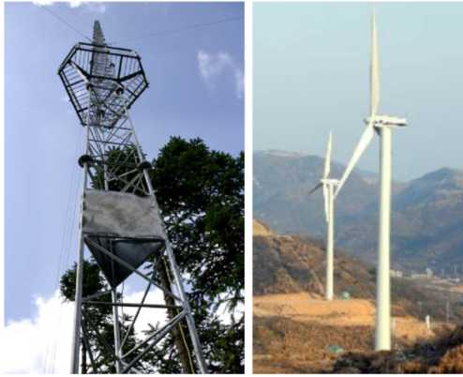
朝天芳草坪风力发电站、测风塔
Wind farm and anemometer tower of Chaotianfang Lawn
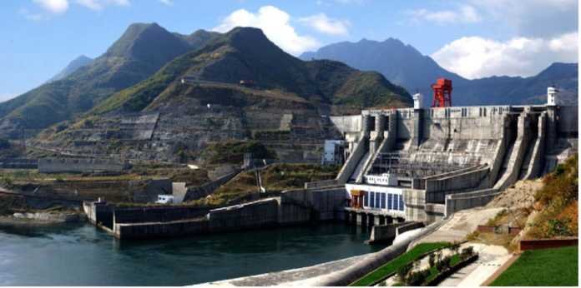
华电集团宝珠寺电站
Baozhusi Power Station of Huadian Group
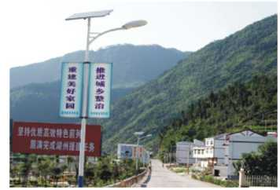  大力推广太阳能利用  Well promoted utilization of solar energy | 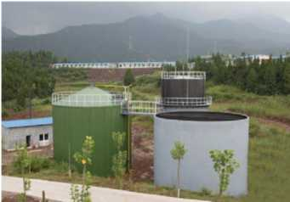  发展沼气  Biogas development
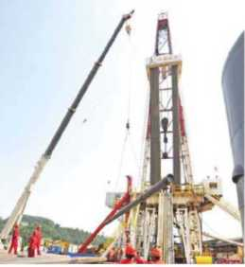  天然气勘探  Natural gas exploration | 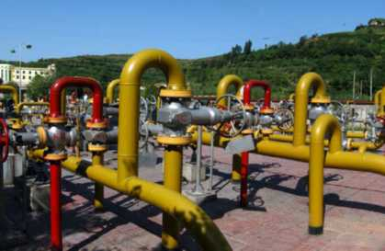  天然气加压站  Natural gas compressor station
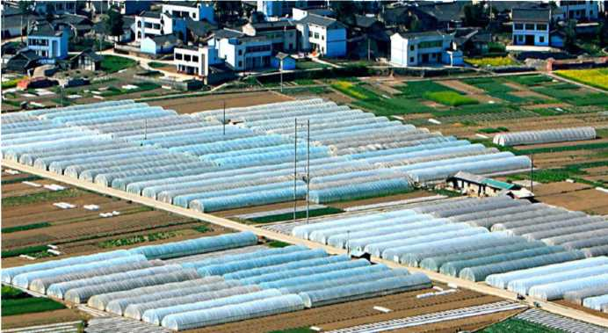
元坝区地热农业综合开发及观光度假园区
Geothermal comprehensive agricultural development and tourist resort park of Yuanba District
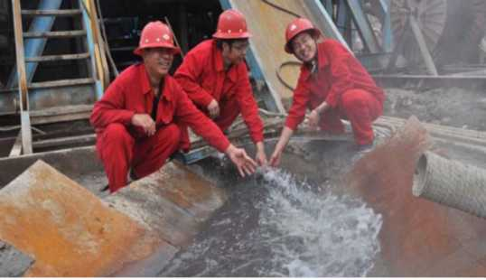
丰富的温泉资源
Rich hot spring resources
03 主导产业低碳化
Low Carbonization of the Leading Industries
■ 淘汰改造落后产能
Transformation or elimination of outdated industrial capacity
坚持以新型工业化为主导，做大做强清洁能源、农副产品加工、电子机械、新材料等工业板块；坚决淘汰落后产能，关闭小煤矿、炼铁小高炉等企业55家，整合转产79家，实施“煤改气”317家，震后新引进64个投资过亿的产业项目全部符合低碳发展要求。推进高能耗高污染企业优化升级，实现节能减排，努力推动产业结构和产业运营低碳化，实现经济发展与生态保护有机统一。2010年，全市GDP能耗下降6.12%，化学需氧量、氨氮和二氧化硫排放量持续实现"三下降"目标。
Adhere to the guidance of new industrialization, to expand and strengthen clean energy, agriculture and by-product processing, electrical machinery, new materials and other industrial sectors; resolutely eliminate outdated industrial capacity, close down 55 small businesses such as small coal mines, iron blast furnaces, etc., and carry out integration or conversion of 79 businesses, and "coal to gas conversion" of 317 businesses. All of the 64 new investment projects of over 100 million introduced after earthquake are all in line with the requirements of low-carbon development. Promote the optimization and upgrade of high-energy-consumption and high-polluting businesses to save energy and reduce emission, and promote the low carbonization of industrial structure and industrial operation, so as to achieve organic unity between economic development and ecological protection. The GDP energy consumption of the city fell by 6.12%, and the "three downs" target of decreased chemical oxygen demand, decreased ammonia and sulfur dioxide emissions are realized again in the year of 2010.
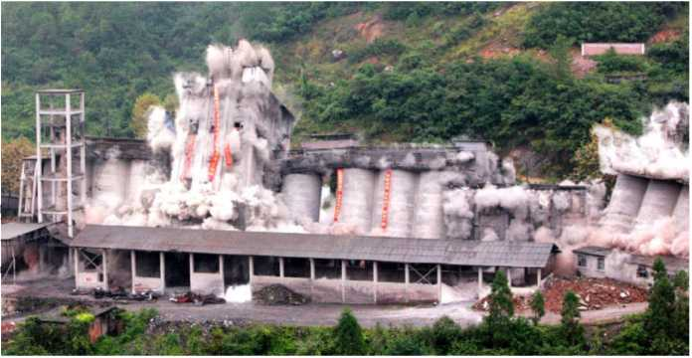
爆破淘汰五洲工业公司水泥厂
Blasting out of Cement Factory of Continental Industrial Company
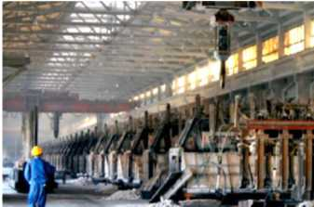  启明星铝业优化节能工程  Optimization and Energy-saving Project of Aostar Aluminum Co., Ltd. | 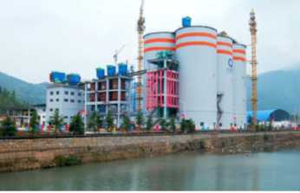  海螺水泥厂余热发电  Waste heat power generation of  Conch Cement Co., Ltd.
■ 构建低碳工业体系
Establish a low-carbon industrial system
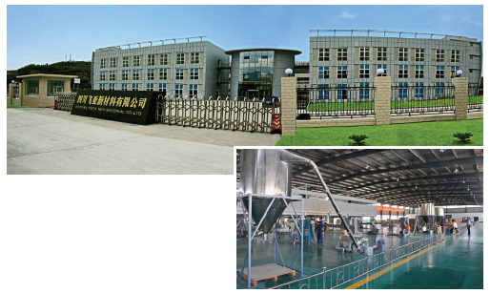
四川飞压新材料有限公司年产1000吨“聚芳醚醚睛合成材料”生产线项目。
Production line project of 1,000 t/a polyarylene ether ether nitriles composites of Sichuan Feiya New Materials Co., Ltd.

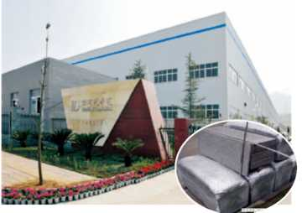  四川元泰达有色金属材料有限公司年产合标准规格泡沫铝板材120万平方米  Sichuan Yuantaida Non-ferrous Metals Co., Ltd has an annual output of TEDA-standard specification aluminum foam sheet of 1.2 million square meters | 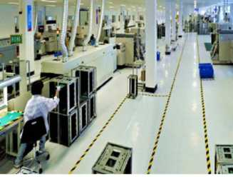  四川长虹欣锐电子有限公司  Sichuan Changhong Xinrui Electronics Co., Ltd.
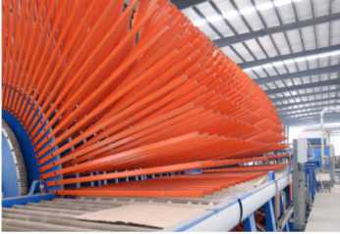  升达林业一期投资4.38亿元建设广元林产业基地，其中1.2亿元用于40 万亩工业原料林建设。  Shengda Forestry Industry (Group) Co. Ltd. invested 438 million yuan in the development of Guangyuan forest industry base during Phase I, of which 120 million yuan was invested in the cultivation of 400,000 mu (1mu=0.067 hectare) industrial raw material forest. | 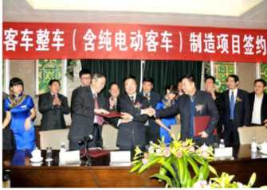  2010年12月，广元客车整车（含纯电动客车）制造项目在蓉签约。  The contract of Guangyuan passenger vehicle (including pure electric vehicle) manufacturing project was signed in Chengdu in December 2010.
■ 建设低碳农业园区
Construct a low-carbon agricultural park
2009年以来，全市共整合财政项目资金5.9亿元，吸纳社会投人8.2亿元，建成10个低碳现代农业示范园区。到2012年全市将累计建成50个现代农业示范园区，园区规模达到50万亩，覆盖农户20万户， 辐射带动农户20万户，园区生产总值占农业总产值的比重达30°/。以上。
The city has integrated financial project funds of 590 million yuan, and absorbed 820 million yuan of investment from the society to build 10 low-carbon modern agricultural demonstration parks since 2009. By 2012, the city will have built 50 modern agricultural demonstration parks in total, with a size of 500,000 mu, covering 200,000 households, radiating to 200,000 households, and the park's output value accounts for over 30% of the total agricultural output value.
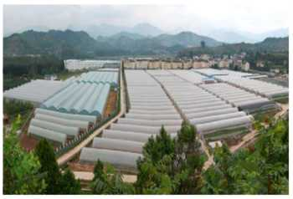  循环经济园区  Circular economy park | 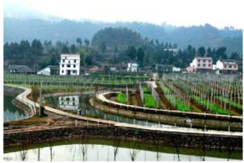  现代农业示范园  Modern agriculture demonstration park
■ 发展低碳生态旅游
Develop low-carbon ecological tourism
旅游产业作为全市实施资源转化战略的重点领域，作为灾后重建的先导产业，震后建成国家AAAA级旅游景区6个，累计达到8个。2010 年，全市旅游接待游客和旅游总收人分别同比增长36.7%和37.8%。“剑门关蜀道、武则天故里”旅游品牌正逐步走向全国，走向世界。
As the strategic focus of converting the city's resources, and as the leading industry of the post-disaster reconstruction, 6 national AAAA level scenic spots have been built after the earthquake, totaling up 8. In 2010, the city's tourists and tourism revenues were up 36.7% and 37.8% respectively. The tourism brand of "Jianmenguan, Shudao and Hometown of Wu Zetian" is gradually getting recognized in China and throughout the world.
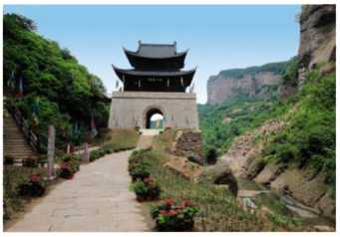  国家级重点风景名胜区一剑门关  Jianmen Pass -- key national scenic spots | 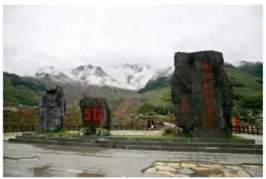  东河口地震遗址公园  Donghekou earthquake relics park
04 居民消费低碳化
Low-carbonization of resident consumption
广元市第五届人大常委会第35次会议审议通过将每年8月27日设为“广元低碳日”。2010年8月27日，广元隆重举行首个“低碳日”启动仪式暨“倡导低碳生活，建设低碳城市”万人签名活动。全市上下积极参与，主动作为，开展“熄灯1小时”、“少开一天车”等“低碳日”主题活动。首批便民自行车投放暨市民低碳出行启动仪式同时举行，市城区设立便民自行车站33个，首批投放便民自行车5000辆。2011年8 月27日“第二个低碳日”举行了第四批碳交易项目签约暨500万只节能灯惠民节能行动启动仪式、广元市绿道骑游暨“无车日”活动。
The 35th Session of the Fifth Guangyuan Municipal CPC Standing Committee has reviewed and passed the proposal to set August 27 of each year the "Guangyuan Low-carbon Day." Guangyuan held the first "Low-carbon Day" launch ceremony and ten thousand signatures campaign of "promoting low-carbon life, and developing low-carbon city" on Aug. 27, 2010. All of the city residents actively participated in the initiatives of such theme activities as "lights out for 1 hour", "no drive for one day" and "low-carbon day". The placement ceremony of the first batch of bikes and launch ceremony of "low-carbon travel" were held at the same time, and 33 bike convenience stations established in the city's urban areas, with 5,000 convenience bikes put in place. Signing ceremony of the fourth installment of low-carbon trading projects, launch ceremony of energy-saving actions with five million energy-saving lamps, Guangyuan green road riding and the "No Car Day" activities were held on August 27, 2011, "the Second Low Carbon Day".
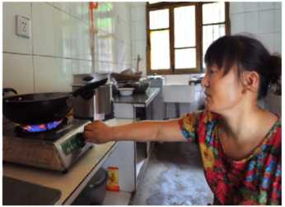  全市已建成农村沼气29.6万口，入户率44.18%,减少二氧化碳排放59.2万吨。  296,000 biogas wells were built in the rural areas of the city. With household access rate of 44.18%, the reduction in carbon dioxide emissions measures up to 592,000 tons. | 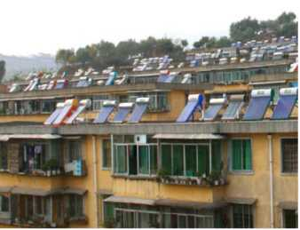  城区居民使用太阳能热水器  Solar water heaters are used by city residents
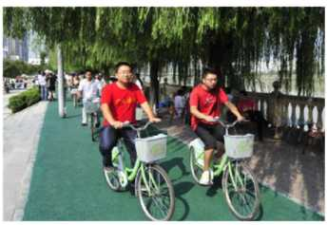  市民绿色出行，低碳生活  Eco-friendly travel, and low-carbon living | 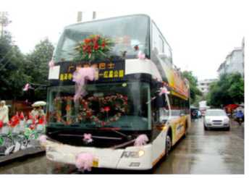  市民低碳婚礼  Low-carbon wedding of city residents
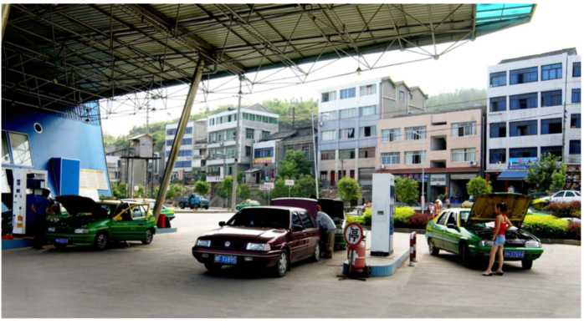
广元市100%的出租车、96%的公交车已完成油改气，以替代汽油为基准， 减少二氧化碳排放4230吨、二氧化硫128吨、一氧化碳906吨。
100% of the taxis and 96% of buses have completed the oil-to-gas conversion, calculated by replacement gasoline, reducing emissions of 4,230 tons of carbon dioxide, 128 tons of sulfur dioxide and 906 tons of carbon monoxide.

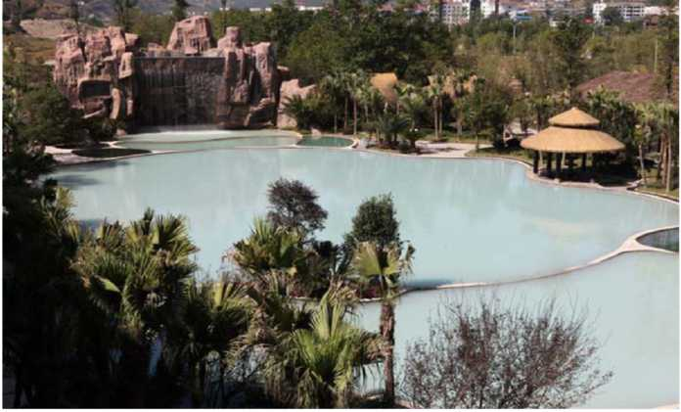
综合开发利用地热能一剑阁天赐温泉
Comprehensive development and utilization of geothermal energy -- Jiange Heaven Hot Springs
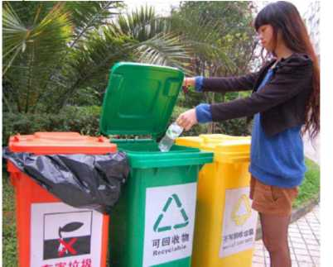  我市全面实施生活垃圾分类处理工作，力争两年内垃圾分类处理率达到85%。  The city has fully carried out the garbage classification, and striven to achieve garbage sorting treatment rate of 85%within two years. | 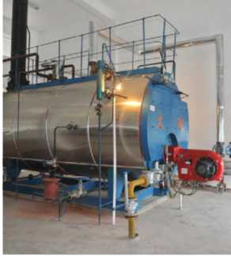  景特包装公司煤改气工程  Coal-to-gas project of Jingte Packaging Company
■ 城乡住房低碳重建
Low-carbon reconstruction of urban and rural housing
广元市坚持因地制宜，尊重自然与科学，全力推进城乡住房低碳重建，全市19.96万户农房重建全部完工。在龙门山地震断裂带大力推广建设具有川北民居风貌的抗震性能强的轻钢结构、木结构住房6万余户，户均节约资金3万余元，全市共节省资金近20亿元，户均节约用砖2.5 万匹，减少二氧化碳排放约97万吨。
The city of Guangyuan adheres to the principle of adapting to local conditions, respecting nature and science and vigorously promoting low-carbon housing reconstruction in urban and rural areas, and 199,600 rural housings have all been reconstructed. More than 60,000 light-steel-structured and wood-structured housings with residential building character of North Sichuan and strong seismic performance were built in the Longmenshan earthquake fault zone, with the average saving for each household of 30,000 yuan, the total saving for the city nearly of 2 billion yuan, saving 25,000 bricks for each household on average while reducing about 970,000 tons of carbon dioxide emissions.
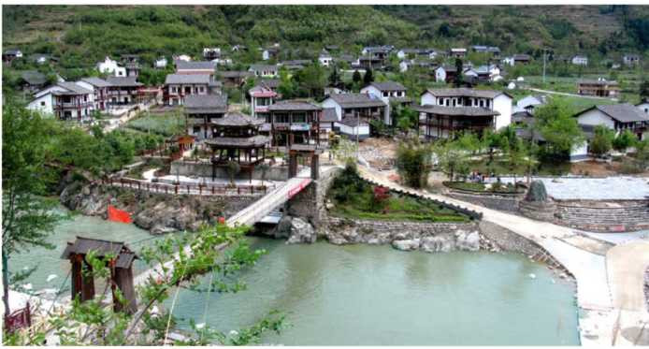
青川县阴平村木结构农房
Wood-structured rural housings in Yinping Village, Qingchuan County

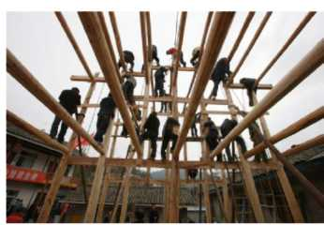  穿斗木结构民居  Through-funnel wood-structured residential housing | 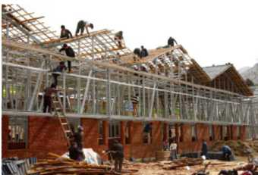  轻钢结构农房建设  Construction of light-steel-structured rural housing
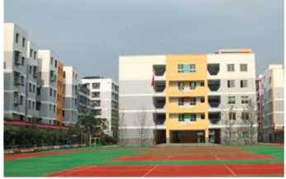  低碳示范学校-利州区北街小学  Model low-carbon school -- Beijie Primary School of Lizhou District | 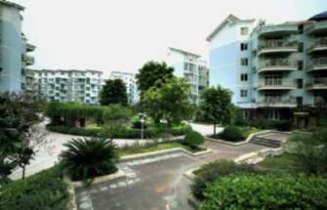  低碳节能示范小区-翡翠城住宅小区  Model low-carbon and energy-saving living quarters of Emerald City
05 增加碳汇能力
05 Increase carbon sink capacity
生态建设践行低碳绿色。认真实施退耕还林、天然林保护等生态工程，大力推进生态修复和重建，积极创建"国家森林城市"，全面开展城乡环境综合治理，大力推动小区环保、绿色交通、垃圾利用等，着力控制"奢侈性排放"，努力建设资源节约型、环境友好型社会。目前，全市森林覆盖率达到53.2°/。，道路、水系绿化率达到90°/。以上，城市建成区绿地率达到38.5°/。，绿化覆盖率达到39.4%，城区空气质量优良天数连续三年达364天，城乡一体的森林生态体系初步建立。
Ecological development shall adhere to the low-carbon and eco-friendly practice, conscientiously carrying out the "Grain for Green Project", "Natural Forest Protection Project" and other ecological projects, and vigorously promoting the ecological restoration and reconstruction, and actively creating a "National Forest City", fully implementing the comprehensive management over urban and rural environment, and vigorously promoting the environmental protection, eco-friendly transportation, waste utilization, etc., actively controlling "luxury emissions" so as to build a resource-saving, environment-friendly society. Currently, the city's forest coverage rate reaches up to 53.2%. Greening rate of roads and water system reaches up to 90% and the greening rate of urban built-up area reaches 38.5%, and the green coverage ratio reaches 39.4%. Urban air quality has been rated as "excellent" for 364 days continuously for three consecutive years, and a forest ecosystem integrating urban and rural areas was preliminarily established.
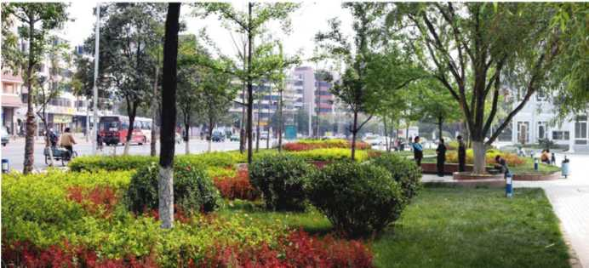
城市绿化
Urban greening
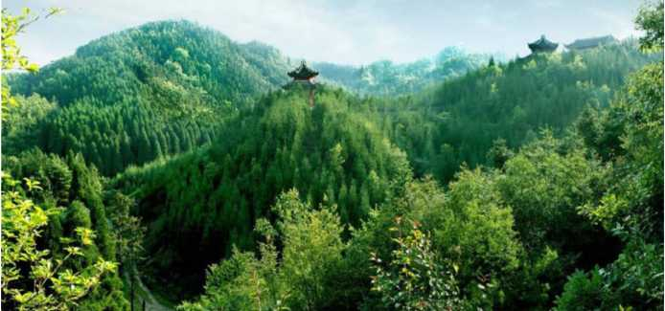
人工造林初见成效
Initial success of forest plantation

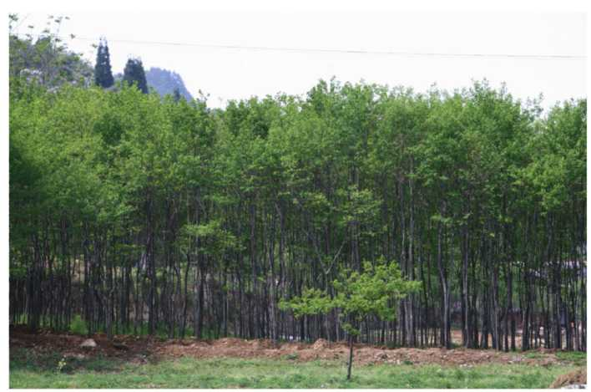
旺苍杜仲林
Eucommia woods in Wangcang
 | 首批2万张四川广元碳指标世博“绿色出行”低碳交通卡在上海堪博会上公开发行。  The 20,000 low-carbon transportation cards of the first batch of Sichuan Guangyuan Carbon Indicators World Expo "green travel" were publicly issued for Shanghai World Expo. | 2010年，1万吨四川广元碳指标“亚运会绿色出行羊城低碳卡”在广州亚运会上公开发行。  10,000 tons of Sichuan Guangyuan Carbon Indicators "Guangzhou Green Travel Low-carbon Card for the Asian Games " were publicly issued for the Asian Games in Guangzhou in 2010 | 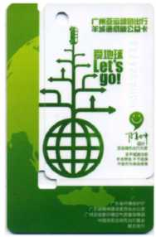
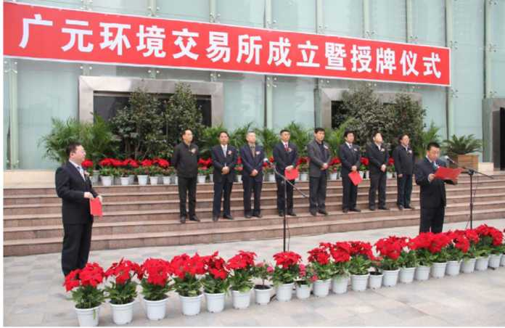
四川省首家环境交易所在广元挂牌成立
The first environmental exchange of Sichuan Province was set up in Guangyuan
