


Livestock Sector Evolution:
Trade-offs with Food, Feed and Biofuels;
and Solutions to Deforestation

- Side Event -

UNFCCC COP 15
Copenhagen, DK, 12 December 2009,
Room 3, Liva Weel 18:15-19:45

International Livestock Research Institute (ILRI),
Forestry Program, International Institute for Applied Systems Analysis (IIASA)
National Wildlife Federation (NWF)
Amigos da Terra- Amazônia Brasileira
Forest Footprint Disclosure Project
Amazon Institute of People and the Environment (IMAZON)

Livestock, as part of global ecological and food production systems, are a key commodity for human well-being. Their importance in the provision of food, incomes, employment, nutrients and risk insurance to mankind is widely recognized. Livestock provide many services but use large quantities of natural resources and also produce significant amounts of GHGs. Considering that the demand for meat and milk is increasing rapidly, and that livestock is only one of many sectors requiring to grow to satisfy human demands, more trade-offs in natural resources use can be expected.

This side event examines following sides of the cattle conundrum:

- Global - Key trade-offs arising between livestock rearing, human well-being and environmental sustainability;
- Livestock biomass trade-offs in food, feed and and fuel systems
- Sustainable livestock systems for livelihood benefits
- Livestock and deforestation
- Integrated livestock modeling and assessment

- Local - latest developments in Brazil
- New and unprecedented research about the carbon balance of the Brazilian livestock sector
- New initiatives to reduce deforestation
- Modern ranching methods to increase productivity while decreasing deforestation and GHG emissions,
- Win-win scenarios for supply chains from producer to consumer, and the climate.

Agenda
Organizations: Part I: International Livestock Research Institute (ILRI),
Forestry Program, International Institute for Applied Systems Analysis (IIASA)
Part II: National Wildlife Federation (NWF), Amigos da Terra Amazônia Brasileira,
Forest Footprint Disclosure Project and IMAZON.

Side Event Title: Livestock sector evolution: trade-offs with food, feed and biofuels; solutions to
deforestation
Moderation: Henning Steinfeld, Food and Agriculture Organization of the United Nations (FAO)
Time | Title of presentation | Speaker (Institution)
18:15 – 18:20 | Objectives of the side event, introductory remarks | Henning Steinfeld * (Food and Agriculture Organization of the United Nations, FAO)
18:20 – 18.35 | Livestock, livelihoods and the environment: understanding the trade-offs | Carlos Seré *, Mario Herrero, Philip Thornton (International Livestock Research Institute, ILRI)
18:35 – 18:45 | Livestock, GHG and global models for integrated assessment (ILRI-IIASA Cooperation) | Petr Havlik * (Forestry Program, International Institute for Applied Systems Analysis, IIASA), Mario Herrero (International Livestock Research Institute, ILRI)
18:45 – 18:55 | Clarifying Questions/Discussion
18:55 – 19:10 | Legal and market pressures to reduce Deforestation for Cattle Expansion in the Brazilian Amazon | Barbara Bramble (National Wildlife Federation, NWF), Paulo Barreto* (Imazon),
19:10-19:25 | Carbon Balance of Cattle Ranching in Brazil (2003-2008) | Barbara Bramble, (National Wildlife Federation, NWF), Roberto Smeraldi * (Amigos da Terra Amazonia Brasileira)
19:25-19:30 | Clarifying Questions/Discussion
19:30 – 19:45 | Panel – Plenary DiscussionClarifying Questions/Discussion | Speakers * and Steven Ripley (Forest Footprint Disclosure)
19:45 | Concluding Remarks and Closing of the Side Event  Drinks will be served | Thomas Rosswall* (Climate Change Agriculture and Food Security, CCAFS)

For more information see:
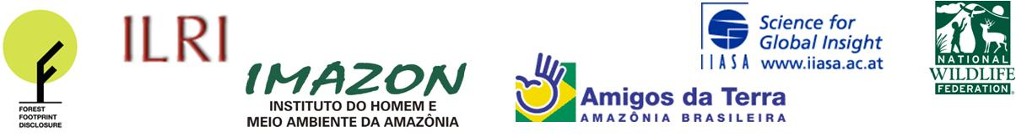
http://regserver.unfccc.int/seors/reports/events_list.html?session_id=COP15

