SB60 biographies
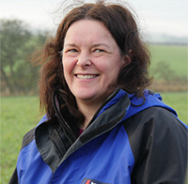
Dr Elizabeth Stockdale is Head of Farming Systems at The Translational Research Institute (NIAB). Elizabeth has over 25 years applied soil and nutrient management research experience and has engaged with a wide range of research projects connected with the study of nutrient cycling in soils and with the environmental impact of farming systems. At the smallest scale she has applied isotope dilution techniques to investigate mineralisation, immobilisation and nitrification processes. Most recently she has been very active in developing farmer-focussed approaches to measurement of soil health and developing on-farm toolkits for improved soil management. She moved to NIAB and became head of the integrative interdisciplinary farming systems research team in 2017.

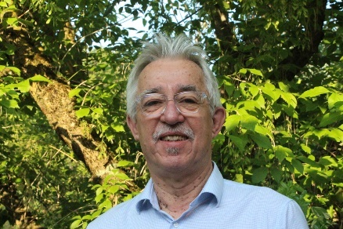
Jean-Luc CHOTTE is a research director at the IRD (Institut de Recherche pour le Développement), France. His research topic is the impact of climate change and land use on soil organic matter dynamics (stocks and fluxes) in the tropics. He has led several research units. His recent work focuses on i) trade-offs and synergies between the Sustainable Development Goals (SDGs), ii) the role of soil and land as levers in the 2030 Agenda for Sustainable Development: Land Degradation Neutrality (LDN), United Nations Decade for Restoration (terrestrial ecosystem), Koronivia Joint Work on Agriculture (KJWA).
Former (2015-2019) UNCCD SPI member, Jean Luc Chotte is the current Chair of the French Scientific Committee on Desertification. He is the elected representative of Research and Higher Education college in the 4P1000 initiative. Jean-Luc Chotte is corresponding member of the French Academy of Agriculture and visiting Professor at Paris School of International Affairs at Sciences PO, Paris. He has recently been nominated as a member of the “Strategic Orientation Committee” of the Sahara and Sahel Observatory.

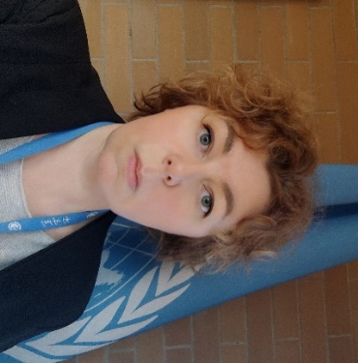
Dr Olga Andreeva is a Programme Officer of Scientific Affairs at the UNCCD.
Olga has a background is Soil Science, with a Master’s degree with Excellence in Soil Science obtained in Moscow State Lomonosov University in 1998, followed by a PhD on desertification/ land degradation assessment in Russia. For more than 15 years, Olga has worked as an Associate Professor at Moscow University, giving courses inter alia on SLM, LDN, Agroecology and Global Environmental facilities. Olga is one of the authors of SLM training course for students, including modules on WOCAT database, economics of land degradation and Ex-Ante Carbon-balance Tool (EX-ACT). In 2016, Olga became the UNCCD LDN Target Setting Programme country consultant for Russia. Olga is a member of the author team of the Study on land degradation, climate change and migration nexus in Central Asia, and also joined the Science, Technology, and Innovation Unit, UNCCD in 2023.

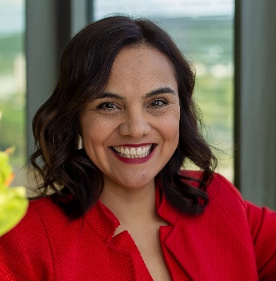
Miriam G. Medel Garcia is a career diplomat from Mexico with deep expertise and knowledge in multilateral negotiations, particularly in the areas of climate action and sustainability. For the past six years, she has held leadership roles at the UNCCD and UNFCCC Secretariats, developing vast expertise in policy advocacy related to the Rio Conventions and their implementation for people and planet. Previously, she was the Political Attaché of Mexico to Germany and has held several positions as a Mexican diplomat and multilateral negotiator. In August 2023, she joined onepoint5, an international consultancy specializing in climate and sustainability, to dedicate all her efforts to supporting governments, businesses and institutions who are ready to accelerate the transformation envisaged by the Paris Agreement, the Rio Conventions, and the SDGs. She holds a Master’s degree in International Affairs from Carleton University in Canada and a Bachelor’s degree in International Relations from the Universidad Nacional Autonoma de Mexico (UNAM). She speaks Spanish, English and German and has some knowledge of French.

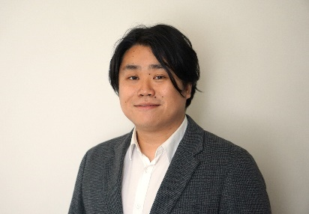
Miguel Ángel Zhan Dai is the Climate Policy Officer at FOUR PAWS International. Having studied International Relations Theory at the London School of Economics and Political Science (LSE), he works on climate and environmental policies in relation to animal farming. He previously worked as a consultant on institutional affairs strategies for private companies and NGOs in the areas of sustainability and digital transition. He is the lead author of the upcoming report 'Sustaining our Soils: An animal welfare solution for the environment and the climate'.

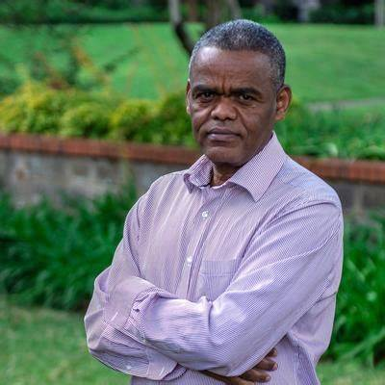
Lulseged Tamene Desta is a Landscape Ecologist with over 15 years of experience in land degradation, spatial prioritization, landscape restoration, sustainable land and water management, ecological intensification, and assessing the performance of ecosystem health. After joining the Alliance of Bioversity International and the International Center for Tropical Agriculture (CIAT), Lulseged coordinated various projects such as the Africa Soil Information Service in the Southern Africa region, served as the Dryland Systems CGIAR Research Program (CRP) focal point and contributed to the implementation of the Water, Land and Ecosystems CRP. Currently, he is leading one of the Excellence in Agronomy Initiative Use Cases in Ethiopia and is coordinating the Alliance engagements associated with the Sustainable Intensification of Mixed Farming Systems Initiative. He is also supporting implementation of Accelerating Impacts of CGIAR Climate Research for Africa, Supporting Soil Health Initiatives in Ethiopia, and many other projects.

