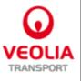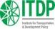Did Durban deliver? The 2011 climate conference and its implications for land transport

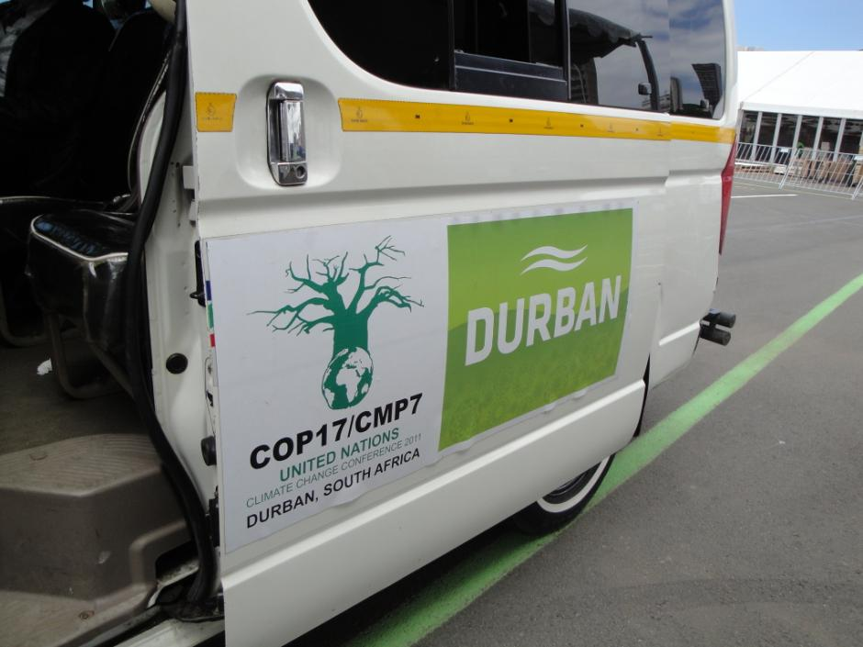
A summary of the proceedings from the United Nations Climate Change Conference in Durban, South Africa, and their significance for the land transport sector
March 2012
The full paper can be downloaded from http://www.transport2012.org/

The Bridging the Gap initiative is a multi-stakeholder initiative formed at the COP14 in 2008 between GIZ, ITDP, TRL, UITP and Veolia Transdev to bridge the gap between the transport and climate change sectors and promotes the potential for land transport to play a more prominent role in addressing climate change. Bridging the Gap is part of the SloCaT Partnership, comprising over 60 organisations, including UN agencies, multilateral development banks and research organisations.

