Official United Nations Side Event
The Global Stock Take:
Who needs to do the heavy lifting to keep within 1.5 degrees of warming?
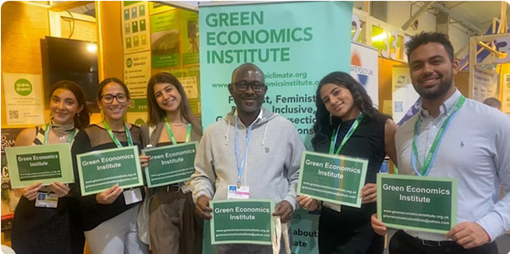
Side Events and Bonn Climate Change Conference (SB 58)
June 5th 2023 in UNFCCC Headquarters Bonn, Germany
Kamin Zimmer for 110 delegates. 15.15-16.30 pm CEST
Spotlighting alternative voices: Intersectional implications: Less or more developed countries? Equitable Just transition approaches for indigenous peoples + leadership.
Engaging stakeholders: the importance of broad stakeholder engagement in the process + delivery of concrete action, implementation, investment, action agenda a key focus for COP 28 building on the rich action agenda at COP 27. Integrated + holistic- gendered, approaches including youth, oceans and seas. Differentiation and equity; Human rights; Indigenous peoples
Partners:
Lead applicant: Green Economics Institute (GEI), by Ms. Miriam Kennet.
Co-applicant: Global Greens (Verts Mondiaux) (Global Greens), by Mr. Frank Sheridan.
Co-applicant: Technology Education Research and Rehabilitation for Environment Policy Centre (TERRE Policy Centre)by Mme Vinitaa Apte
Co- applicant: Club UNESCO du centre d'action femme et enfant (CUCAFE), by Mme Georgette Bilonda Mpenda
Co- applicant: Environment-People-Law (EPL), by Ms. Hanna Khomechko. TBC
Speakers:
For Lead Partner The Green Economics Institute:
Miriam Kennet Founder and Director, The Green Economics Institute, Alumni Mansfield College, University of Oxford, Founder and Editor The International Journal of Green Economics. (Virtual speaker)
Merem Tahar Association Women of the Diaspora, first young woman representative of the Indigenous people -Toubou GA (Chad)
Indigenous perspectives from other indigenous speakers from around the world in person.tbc
Aissatou Ba-Linnarz (Germany and Senegal)
Dr Manasse Bangagnan Doya (UK and Congo) Medical Practitioner
Professor Thomas Duncanson (USA)
Dorothy Nalubega (UK and Uganda) on line virtual speaker
Professor Ehtisham Abassi ( India and Morocco) Dr. Ehtesham Abbasi.
PhD (Accounting), Master of Finance & Control Assistant, Professor of Accounting Economics and Finance virtual speaker
For Technology Education Research and Rehabilitation for Environment Policy Centre (TERRE Policy Centre)
Mme Vinitaa Apte Terre Policy (India) on line virtual speakers
For Partner: Club UNESCO du centre d'action femme et enfant (CUCAFE):
Mme Georgette Bilonda Mpenda, (D R Congo and France)

For Partner: Global Greens: Verts Mondiaux
Jacquelyn Jepchirchir (Kenya) Programme Officer Kitui Cha Sheria: Social Impact and policy advocate. On line from Korea virtual speakers
Lucy Kagendo Global Greens and Green Dimensions Network (Kenya) on line from Korea virtual speakers
Tamara Wamucii Kahuthia (Kenya) student at Kenya School of Accountancy, member of the young global greens on line from Korea virtual speakers

Bookings
To book for this side event please register on the link below:
https://www.eventbrite.co.uk/e/sb58-united-nations-climate-conference-june-2023-bonn-tickets-558935480067
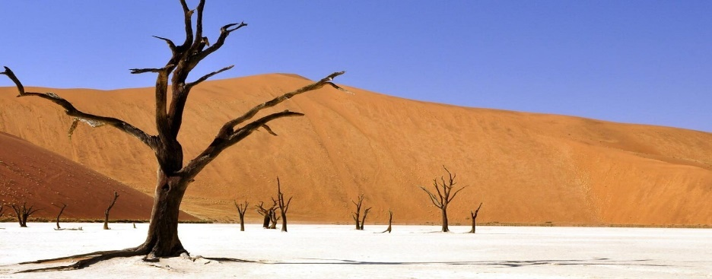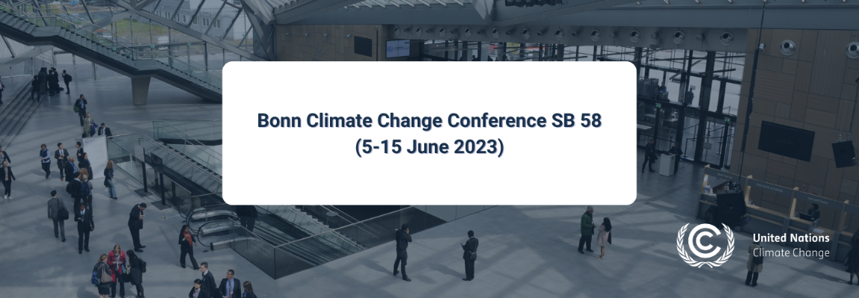
info@greeneconomicsinstitute.org.uk
greeneconomicsinstitute@yahoo.com
www.greeneconomicsinstitute.org.uk
www.geiclimate.org

United Nations Climate Conference, Bonn, Germany and Global Greens Conference, Korea
Additionally we have a link up with Korea with the Global Greens and our speakers on Thursday June 8th 2023 via UNFCCC SB 58 conference at 10.30 am uk time and 5.30 pm Korean time-. Hosts for the link ups are Miriam Kennet, the Green Economics Institute (UK and Bonn) and Lucy Kagendo The Global Greens in Korea. Please Email to participate.

