Accelerating Implementation: Transitioning to low carbon and climate resilent development pathway
Side Event hosted by International Development Research Centre (IDRC), Republic of Uganda, The Energy and Resources Institute (TERI), Business for Social Enterprise (BSR), and African Centre for Technology Studies (ACTS) at COP22

Goal
Share experiences from different countries on the efforts to transition to low carbon and climate resilient development pathway

Background/Thematic information

With the adoption of the Paris Agreement at the conclusion of the twenty-first Conference of the Parties (COP21) held December 2015 in Paris, France, the global community reiterated their commitment to address climate change. The Paris Agreement provides a framework through which all countries commit themselves to a universal global response with a view to holding the increase of global average temperature well below 2ºC and to the extent possblie below 1.5ºC above pre-industrial levels as science demands. To ensure that science informs climate actions taken by countries, it was further agreed that the Intergovernmental Panel on Climate Change (IPCC) to prepare a Special Report in 2018 on the impacts of global warming of 1.5ºC above pre-industrial levels and related GHG emission pathways. The outcome of the IPCC Special Report will be very important in informing the preparation of the first nationally determined contributions (NDCs) to be submitted by countries upon ratification of the Paris Agreement. It will also inform the formulation of respective national low green house gas emissions and climate resilient development strategies in accordance with Article 4 paragraph 19 of the Paris Agreement and in furtherance the attainment of Agenda 2030. Many developing countries are at different stages of reviewing their INDCs and formulating low green house gas emissions and climate resilient development strategies. The side event will provide a forum at which different countries and experts share their experiences, challenges and lessons learned with a view of identifying keys issues and critical aspects that would enhance transitioning to low green house gas emissions and climate resilient development pathways.

Relevant Themes
Category 1: Enhancing ambition: pre2020 action; any issues that help increase ambition.
Category 2: Promoting implementation: methodologies, showcasing of climate action, global stocktake

List of Speakers

Hon. Chebet Maikut, Climate Change Commissioner/UNFCCC National Focal Point for Uganda
Dr. Ajay Mathur, Director General, The Energy and Resources Institute (TERI)
Dr. Abid Suleri, Executive Director, Sustainable Development Policy Network
Dr. David Cameroon, Director, Business for Social Responsibility
Dr. Cosmas Ochieng, Executive Director, African Centre for Technology Studies (ACTS)

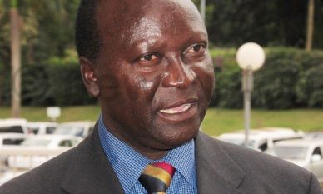

Hon. Chebet Maikut, Ag Commissioner Climate Change Department, Uganda
UNFCCC National Focal Point for Uganda

Hon. Chebet Maikut is the Ag. Commissioner, Climate Change Department of Uganda’s Ministry of water and environment and the UNFCCC National Focal Point for Uganda. He served as a member of Uganda’s parliament where he led several standing and sessional committees. He also served as a Constituent Assembly Delegate, an elected body that debated, passed and promulgated Uganda’s 1995 constitution. Earlier, Mr. Maikut served as president of Uganda National Farmers Federation and Vice President of the Eastern African Farmers Federation. He sits on the Adaptation fund Board and is the UN CC Learn Ambassador for Uganda. Hon. Maikut’s main interest areas include; thinking Climate, natural resources and environmental issues, poverty reduction and rural development, education, human rights and democracy.

Presentation Brief
Hon Chebet will speak about “commitment to action: the challenges and opportunities for NDC implementation in Uganda”. Uganda’s submitted NDC represents commitment and ambition with 22% emission reduction proposed by 2030. There are enormous challenges to walk the talk and attain the emission reduction targets. On the other hand there are opportunities Uganda can take advantage of to meet these obligations. Hon Chebet will present the challenges and highlight the opportunities for progress.

****************************************

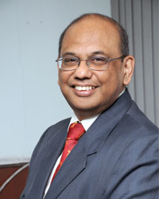
Dr Ajay Mathur - Director General, The Energy & Resources Institute (TERI)

Dr. Ajay Mathur is the Director General of TERI – The Energy & Resources Institute, and a member of the Prime Minister’s Council on Climate Change. He was previously the Director General of the Bureau of Energy Efficiency in the Government of India for the last 10 years since 2006 and 2016, and responsible for bringing energy efficiency into Indian homes, offices, and factories. Dr. Mathur worked for TERI from 1986 to 2000, and also headed the Climate Change Team of World Bank in Washington DC. He was the President of Suzlon Energy Limited and also headed the interim Secretariat of the Green Climate Fund. He has been a key Indian climate-change negotiator, and was also the Indian spokesperson at the 2015 climate negotiations at Paris. He is a global leader on technological approaches to address climate change; recently, he joined the global group of industrial, financial and think-tank leaders to co-chair an Energy Transitions Commission which will suggest ways for companies and countries to move towards climate-friendly energy futures.

Presentation Brief
Dr. Mathur will speak about policies for effective and ambitious actions in the field of renewable
energy, energy efficiency and coastal infrastructure.

*********************************************
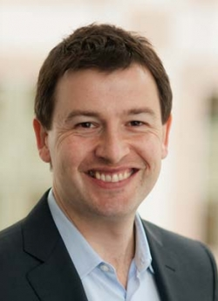
Dr. Edward Cameron, Managing Director, Business for Social Responsibility (BSR)

Dr Cameron is a specialist in climate change and human rights. He leads BSR’s climate change practice with a focus on driving greenhouse gas emissions reductions and enhancing business and societal resilience. He further serves as policy director for the We Mean Business coalition, which BSR cofounded in 2014 to accelerate the transition to a low-carbon economy. This work has facilitated the positive engagement of the private sector in shaping global climate policy and helped forge the historic Paris climate agreement adopted by 196 governments in December 2015. Previously, Edward was director of the International Climate Initiative at the World Resources Institute, leading work on the United Nations Framework Convention on Climate Change. At the World Bank, Edward designed a training program on vulnerability and resilience for more than 10,000 development practitioners. As senior advisor at the Department of Foreign Affairs of the Maldives, he launched the first state-led initiative on climate change and human rights. And during nine years in Brussels, he worked with EU institutions on environmental policy, innovation, and sustainable cities.

Presentation Brief
Dr. Cameron will speak on private sector resilience honing in on how the private sector can act, enable, and influence broader societal resilience. Specifically, this includes resilience not only in their own operation but through their supply chains and within the communities in which they operate.

*********************
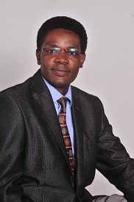
Dr. Cosmas Ochieng, Executive Director, African Centre for Technology Studies (ACTS)

Dr. Ochieng has held various positions in a number of university, research, development and conservation organizations around the world. These include IUCN (International Union for the Conservation of Nature); Technical University of Denmark (DTU - UNEP Risoe Centre); Lancaster University (Lancaster Environment Centre); Ecoagriculture Partners; IFPRI (International Food Policy Research Institute); ActionAid International (UK); IDRC (International Development Research Centre); Kenyatta University and IIRR ( International Institute of Rural Reconstruction). Dr. Ochieng has conducted research, policy analysis and teaching in the areas of agriculture and food security; sustainable land, water and energy ecosystems management; biodiversity and natural resource governance; national systems of innovation; international trade and development; green economy and climate change; ICTs and development in Africa; and political economy of African agrarian development.

Presentation Brief
Dr Ochieng will speak on “climate change innovation systems for technology transfer” which remain key to Africa’s pursuit of climate-compatible development. He will share insights from projects implemented by the Africa Sustainability hub (ASH) on the development of climate change innovation systems for technology transfer, which are critical to the successful implementation of the 2015 Paris Agreement on Climate Change, and African countries’ Nationally Determined Contributions (NDCs) in particular.

*******************

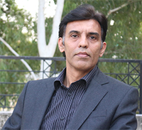
Dr Abid Qaiyum Suleri, Executive Director, Sustainable Development Policy Institute (SDPI)

Dr Abid Qaiyum Suleri is a member of various official bodies, including National Economic Advisory Council, Advisory Committee of Planning Commission of Pakistan, and National Advisory Committee --- a body formed jointly by the Government of Pakistan and the USIAD for Pakistan Strategic Support Program. He is also an Adjunct Professor at the Institute of Business Management Sciences, University of Agriculture, Faisalabad. From 2010-12, he served as the Member of Board of Management of Pakistan State Oil (PSO). Prior to joining SDPI, he was the Head of Programs, OXFAM GB, Pakistan. He has conducted intensive research on various issues including resilient livelihoods, food insecurity, regional trade, and political economy of development. His other research interests include institutional reforms, non-traditional security issues, and energy governance.

Presentation Brief
Dr. Suleri will speak on the implications of a 1.5degree target and what it means to transition to low carbon and climate resilient development.

*************************
Date and Location

Wednesday, 16th November 2016, 3.00-4.30pm
Room: Mediterranean Room (300)

Anticipated number of Attendance

150

Contact details

Edith Ofwona Adera
Senior Program Specialist
Climate Change Program
International Development Research Centre (IDRC), CANADA
P.O. Box 62084- 00200
Nairobi, Kenya
Cell: +254 722 903442
Email: eofwona@idrc.ca

