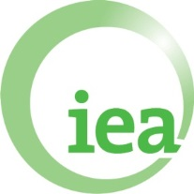
Identifying progress towards national and global adaptation goals
Wednesday 18th May, 18:30-20:00
Room Berlin
This interactive IIED/OECD side event will explore issues relating to measuring adaptation and assessing its effectiveness, and how this might inform international discussions on progress towards achieving national and global adaptation goals and the global stocktake.
Facilitator: Jacob Werksman (CCXG Chair)
Presenters:

- Jane Ellis (OECD)
- Susannah Fisher and Brianna Craft (IIED)
Panellists: Klaus Radunsky (Austria), Pepetua Latasi (Tuvalu), Fred Kossam (Malawi)

Main discussion questions:
1. What are the key areas of adaptation that need to be tracked in countries to assess global progress in adaptation? (for example institutional plans, effectiveness, adequacy?)
2. How could this information be collected in an objective and timely manner? Do Parties and/or organisations already collect/monitor this information?
3. What, if any, role should different bodies (national and international) play in supporting the assessment of the global adaptation goal?

