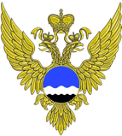Russian Federation – Wetlands International 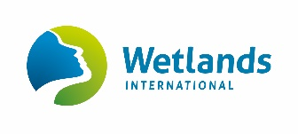
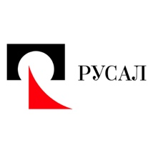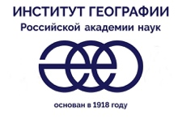

Realities of cryosphere changes and risks for people

Tuesday, 10 December 2019,15:00-16:30, Room 4

Realities of cryosphere changes (glaciers, ice sheets, snow, sea ice, permafrost) and risks for people. Nature-based solution for mitigation and adaptation in the Arctic. Vision of the Russian scientists of what changes of the ice we observe on the Planet including the key scientific outcomes of the Lake Vostok drilling in the Antarctic.

Introduction
Igor Shumakov, Head of Roshydromet, UNFCCC National Focal Point in the Russian Federation

Past and future of Earth’s climate from deep ice drilling in Antarctica
Vladimir Lipenkov, Arctic and Antarctic Research Institute of Roshydromet

Permafrost, wetlands and land-use change:
nature-based solutions for emissions reduction
Arthur Neher, Wetlands International

Glacier changes and associated impacts on natural and
human systems in high mountain areas
Stanislav Kutuzov, Russian Academy of Sciences

Rational use of water resources under climate change
Lord Barker, Executive Chairman, En+ Group

UC RUSAL's Activities in Extreme Temperature Conditions.
Challenges and Opportunities
Sergey Chestnoy, UC RUSAL Official Representative
for External Relations

QA

