REPORT OF THE UNITED NATIONS CLIMATE CHANGE CONFERENCE IN DOHA, QATAR, 26thNOVEMBER – 8thDECEMBER 2012
The United Nations Climate Change Conference in Doha, Qatar, took place from the 26th of November to the 8th of December 2012.
It included the eighteenth session of the Conference of the Parties (COP 18) to the United Nations Framework Convention on Climate Change (UNFCCC) and the eighth session of the Conference of the Parties serving as the Meeting of the Parties to the Kyoto Protocol (CMP 8). The conference also included side events as organized by civil society groups, intergovernmental organizations, regional organizations, governments etc.
Marking the first time that UN climate change negotiations took place in the Middle East, the conference drew approximately 9,000 participants, including 4,356 government officials, 3,956 representatives of UN bodies and agencies, intergovernmental organizations and civil society organizations, 683 members of the media and around 225 side events focused on major issues in theConvention process.
OUTCOME OF THE CONFERENCE
Negotiations in Doha focused on ensuring the implementation of agreements reached at previous conferences.
The conference opened on Monday morning, 26 November 2012 with the COP 17 President MaiteNkoana-Mashabane, Minister of International Relations and Cooperation, South Africa, urging delegates to: adopt a second commitment period under the Kyoto Protocol; complete work under the AWG- LCA; and find appropriate space to undertake other work under the COP, subsidiary bodies or new institutions. She stated that it would be a “step backwards for the ADP to become the AWG-LCA under a new name.” UNFCCC Executive Secretary Christiana Figueres stressed that COP 18 will be unique in marking the end of the first commitment period and launching the next one and will move the Bali Action Plan from design to full and effective implementation. She urged work on a future framework that ensures equity and responds to science, and challenged delegates to find a common ground.
Prior to the commencement of the negotiations, Abdullah bin Hamad Al-Attiyah, the Deputy Prime Minister of Qatar, was elected COP 18/CMP 8 President by acclamation. He noted the challenge posed by seven bodies convening in Doha and called on delegates to agree to a second commitment period under the Kyoto Protocol, finish work started in Bali and achieve progress on work undertaken in Durban.
The package of “Doha Climate Gateway” decisions adopted on the evening of Saturday, 8 December, included amendments to the Kyoto Protocol to establish its second commitment period. Having been launched at CMP 1 in 2005, the AWG-KP terminated its work in Doha.
The parties also agreed to terminate the AWG- LCA and negotiations under the Bali Action Plan. Key elements of the outcome also included agreement to consider loss and damage, “such as” institutional mechanism to address loss and damage in developing countries that are particularly vulnerable to the adverse effects of climate change.
While developing countries and observers expressed disappointment with the lack of ambition in outcomes onAnnex I countries’ mitigation and finance, most agreed that the conference had paved the way for a new phase, focusing on the implementation of the outcomes from negotiations under the AWG-KP and AWG-LCA, and advancing negotiations under the ADP.
Prior to the COP closing plenary, Parties watched a short film by civil society, encouraging delegates to “get involved now” to build a better future for everyone.
After the adoption of the package, a joint COP and CMP plenary was opened for parties to make statements. The US underlined that “much good work” has been accomplishedunder the AWG-LCA and clarified their interpretation of the Doha outcome. On reference to the CBDR principle in the text on shared vision, the US stated they would not accept the text to the extent it is not read as consistent with the UNFCCC and the Cancun Agreements. On the preambular text in the ADP decision, which references the Convention’s principles, theUS stated that this cannot affect the mandate given to the ADP under the Durban Platform and will not be the basis on which the US will engage in the work of the ADP. On unilateral trademeasures, the US clarified their interpretation of the wording “of concern” to mean the party that raises the issue.
Algeria, for the G-77/China, called this package a “milestone” for the implementation of a new post-2020 climate regime. She stated that the Doha package, with its “shortcomings,” shouldbe seen as a “delicate balance” and should be considered in its entirety.
The Russian Federation underscored that he had requested the floor before the COP/CMP President gaveled the Doha Climate Gateway package, and stressed his expectation that the President would introduce the proposal submitted by the Russian Federation, Ukraine and Belarus on the CMP outcome to the plenary. President Al-Attiyah responded that this concern and proposal would be reflected in the meeting’s report.
China, on behalf of BASIC (Brazil, South Africa, India andChina), said that, although disappointed with certain aspectsof the package, members of the group accept the decisions and promised a “proactive approach” to deal with climate changein the future. Australia expressed concern that surplus Assigned Amount Units (AAUs) could be as high as seven billion tons, noting that this puts the environmental integrity of the Kyoto Protocol at risk. He underscored that Australia will not purchase AAUs from the first commitment period and that such AAUs will not be eligible in the domestic emissions trading scheme. The EU, Liechtenstein, Japan, Monaco and Switzerland also stated they would not purchase surplus AAUs carried over from the first commitment period.
Nauru, for AOSIS, lamented that the adopted package is deficient in terms of mitigation ambition and finance, stating that it “only promises that something might materialize in the future.” He further expressed his expectation that the 2014 climatechange leaders’ summit announced by UN Secretary-General Ban Ki-moon will work to close the ambition gap. He lamented that the outcome “provides little more than a gateway to a long path,” and warned that if delegates take “a wrong turn in the road, this process will collapse and our nations will disappear.”
The EU stated that it will undertake immediate application of the second commitment period, as this is already provided for in EU law. In addition, noting that Protocol Article 4 foresees the possibility of parties fulfilling their commitments jointly, the EU explained that the commitment inscribed in Protocol Annex B for the EU, Croatia and Iceland for the second commitment period is based on the understanding that this commitment will be fulfilled jointly.
Egypt, for the Arab Group, said that decisions taken in Doha represent hope for the future of multilateral action on climate change; noted success on ambitious objectives and the opening the second commitment period; and looked forward to fulland continuous implementation of the decisions. Noting that “we are heading towards dangerous territory” by failing to set a pathway toward keeping the global temperature rise below1.5°C, Swaziland, for the African Group, said that the Doha decisions are in the right direction despite concerns on finance for implementing the Convention between now and 2020.
The Gambia, for the LDCs, said that they came to Doha for a balanced package and lamented that a number of elements have not been addressed. He said that commitments on mitigationare insufficient for closing the ambition gap and expressed disappointment with the lack of detail on 2013-2020 finance.
COP President Al-Attiyah commended the parties’ support of the political initiative to move forward and the negotiators’ flexibility that has “helped us reach solutions.” Recognizing that on some issues it was not possible to achieve common ground,he noted that consensus on AWG-LCA strengthens the conviction that parties are willing to work together, and highlighted agreement on financial resources for the period 2013-2020.
The Philippines, speaking for Like-Minded Developing Countries, expressed concern with “uneven texts” and weak ambition. He also expressed “deep disappointment” that after Doha, finance remains an “empty shell.” He highlighted major deficiencies in the AWG-LCA outcome including on developed country mitigation, comparability of efforts, response measures and finance.
Climate Justice Now said that Doha had neither delivered on an effective and fair deal, nor ensured the required finance for fighting against climate change. He rejected the Doha texts and said the “Doha gateway” is a gateway to climate injustice and climate death. Climate Action Network (CAN) said parties’ attitudes must change to secure a binding deal by 2015. Trade Unions urged for transition to start now. Youth said the Doha Climate Gateway has shut the door on equity.
Noting the submission from Bahrain, Saudi Arabia, Qatar and United Arab Emirates, the COP then adopted the decision on an economic diversification initiative. The US congratulated the concerned states for this submission, saying it represents “a significant shift” in their positions and efforts to address climate change.
The COP also approved the credentials of delegations, adopted the reports of SBI 36 and SBI 37, adopted the reports of SBSTA 36 and adopted the report of the ADP (FCCC/ADP/2012/L.3).
The COP also adopted a decision on future sessions. In the decision, the COP: accepts the offer by Poland to host COP 19 and CMP 9 in Warsaw from 11-22November 2013; notes that COP 20 and CMP 10 will be in Latin America and the Caribbean, and invites parties to consult on the hosting of these sessions; and takes note of the offer of France to host COP 21 and CMP 11 in 2015.
The COP then adopted the meeting’s report and a decision expressing gratitude to Qatar and the people of the city of Doha for hosting the conference. COP 18 President Al-Attiyah thanked the delegates for their hard work to reach a successful outcome and gaveled the meeting to a close at 9:34 pm.
Closing the meeting, COP President Al-Attiyah remarked: “I am not saying what is in store is a perfect package. Perfection is just a concept. If great minds like Plato and Socrates werein the COP presidency, I assure that even they would not been able to deliver a perfect COP 18 package…” He acknowledged the sentiments of many that Doha had reached an agreement but at the same time had also fallen short.
The next major UNFCCC Climate Change Conference, COP 19/ CMP 9, is to take place 26 November to 7 December 2013 in Poland.
WOMEN ENVIRONMENTAL PROGRAMME’S (WEP) PARTICIPATION AT THE DOHA CONFERENCE
Women Environmental Programme been a key actor and at the forefront on issues of environment and climatic change most especially as it affects gender in Nigeria, considered it very imperative to not only attend the Doha conference, but actively participant: holding a side event and participating in several other discussion forums as was organized by different institutions.Women Environmental Programme had five major objectives for participating at the Doha conference and they included the following:
1. Organize a side event on “Exploring the link between climate change and its impacts on the livelihoods of farmers”.
2. Participate in events to project environmental sustainability and livelihood sustainability
3. Follow the negotiations and provide feedback
4. Support party and observer members’ participation at Doha
5. Networking with the global climate change community

WEP’S SIDE EVENT ON EXPLORING THE LINK BETWEEN CLIMATE CHANGE AND ITSIMPACT ON THE LIVELIHOODS OF FARMERS
Women Environmental Programme (WEP) in partnership with the Charles and Doosurgh Abaagu Foundation organized a side event with the aim ofbringing to bear, the linkages between climate change and its impacts on the livelihoods of farmers in African.
The side event held on the 6th of December, 2012 at Room 10, Hall 5 of the Qatar National Convention Center between 13:15pm —14:45pm. The event brought participants from across civil society organizations, the Caribbean, EU, Experts, Indigenous peoples and governmental representatives of various countries.
The side event was anchored by the Executive Director of Women Environmental Programme (WEP) Ms. Priscilla Achakpa and featured Dr. Emmanuel Tembe of the Green Watch Initiative Nigeria, Mr. Frank Yawon of Women Environmental Programme Abuja, Nigeria, Ms. Zenabou Segda of Women Environmental Programme Burkina Faso and Ms. Winifred Masiko of Women Environmental Programme Uganda as guest speakers of the event.
The side event had the following specific objectives.
- Contributing to addressing the key climate change challenges affecting the livelihoods of farmers in Africa.
- Increasing awareness and capacity building for African Stakeholders on the sustainability of agricultural livelihoods.
- Promote Strategic governance framework on agriculture and further enhance the UNFCCC negotiation processes during the COP 18.
METHODOLOGY
The side event adopted a participatory and inclusive method in which guest speakers made presentations on various aspects relating to the subject matter in their respective countries after which participants seek further clarifications or made more inputs into the various discussions. The event was interactive amongst participants and brought to light, the practical links between climate change and its impacts on the livelihoods of farmers in Africa.
PLENARY
The event began with Ms. Priscilla Achakpa giving an overview of the proposed theme of the event after which she introduced the team of panelist for the discussions. In her remarks, she observed that Climate change directly impacts on agricultural productivity and food security, largely due to the fact that agricultural productivity depends on external steady weather patterns, thus affecting the livelihoods of farmers in Africa, majority of who are women. The presentations from the guest speakers will explore the links between climate changeand its impact on the livelihoods of these farmers in Africa.
Mr. Frank Yawon in his presentation did bring bear, the impacts of climate change on farmers as documented by Prof. Chinue Achebe in his book ‘Things fall Apart” written in the year 1958. Mr. Yawon as extracted from the book, observed that the threats of climate change on the livelihoods of farmers had long been with us and has only increased as a result of anthropogenic factors. Prof. Achebe as showed in his book and revealed by Mr. Frank in his presentation, did show the importance of farming as an economic activity of the rural people and the impacts of climate change to this vital source of livelihood in Africa. As presented by Mr. Frank, farm lands were degraded as a result of climate change which brought about massive floods across the community. There was low crop yields recorded with an adverse effect on the income of the farmers. Farm lands were destroyed despite all adaptive efforts by the community members. This further resulted in a farmer not been able to live with the apparent loses, killing himself by hanging. Mr. Frank likened the literature to the present experiences recorded in the year in several parts of the African countries together with Nigeria these countries did witness massive flooding like never before in the year 2012 with all the concomitant effects on agricultural livelihoods.
Ms. Winifred Masiko of WEP, Uganda in her presentation focused on initiatives of the women farmers towards adapting to the impacts of climate change in Uganda. She did note that Uganda is mainly an agricultural country with agriculture contributing 60% to the national economy. The Women as she noted, contribute about 80% of agriculture in both crop and animal farming. She observes that there has been an increased frequency and intensity of climate change in Uganda with the women been the worst hit by the impacts of climate change. This as she stated is mainly due to the fact that women in Uganda are Women are the food providers to families, carry out cultivation at subsistence level, collect firewood, which is the main source of cooking energy and provide support to children-clothing, fees, shelter etc.
She brought to light the impacts of climate change as she notes that extreme conditions and climate variability has led to long draughts, erratic rainfall that has created uncertainty and risk in Agricultural productivity. Also, flooding has destroyed crops and made transportation of crops to markets difficult.Heavy hailstorms as she held, has destroyed crops leading to food insecurity, family conflict and domestic violence. Less income from crop sales, increased poverty rate, High crop failure leading to food insecurity - malnutrition, Poor quality of crops harvested, Greater post-harvest loses, Encroachment on wetlands and forested areas, abandoned agriculture for petty trade, rural –urban migration, destruction of cultural and social fabric, increased work burden of women, increased spread of diseases such as HIV/AIDs,increased incidence of pests and disease in human, livestock and crops are all impacts of climate change been witness in Uganda as she further observed.
In the face of these biting effects of climate change on the farming activity of the women in Uganda, Ms. Winifred observed that the women have engaged in adaptive activities so as to ensure the sustenance of their economic activity. Some of these adaptive actions include the following:minimum tillage practices been adapted, more practices of soil cover such as mulching, crop rotation been more widely use, use of herbicides and pesticides has been on the increased, manure usage has also been on the increased, diversification of crop and animal husbandry, improved seeds and better animal breeds.
She concluded by noting that women are facing many challenges that have affected them negatively in the agricultural sector.
The third guest presented was Dr. Emmanuel Tembe of Green watch Initiative from Nigeria. Dr. Tembe spoke extensively on the side event theme from the Nigerian perspective. He brought to bear, climate change impacts and associated weather events been experienced in Nigeria and did observed that they are directly linked to the wanton destruction of farmer’s livelihood in recent times. These extreme weather events are also responsible for the devastating flash foods, drought, short duration rainfall, diseases/epidemics and seasonal variation. Other impacts as he noted include erosion, siltation of streams and rivers, crop failure, heat stress, water scarcity, extreme poverty and conflicts for competition of scarce resources.
Dr. Tembe did state suggestive strategies which would enhance the adaptive capacity of the local farmers and also did share experience of adaptation practices from Nigeria. Some of his views included the following: A firm commitments by COP18 towards capitalization of the Green Climate Fund and Adaptation funds to provide finance for farmers livelihood improvement, prioritization of climate finance in National, state and LG budgets to support adaptation projects for farmers, the use of innovative ways and means of raising adaptation funds from private sector (CSRs, interest free/concessional loans and fundraising etc..), use of early warning signals and weather prediction to avoid impacts, use of improved crop varieties that are early maturing, disease/drought resistant and high yielding, crop diversification and planting of cash crops like citrus and Acacia sp, tree planting, use of energy efficient woodstoves for domestic cooking and watershed protection, transfer of efficient technologies by annex 1 countries (flexible mechanism) will also enhance farmers livelihood activities in Nigeria.
He concluded by observing that Climate change impacts have inflicted severe hardship on farmers in Nigeria with the scale of affliction likely to increase with increasing temperatures, except urgent steps are taken to peg temp increases to below 1oc as contained in KP.
The final presentation was made by Ms. Zenabou Segda, the director of Women Environmental Programme in Burkina Faso. Ms. Zenabou brought to lime light, the plight of the rural women as impacted upon by climate change. She observed that the country which is agrarian in nature have the majority of farmers who are women and engaging in small scale farming activities. These women as she observed have in the recent years been impacted negatively by the impacts of climate change to the detriment of their economic well being.
Land degradation arising from the impacts of climate change is occurring across the country affecting the women severely. The women in a bid to adapt to the impacts of climate change have engaged in some sustainable land management practices. These practices as she noted include, crop diversification, use of manure and high yielding crops, water harvesting, use of organic chemicals, mulching and tree shedding, tree planting and planting of economic trees. She also reported that the women have formed themselves into cooperative groups so as to be able to attract assistance from the government and other agencies.
Ms. Zenabou emphasized the challenges of the women and pleaded for support from the international organizations for the poor rural women in Burkina Faso.
Presentations made by the guest speakers stimulated discussions between and amongst the participants as issues raised were further deliberated upon by the different people present. Several participants spoke of their respective country’s scenario on the issue of food insecurity caused by climate change impacts on the agriculture and the issue of women bearing the risks and consequences.
Following the extensive discussions by the presenters and the participants, the Executive Director of WEP, Priscilla Achakpa in her concluding remarks did observe the need for timely actions towards combating climate change as livelihoods of communities across the African continent are fast depleting, giving great cause for concern and worry. She re-emphasize the need to engage in sustainable development and land management practices and pledged WEP’s readiness to partner with desirable institutions towards combating the impacts of climate change.
OUTCOME OF WEP’s SIDE EVENT
● The side event expanded the knowledge base and brought about an increased awareness on issues of climate change and its impacts on farmers in Africa.
● The event contributed in no small measure towards addressing the key challenges for developing and implementing climate smart agricultural practices as an adaptation strategy to the impacts of climate change in Africa.
● Participants at the event called upon the African governments and relevant stakeholders to take a holistic approach towards developing, fundingand implementing sustainable agricultural practices in Africa.
● Theside event brought about practical experiences and best practices among and between countries towards the sustenance of agricultural livelihoods.
● Participants at the event seek for the protection of the rights of the indigenous people most especially women in the sustenance of their economic livelihoods.

PHOTO GALLERY OF THE SIDE EVENT
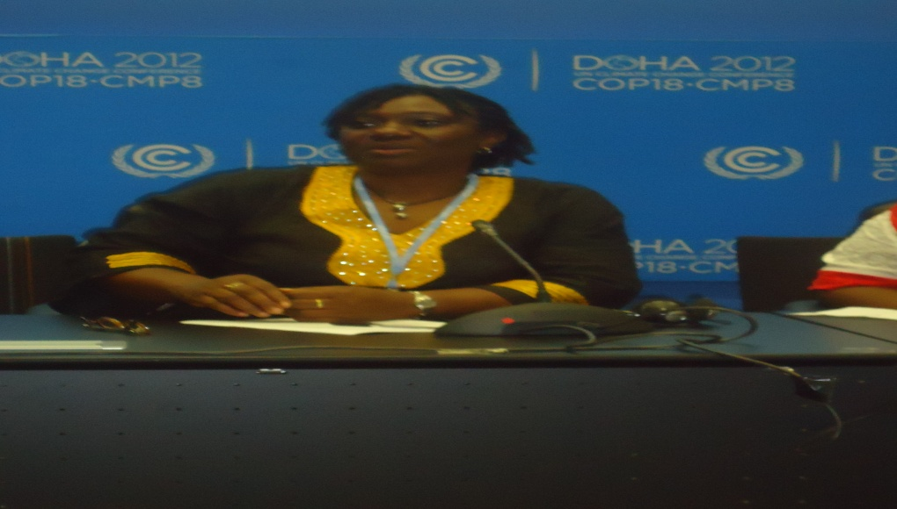
ED WEP, Priscilla Achakpa anchoring the event.
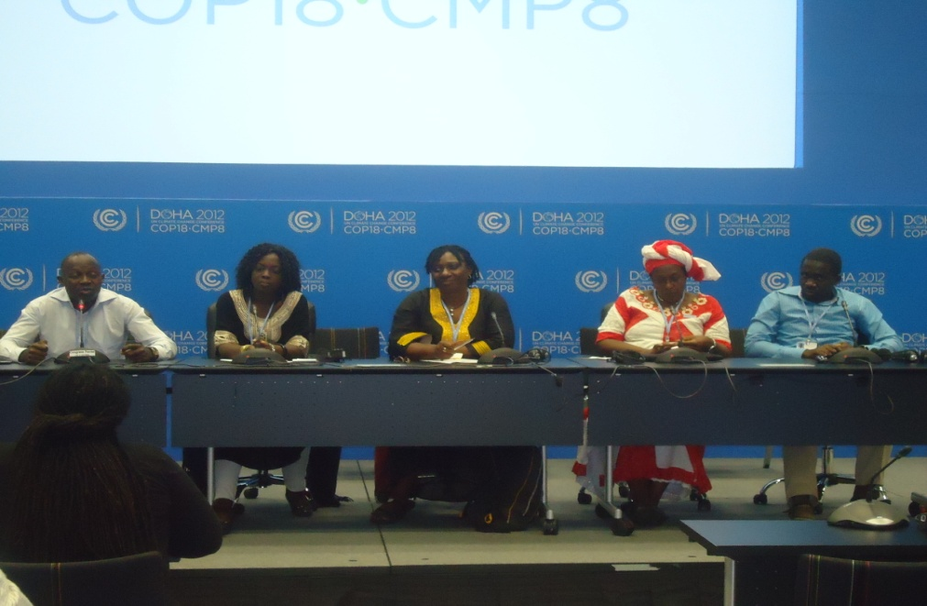
Guest Speakers and Facilitator of the side event

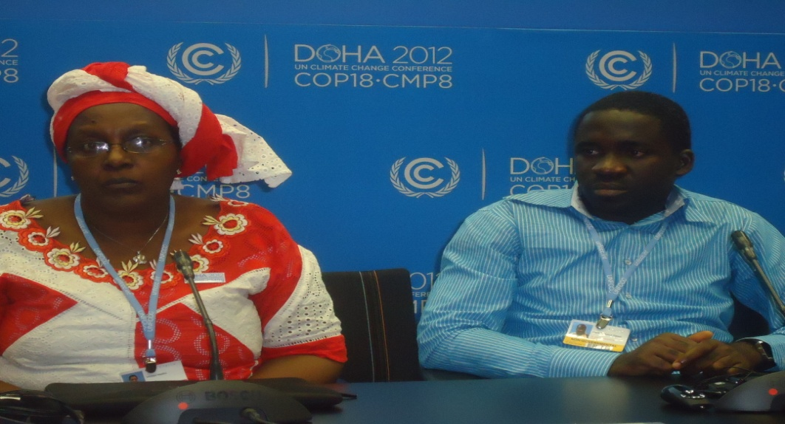
Ms. Winifred Masiko and Mr. Frank Yawon
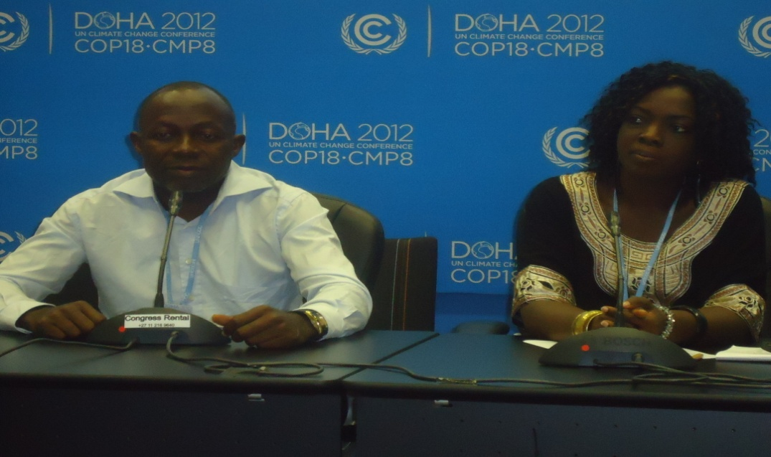
Dr. Emmanuel Tembe and Ms. Zenabou Segda
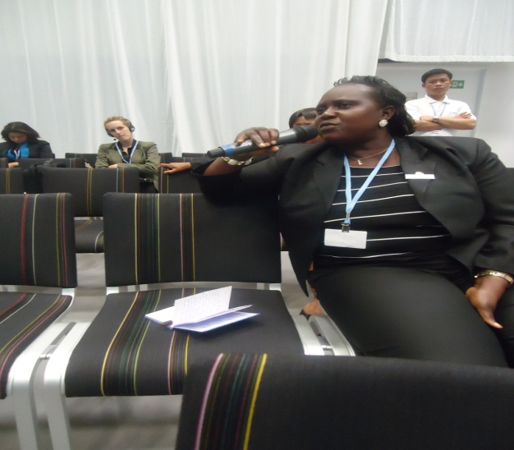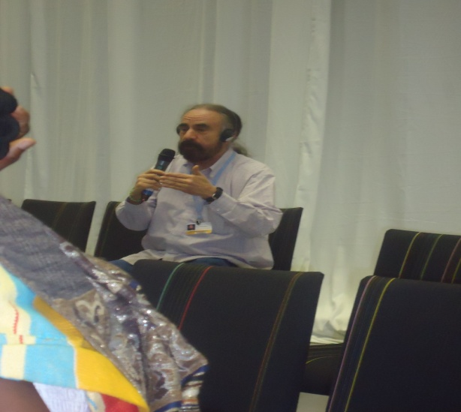
Participants sharing country experiences at the event.

