Results at COP17: SBI Work Program on Loss & Damage

At COP17 in Durban, South Africa negotiators were able to reach consensus on elements of the SBI Work Program on Loss and Damage from COP17 to COP18 (2012). This section summarizes the major elements of the decision and its implications for LDC and other Party work in 2012. The section also reflects on some of the elements of that consensus and reflects on opportunities for Parties to utilize 2012 to articulate their needs and positions in the issue area.

Decision -/CP.17 outlines the underlying ideas and specific activities that will be undertaken between COP17/SB35 and COP18/SB37 under the SBI work Program on Loss and Damage. Some of the main characteristics of the decision include:

- Paragraph 1: requesting “the Subsidiary Body for Implementation to continue the implementation of the work programme on approaches to address loss and damage associated with climate change impacts in developing countries that are particularly vulnerable to the adverse effects of climate change and to make recommendations on loss and damage to the Conference of the Parties for its consideration at its eighteenth session;
- Paragraph 2: accounts for Party questions articulated in the annex when implementing the work program in 2012
- Paragraph 3: invites Parties, relevant intergovernmental organizations, regional centres and networks, the private sector, civil society and other relevant stakeholders to consider the three thematic areas of the Work Program in their own activities. The goal of this inclusive approach is to assist Parties in understanding and building expertise for addressing loss and damage. Such organizations are invited to share the outcomes, lessons learned, and good practice related to the implementation of existing risk assessment and risk management approaches
- Paragraph 4: This inclusive approach extends to a large and diverse representation of experts, especially those from developing countries (of note: least developed countries and small island developing States) in undertaking the work under the three thematic areas;
- Paragraph 5: “Appreciates the need to explore a range of possible approaches and potential mechanisms, including an international mechanism, to address loss and damage, with a view to making recommendations on loss and damage to the Conference of the Parties for its consideration at its eighteenth session, including elaborating the elements set out in decision 1/CP.16, paragraph 28 (a-d);”

Following these first five paragraphs, the rest of the decision is devoted to three thematic areas and an annex containing Party questions for thematic areas one and two. Note that below the deliverables/milestones are organized chronologically, reflected in Figure 1.

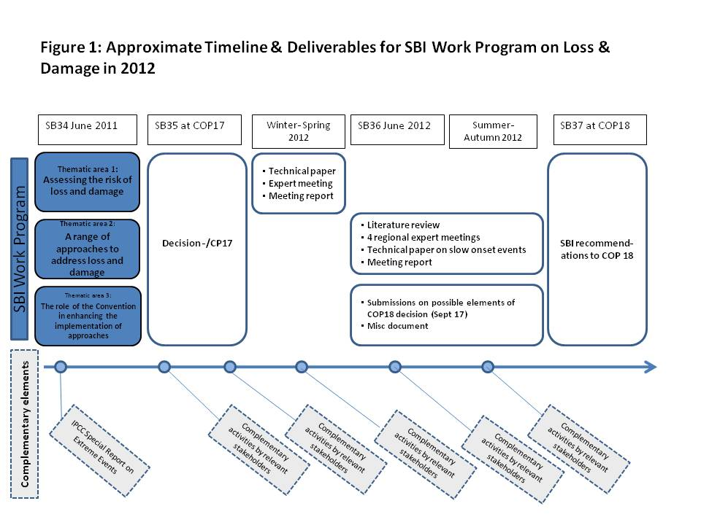

Thematic area 1: Assessing the risk of loss and damage associated with the adverse effects of climate change and the current knowledge on the same

- Paragraph 6: Expert meeting on this issue before SB36 (June 2012), and taking into account inputs from relevant organizations and other stakeholders. The goal of this expert meeting is to draw on a range of expertise and experience (within and outside the Convention) to prepare for and build a knowledge base for Party discussion of thematic area 2.
- Paragraph 7: To support this expert meeting, the Secretariat will undertake:
  - Technical paper. The Secretariat will prepare a technical paper before the expert meeting (in collaboration with relevant organizations and stakeholders). This technical paper will summarize current knowledge on relevant methodologies, address data requirements, lessons learned, gaps in assessment approaches at different levels, and existing relevant work and literature.
  - Meeting report. The Secretariat will make the report from this expert meeting to SBI at COP18.

Thematic area 2: A range of approaches to address loss and damage associated with the adverse effects of climate change, including impacts related to extreme weather events and slow onset events, taking into consideration experience at all levels

- Paragraph 8: For this thematic area the Secretariat will
  - Literature review of existing information and case studies on the topics in the context of this thematic area, to feed into four regional expert meetings
  - 4 regional expert meetings. The Secretariat will organize four expert meetings, three at the regional level and one for small island developing States, (in conjunction with other related events where possible) before SB37 at COP18 (Dec 2012). These workshops will take into account the outcomes of the expert meeting on assessment.
  - Technical paper on slow onset events, taking into consideration the outcomes of the regional expert meetings
  - Meeting report: The Secretariat will make the report from this expert meeting to SBI at COP18.

Thematic area 3: The role of the Convention in enhancing the implementation of approaches to address loss and damage associated with the adverse effects of climate change

- Paragraph 9: Invites submissions of views on possible elements to be included in the recommendations on loss and damage to COP18. These submissions should be submitted to the Secretariat from Parties and relevant organizations and other stakeholders by 17 September 2012. The submissions should take into account the activities and insights gained during the implementation of the work programme on loss and damage prior to that date.
- Paragraph 10: Misc document of all these submissions for consideration by SBI at SB37 / COP18.
- Paragraph 11: Encourages the Subsidiary Body for Implementation to take into account outcomes of the work program up to SB37, submissions, actions by relevant organizations in the context of the work program, and inputs from processes related to loss and damage.
- Paragraphs 12 – 15 discuss financial matters related to the realization of the above-noted activities between SB35 and SB37 for the SBI Work Program on Loss and Damage.

Key features of annex with Party questions:
The decision at COP17 on the SBI work Program on Loss and Damage included guiding Party questions for the first two thematic areas. The questions below will help shape the agendas of the 5 expert workshops (one technical and four regional), and activities (literature review, technical paper on assessment, technical paper on approaches to address slow onset loss and damage, literature review on approaches, and meeting reports).

Thematic area 1 questions (assessing the risk of loss and damage)
Questions in this section relate to understanding the data and information requirements, methods and tools, implementation, and decision-making support. It will be essential that activities between SB35 and SB37 take into account not only existing ways of assessing the risk of loss and damage associated with climate variability (such as weather-related risks), but also assessing risks of climate change (such as slow onset, creeping adverse effects like sea level rise). In some cases there may be gaps in approaches, particularly on assessment of risk of loss and damage for longer-term potential consequences. These should be noted (such as in the technical paper), but must be considered in order to maintain a comprehensive perspective. Many of the issues related to longer-term slow onset adverse effects of climate change may not be fully reflected in current risk assessment approaches, but are of great concern for least developed countries and small island developing states. Also, this thematic area has the opportunity to address the interaction between climatic variability and climate change (such as storm surges and sea level risk impacts). The questions aim to gather information about:

- Data and information requirements, and availability of data and information for assessing impacts and climate risk, at different levels and for a broad range of sectors and ecosystems
- Methods and tools available for risk assessment, including requirements, strengths and weaknesses, and whether they are able to also address social and environmental impacts
- Capacity needs for applying risk assessment methods on the ground, and what is needed to apply such methods in developing countries
- The communication of risk assessment results to inform and support decision-making

Thematic area 2 questions (approaches to address loss and damage)
Questions in this section relate to getting a comprehensive overview of approaches and tools to address the full range of loss and damage, from climate variability (such as weather-related hazards) to climate change (such as slow onset impacts like sea level rise, ocean acidification, desertification, etc.). The questions aim to gather information about:
- Conventional and non-conventional and innovative instruments that can be used for specific types of loss and damage.
- Cost effectiveness of various approaches, and what level various tools are employed at (from local, national, regional and international).
- Resources required for successful implementation of various tools, including budget, technical capacity for implementation, data, infrastructure, etc.
- Lessons learned from existing efforts within both the public and private sectors, considering elements of design, limitations, challenges and best practices?
- Links and synergies between risk reduction and other instruments such as risk transfer, and how comprehensive risk management portfolios or toolkits can be designed
- Tailoring risk management approaches to national contexts, and ways to evaluate which tools might be most appropriate for the particular risks and circumstances of a country

Contact: Koko Warner warner@ehs.unu.edu

Para 7(a)
Para 7(b)
Para 8(d)
Para 8(a)
Para 8(c)
Para 8(b)

