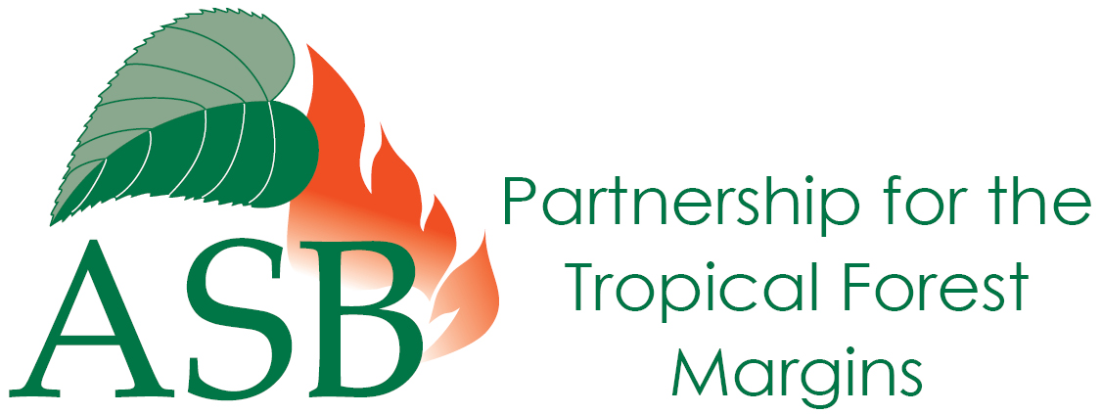

A whole landscape approach to emissions accounting is necessary for REDD+ to succeed because drivers of deforestation are mostly outside the forest and changes in land use following protection need to be accounted for

Current efforts to obtain commitment and create incentives for Reducing Emissions from Deforestation and forest Degradation in developing countries (REDD) are not clear about what types of forests are targeted and how they relate to ‘non-forest’ land uses. Different forest types and conditions represent different degrees of emissions and options for sequestration. This is particularly important because the main drivers of deforestation, such as agriculture, commercial demand, policy and population growth, lie mostly outside the forest domain.

The absence of a commonly agreed forest definition, inadequate appreciation of drivers of deforestation and degradation from outside the forest sector, potential leakage and shifts in emissions to non-forest land pose real threats to the success of any emission reduction scheme. However, the Intergovernmental Panel on Climate Change’s accounting rules for Agriculture, Forestry and Other Land Use (AFOLU) provide a simple alternative: include all land use proportionate to actual emissions and emission potential. A whole landscape accounting approach is needed in the long term to address these drivers within REDD+

“We have compiled evidence that shows how developing countries can adopt strategies for these high-carbon storing land-uses to reduce global emissions and benefit local people,” said Peter Minang, Global Coordinator of the ASB Partnership for Tropical Forest Margins.

A whole-landscape approach to reducing emissions and managing carbon stocks can help address the drivers of deforestation, reduce problems like leakage, and eliminate the need for precise forest definitions. What is included or not included in REDD+ as currently framed is still subject to much debate. Yet trees on agricultural landscapes represent a globally important carbon stock. Forty-six percent of agricultural land globally has at least 10% tree cover. In Southeast Asia and Central America, 50% has at least 30% tree cover. The carbon stocks in peat lands are equivalent to 70 years worth of current global carbon dioxide emissions. The current REDD+ scope does not include peat lands that constitute already lost forest cover but keep emitting carbon dioxide. This is 3-5% of global CO₂ emissions. “Ignoring this issue will undermine the success of global mechanisms for emission control,” said Henry Neufeldt, Leader of the Global Research Programme on Climate Change at the World Agroforestry Centre in Nairobi, Kenya.

Why is agroforestry important to REDD+?
One REDD scheme with considerable potential in Africa is agroforestry, the use of trees on farms to sustainably intensify agriculture, increase yields and conserve the environment. Developing countries’ quest for food security through agricultural expansion often leads to deforestation and forest degradation. Agroforestry integrates growing trees with agricultural and horticultural production. It can help reduce deforestation indirectly by providing tree products and services that would have otherwise been exploited from the forest, such as wood, charcoal, and nutrient-rich soils.

Poor people in developing countries are the most vulnerable to the effects of climate change. Increasing variability in year-to-year rainfall and more frequent extreme events will change ecosystems and speed up the degradation of soil and water resources. Smallholder farming communities that rely on these resources, and have limited ability to expand or intensify, will suffer most from the negative impacts of climate change. There is growing recognition of the role agroforestry can play in improving the resilience of farming systems to climate variability. The agroforestry approach of increasing the use of trees on farms sequesters carbon and contributes to mitigating climate change, builds resilience to climate variability and increases food security and income.

“Promoting agroforestry should be addressed within REDD+ policies,” said Peter Minang. “There is a need to scale-up proven tree-based farming practices, such as combining conservation agriculture with agroforestry. This requires support from policymakers for effective implementation.” Policymakers need to provide start-up inputs, including high-quality seeds, nurseries, and agroforestry training and extension materials. Further requirements include markets for agroforestry products, effective systems for managing carbon credits and payments for environmental services, and financial stimuli for farmers to plant trees. REDD strategies will also have to address other issues, including the causes of deforestation, sustainable forest management and monitoring capacity. Funding for agricultural research and extension programmes for agricultural intensification must be part of all REDD packages.

The way forward
“What is needed now is a global commitment to move forward, comprehensively, to reduce emissions from all land uses,” said Henry Neufeldt. Promoting high carbon stock land uses and reducing emissions from all land uses is the best option to achieve global climate goals, especially enabling low carbon development pathways in developing countries. “Four ‘pillars’ that support a whole landscape agenda must be considered,” commented Meine van Noordwijk, the Chief Science Advisor of the World Agroforestry Centre. “Reducing forest-based emissions, reducing emissions from peat, restocking land through trees and soil carbon and reducing emissions from agricultural greenhouse gasses.”

To be efficient and effective, REDD schemes must meet several stringent criteria. They must avoid ‘leakage’ – where conservation in one area simply shifts deforestation to another. They need to be ‘additional’ – leading directly to reductions in deforestation and degradation that would not have happened simply because of wider changes in the economy. There must be a project baseline against which to measure progress in reducing greenhouse gas emissions.

Before REDD projects are able to cut carbon emissions and benefit livelihoods, many developing countries will require substantial investments in capacity building, science and institutions. For example, countries will need technical support to develop carbon inventory systems and their remote sensing capacity. In addition, they will need support to set up the institutional infrastructure required to distribute REDD benefits and implement the various incentive schemes. Land tenure and forest governance are key factors determining the success or failure of REDD initiatives.

The pressing need is for deforestation policies that reduce the rate of logging, enforce policies on the replacement planting of felled trees, and recognize and scale up agroforestry options as an important win-win solution to climate change – through mitigation and adaptation – as they improve the environment and generate income for poor people.

##

For further information, please contact:
Peter Minang, Global Coordinator of the ASB Partnership for Tropical Forest Margins: p.minang@cgiar.org; +254 20 7224264
Henry Neufeldt, Leader of the Global Research Programme on Climate Change, World Agroforestry Centre: h.neufeldt@cgiar.org +254 20 7224238
Paul Stapleton, Head of Communications: p.stapleton@cgiar.org, +254 20 762 4260
mobile: +254 717718387

The World Agroforestry Centre, based in Nairobi, Kenya is the world’s leading research institution on the diverse role trees play in agricultural landscapes and rural livelihoods. As part of its work to bring tree-based solutions to bear on poverty and environmental problems, centre researchers—working in close collaboration with national partners—have developed new technologies, tools and policy recommendations for increased food security and ecosystem health. www.agroforestry.org

Founded in 1994, the Alternatives to Slash and Burn (ASB) Partnership for the Tropical Forest Margins brings together local knowledge, policy perspectives and science to understand the tradeoffs associated with different land uses and the roles of markets, regulation, property rights and rewards. While ASB is coordinated by the World Agroforestry Centre, it is a global partnership of international and national-level research institutes, non-governmental organizations, universities, community organizations, farmers' groups, and other local, national, and international organizations. www.asb.cgiar.org

