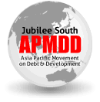
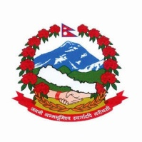
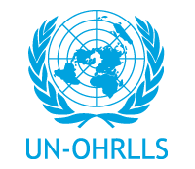

(draft concept note)

CLIMATE JUSTICE FOR LDCs: FINANCING ADAPTATION AND IMPLEMENTING THE ISTANBUL PROGRAMME OF ACTION (IPoA)

Side-Event at the COP18/CMP8, Doha
Tuesday 4 December, 8.15-9.45pm, Room 7

The escalating climate change crisis adversely affects the 48 UN-defined least developed countries (LDCs) the most, although the LDCs are the least contributors to greenhouse gas (GHG) emissions with only a negligible 0.2 per cent per capita. All 33 African LDCs are Sub-Saharan, plagued by increasing desertification, heat stress and drought while the rest of the 15 in the Asia-Pacific are mostly mountain countries,landlocked developing countries (LLDCs) and small island developing states (SIDS), located in low-lying deltas and coastal zones, suffering from increased frequencies of glacial lake outburst floods, sea-level rise, precipitation, cyclones, storms, earthquakes and other extreme and erratic climatic conditions. The current trend is likely to intensify, thus, resulting in more loss of life and livelihoods as well as biodiversity, producing even more massive climate migrants/climate refugees in LDCs - 6 out of 20 countries with the highest level of disaster related displacement in 2008 were LDCs.
In this context, premised upon the principles of “historical responsibility” and “common but differentiated responsibilities” that are part of the UNFramework Convention on Climate Change (UNFCCC); CLIMATE JUSTICE FOR LDCs should be the rallying cry of LDC governments as well as its peoples.The pressing issue is not only about adaptation but also about the loss of lives and livelihoods that are already prevailing in the LDCs.The committed adaptation finance as well as new and additional resources, including technology transfer, must be delivered by development partners as development urgency in LDCs.
The full implementation of Article 4, paragraph 9 of the Convention which states that “the Parties shall take full account of the specific needs and special situations of the least developed countries in their actions with regard to funding and transfer of technology”and which is further reiterated in the Istanbul Programme of Action (IPoA), needs to be duly realised. Paragraph 104 2(d) further states “replenish and expedite, as appropriate, the disbursement of funds for adaptation to least developed countries under UNFCCC, including the Least Developed Countries Fund, the Adaptation Fund, and other funds disbursed through other global and bilateral programmes” as one of the committed actions by development partners.Needless to say, the Green Climate Fund must also be LDC-specific and LDC-responsive,besides being democratic, accountable and upholding the principles of equitable and direct access.
Organisers
LDC Watch, Ministry of Environment, Science and Technology - Government of Nepal, the Office of the High Representative for the LDCs, LLDCs and SIDS (UN-OHRLLS) and Jubilee South Asia Pacific Movement on Debt and Development (JSAPMDD)
Government of Benin (tbc)
Co-organisers
Third World Network, South Centre, Arab NGO Network for Development (ANND), South Asia Alliance for Poverty Eradication (SAAPE).
Pan African Climate Justice Alliance (tbc)
Panelists/speakers
Dr. Keshav Man Shakya, Honourable Minister of Environment, Science and Technology, Government of Nepal
Mr. Gyan Chandra Acharya, Under-Secretary-General and High Representative,UN-OHRLLS
Dr. Arjun Karki, International Co-ordinator, LDC Watch
Ms. Lidy Nacpil, Co-ordinator, JSAPMDD
Mr. Martin Khor, Executive Director, South Centre
More…..
About LDC Watch
LDC Watch is the lead civil society alliance that has been advocating and campaigning in the interests of the LDCs, since its formation in 2001, soon after the Third United Nations Conference on the LDCs (LDC-III) that was convened in Brussels. As the official co-ordinator of the civil society track towards the Fourth UN Conference on the LDCs (LDC-IV), LDC Watch led the international steering committee of the LDC-IV Civil Society Forum.

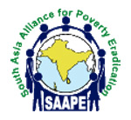
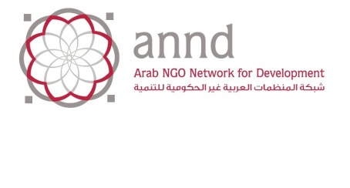
Co-organisers:

33 in Africa, 1 in the Caribbean, 9 in Asia and 5 in the Pacific - Afghanistan, Angola, Bangladesh, Benin, Bhutan, Burkina Faso, Burundi, Cambodia, Central African Republic, Chad, Comoros, Democratic Republic of Congo, Djibouti, Equatorial Guinea, Eritrea, Ethiopia, Gambia, Guinea, Guinea Bissau, Haiti, Lao PDR, Kiribati, Lesotho, Liberia, Madagascar, Malawi, Mali, Mauritania, Mozambique, Myanmar, Nepal, Niger, Rwanda, Samoa, Sao Tome and Principe, Senegal, Sierra Leone, Solomon Islands, Somalia, Sudan, Timor-Leste, Togo, Tuvalu, Uganda, United Republic of Tanzania, Vanuatu, Yemen, Zambia.

