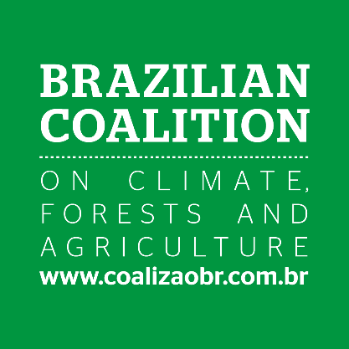

SAVE THE DATE

The role of Brazil, agriculture and forestry in the Paris Agreement agenda
At COP 22 – Marrakesh
Thu, 17 Nov 2016, 16:45-18:15
Room: Bering (150) - Blue Zone .
Host: Brazilian Coalition on Climate, Forests and Agriculture

The Paris Agreement entered into force. Now what? How can Brazil implement, cooperate, share knowledge and experiences with other strategic players?
The challenge of implementing the NDC seems even more relevant for those countries with a large forest asset. Brazil stands out as an important player and has the great task of discussing how it will implement its goals.
For this, the Brazilian Coalition on Climate, Forests and Agriculture built a forum for discussion and co-creation among the key players of Brazilian society - civil society, private sector, academia and financial sector - to make the transition to a low-carbon economy, that contemplates solutions and investment in opportunities for sustainable agriculture and forestry. Thus, this side event aims to bring together decision and opinion makers from countries that are key in these fields in order to learn and share experiences about the political, technical and financial aspects of the Paris Agreement implementation agenda.

About the Brazilian Coalition
The Brazilian Coalition on Climate, Forests and Agriculture is a multi-sector movement established to propose initiatives and influence public policies that lead to the development of a low-carbon economy by creating decent jobs, encouraging innovation, Brazil’s global competitiveness and generating and distributing wealth across society. Over 150 companies, business associations, research centers and civil society organizations have already joined The Brazilian Coalition - coalizaobr.com.br/en.

