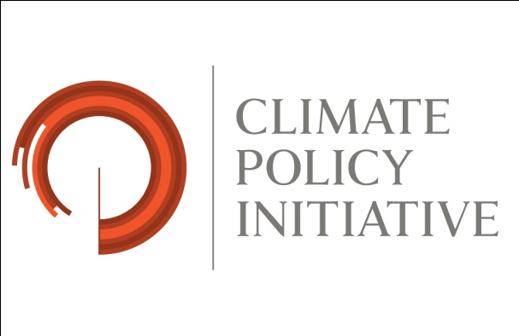
Tracking Emissions and Mitigation Actions:
Learning from National Practice

Side event at UNFCCC conference in Bonn
24 May, 2012
18:15-19:45
Room SOLAR (MoE)

As nations take on ambitious climate mitigation goals, they need good information on their emissions and the performance of their mitigation policies and measures. Domestic systems to measure, report, and verify (MRV) emissions and mitigation actions help countries achieve their goals more efficiently and effectively, by giving policymakers and stakeholders feedback on progress, identifying which policies and measures are working well, and signaling emerging challenges and opportunities for improvement.

Climate Policy Initiative (CPI) is hosting a discussion on national MRV systems for emissions and mitigation actions. The discussion will address current practices in several developed and developing countries, priorities for improving national MRV systems, and initiatives to facilitate cross-country learning. CPI will present the initial results of its survey and evaluation of MRV systems in China, Germany, Italy, and the United States, while MRV experts from South Africa, the U.S., and China will reflect on latest developments and emerging needs and opportunities to improve these systems.

Moderator:
Kath Rowley, Director, Climate Policy Initiative San Francisco

Speakers:
Julia Zuckerman, Analyst, Climate Policy Initiative San Francisco
Brian Mantlana, Policy Advisor, Department of Environmental Affairs South Africa
Bill Irving, Chief, Climate Policy Branch, U.S. EPA
Teng Fei, Associate Professor, Tsinghua University, China (TBC)

Refreshments will be served following the event.

