CALL FOR APPLICATIONS  Climate Justice Feminist Participatory Action Research (CJ FPAR) 2017-2018!  Application deadline: 13 November 2016  APWLD’s CJ FPAR sub-grant programme aims to support grassroots communities to advance participatory democratic rights of women affected by climate change and change systems and structures responsible for marginalisation.  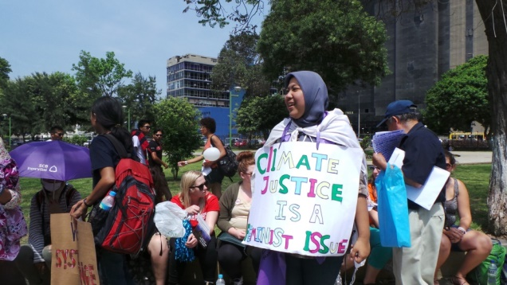  APWLD believes that empowering women and supporting women’s local movements are essential to both gender equality and just responses to climate change. It is critical that women affected by climate change are able to collectively understand, document, discuss the impacts and design their own solutions. The CJ FPAR programme builds the capacity of local women to monitor, engage and influence climate policies that affect them.  Selected organisations will have to appoint two researchers who will take part in the programme: one mentor and one young woman researcher. The CJ FPAR programme provides a grant of about USD 10,000 to contribute to the salary of the young woman researcher and carry out research activities with the community. Both the mentor and the young woman research will be introduced to human rights-based approaches to climate change, feminist participatory action research methods, and advocacy and campaigning tools. They will learn about the existing international human rights standards, including the status of climate negotiations and rights-based approaches.  “This research has enriched my knowledge and experience, in particularly through the discussions in relation to the situation and experiences of women. How my situation and experience as a single parent (which used to get negative stigma from the society) then becoming the experience for me on how to strengthen myself and made me able to strengthen other women. Thus community women can see that even a single parent can fight for her rights.”  - Margaretha Winda Febiana Karotina, community researcher from Philippines  Theme of the Action Research  Priority will be given to research projects focusing on displaced communities or communities facing the treats of displacement due to climate change. Climate Displacement includes (but not limited to):  - Displacement caused by natural disasters (floods, typhoons, etc.);  - Displacement caused by slow onset impacts (droughts, sea level rise, salinisation of soil, etc.);  - Displacement programmes/projects that relate to climate change (implementation of market-based mechanisms programmes such as REDD+, fossil fuel exploitation projects such as coal mining, fracking, etc.).  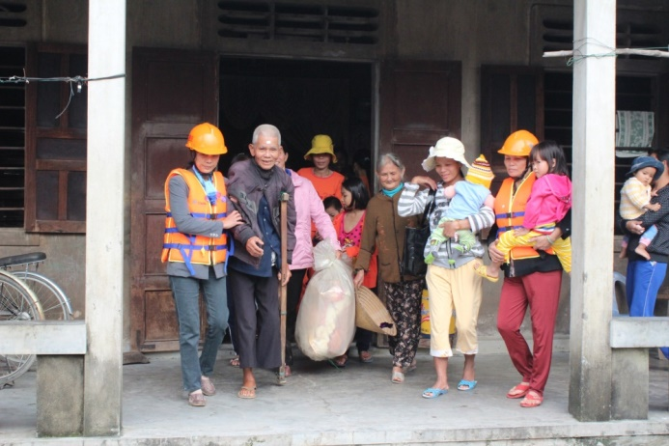  Selection Criteria  Applications must come from grassroots women’s rights organisations in Asia and the Pacific. Individuals applications won’t be considered for the programme;  The organization applying must work directly with the local women in the community level; either the young researcher or the mentor must come from the community in which the action research will take place;  Commit to conduct the 1.5 years action research programme from January 2017 to June 2018.  How to apply  Download the application form from www.apwld.org and if you have any questions email Camille at camille@apwld.org. |  | CALL FOR APPLICATIONS  Climate Justice Feminist Participatory Action Research (CJ FPAR) 2017-2018!  Application deadline: 13 November 2016  APWLD’s CJ FPAR sub-grant programme aims to support grassroots communities to advance participatory democratic rights of women affected by climate change and change systems and structures responsible for marginalisation.  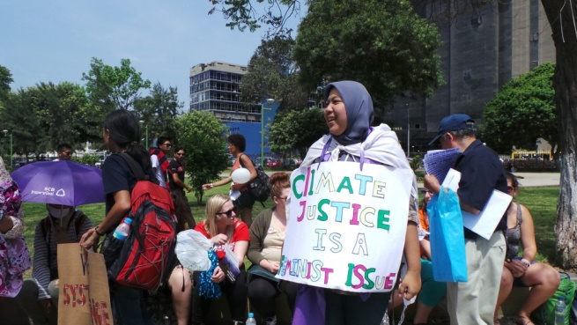  APWLD believes that empowering women and supporting women’s local movements are essential to both gender equality and just responses to climate change. It is critical that women affected by climate change are able to collectively understand, document, discuss the impacts and design their own solutions. The CJ FPAR programme builds the capacity of local women to monitor, engage and influence climate policies that affect them.  Selected organisations will have to appoint two researchers who will take part in the programme: one mentor and one young woman researcher. The CJ FPAR programme provides a grant of about USD 10,000 to contribute to the salary of the young woman researcher and carry out research activities with the community. Both the mentor and the young woman research will be introduced to human rights-based approaches to climate change, feminist participatory action research methods, and advocacy and campaigning tools. They will learn about the existing international human rights standards, including the status of climate negotiations and rights-based approaches.  “This research has enriched my knowledge and experience, in particularly through the discussions in relation to the situation and experiences of women. How my situation and experience as a single parent (which used to get negative stigma from the society) then becoming the experience for me on how to strengthen myself and made me able to strengthen other women. Thus community women can see that even a single parent can fight for her rights.”  - Margaretha Winda Febiana Karotina, community researcher from Philippines  Theme of the Action Research  Priority will be given to research projects focusing on displaced communities or communities facing the treats of displacement due to climate change. Climate Displacement includes (but not limited to):  - Displacement caused by natural disasters (floods, typhoons, etc.);  - Displacement caused by slow onset impacts (droughts, sea level rise, salinisation of soil, etc.);  - Displacement programmes/projects that relate to climate change (implementation of market-based mechanisms programmes such as REDD+, fossil fuel exploitation projects such as coal mining, fracking, etc.).  Selection Criteria  Applications must come from grassroots women’s rights organisations in Asia and the Pacific. Individuals applications won’t be considered for the programme;  The organization applying must work directly with the local women in the community level; either the young researcher or the mentor must come from the community in which the action research will take place;  Commit to conduct the 1.5 years action research programme from January 2017 to June 2018.  How to apply  Download the application form from www.apwld.org and if you have any questions email Camille at camille@apwld.org.

