Sustainability Research Institute
SCHOOL OF EARTH AND ENVIRONMENT
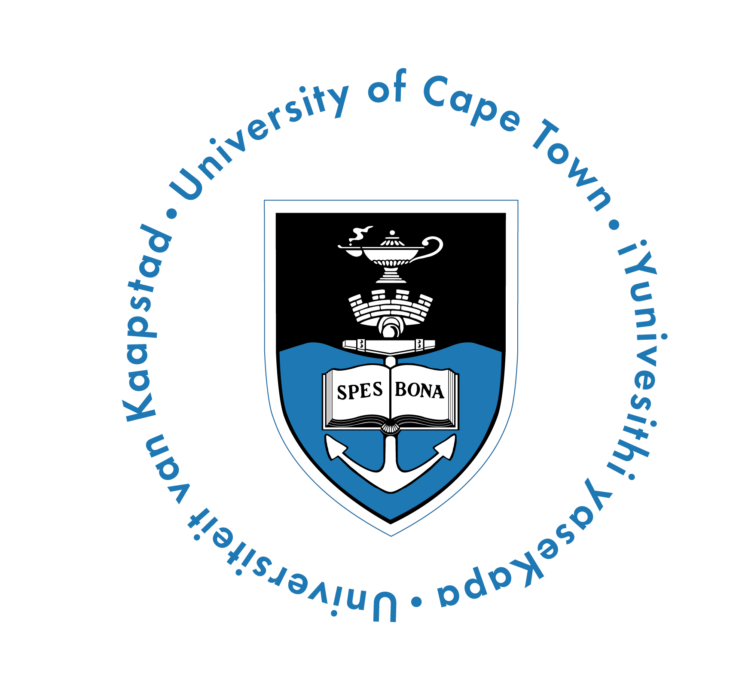
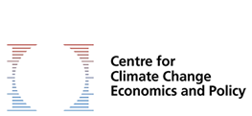
Policy Brief (COP22) - November 2016

What does loss and damage mean to youth in informal settlements of Cape Town, South Africa?

Phellecitus Montana, Susannah M. Sallu, Harriet Thew (University of Leeds)
& Gina Ziervogel (University of Cape Town).
INTRODUCTION
Climate change is causing loss and damage (L&D) to those who are unable to adapt to its impacts. Marginalised groups in society are particularly vulnerable. Much of the L&D they experience is non-material and often difficult to document and measure. Non-material elements of life (e.g. culture, agency, health, social relations) are not traded within markets and thus remain neglected within climate change negotiations¹. While the UNFCCC remains inconclusive on approaches to address L&D, this brief communicates the outcomes of a study that explored how youth in informal settlements of Cape Town, South Africa experience and articulate non-material L&D in relation to flood risk. A recent study from the University of Leeds offers empirical evidence of how L&D is experienced by youth, shedding light upon an understudied, vulnerable group whose engagement is vital for transformative adaptation and sustainable development.
SCOPE OF STUDY
The City of Cape Town experiences regular flooding which climate change projections indicate will increase in frequency and magnitude. Informal settlements are particularly vulnerable due to the poor quality of housing and their location on inadequately drained marginal land. Two flood-prone settlements, Philippi and Khayelitsha, on the outskirts of Cape Town, were studied. Characterized by high levels of poverty, unemployment, crime, poor health conditions and a plethora of complex societal issues, residents face a myriad of daily difficulties which are being further exacerbated by climate variability and for which they have limited adaptive capacity to respond to.

Youth within these settlements are especially vulnerable due to their exclusion from local level decision-making processes, lack of employment opportunities and negative stereotypes which diminish intergenerational cohesion. This research shows that youth suffer from forms of L&D which are unique to their generation, highlighting the need for age (and gender)-sensitive climate change policies and programmes.

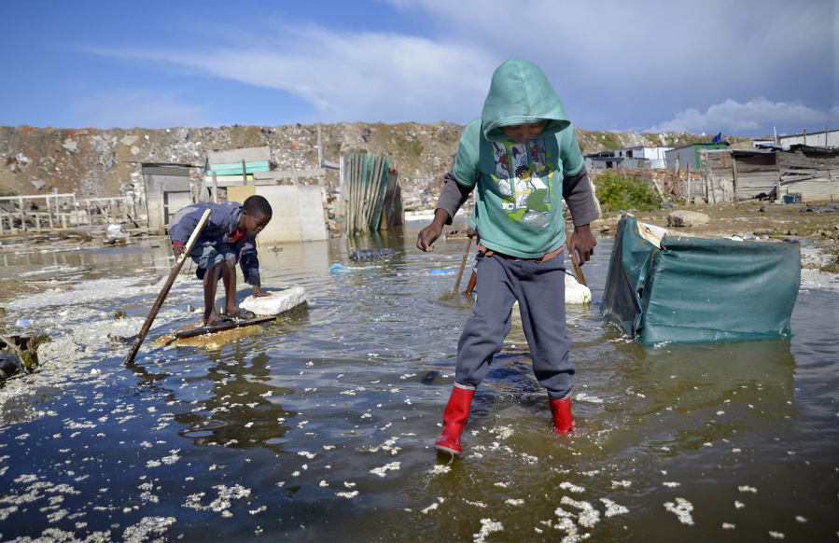

Photo byː Armand Hough, 2014
“Every time it rains, I worry… even if it’s just a few drops”

(Young female from Philippi, Cape Town, 2016).

Contact: Phellecitus Montana, tmntana@gmail.com; Harriet Thew: h.thew@leeds.ac.uk; Dr. Susannah M. Sallu: s .sallu@leeds.ac.uk
Acknowledgements: This work was inspired by and forms part of the ‘Non-economic loss and Damage from climate change’ project led by Petra Tschakert, funded by the World Universities Network and University of Western Australia. Empirical research was funded by The University of Leeds.

FINDINGS
- Climate change is projected to increase flooding in Cape Town, which will amplify the challenges faced by youth in its informal settlements. However, they are largely unaware of this looming challenge and, as such, autonomous adaptation appears unlikely (even if capacity were sufficient to enable this to happen).
- Youth in this context are already experiencing Loss and Damage, with psychological, physical and social implications which appear to be particularly pertinent and possibly unique to their age group.
Psychological impacts include worry, hopelessness and resignation which emanate from the hardships faced within the settlements and the inability to adapt or be adequately supported during times of severe flooding.
Physical impacts: Housing plays a central role in youth transitions to adulthood and, as such, is central to identity creation, social status and independence. A strong desire for independence places youth at increased risk, often compelling them to accept the poorest quality housing in the least developed and most flood-prone parts of the settlement. As these areas are often illegal to settle in, they are ineligible for adaptation and development funding, forcing youth to live beyond the limits of adaptation. Young mothers and their children are particularly vulnerable as their age intersects with their gender, race and class, exacerbating their vulnerability as climate change increasingly infringes upon their human rights. Reduced mobility during flooding affects both their security and dignity, particularly in relation to access to sanitation facilities during floods.
Social impacts include diminished community cohesion, as individuals, fighting for their own survival (and often separated from their families as a result of urban migration) lack the capacity to support one another during times of crisis. This increases perceptions of racial and intergenerational inequity, compounding South Africa’s historic political and racial tensions.
Ability/capacity to change living circumstances: inability to adapt housing and improve overall living conditions due to high rates of poverty and unemployment.
Identity/Self-image: youth face trade-offs as they are forced to choose between achieving independence, which they value highly and suffering damage from flood risk. This affects how they view themselves and damages their relationship with ‘place’ which is important to their identity. This –is a form of solastalgia⁴ (existential distress caused by environmental change).
Time and productivity: inability to continue with day-to-day activities in the event of floods particularly those providing income, empowerment or enhancing well-being, affecting youth development.
Institutional trust: there was a lack of trust in the ability of governmental institutions to change circumstances, particularly related to how impacts from flooding might be addressed.
Play: impact on children and on their young parents from the inability to play freely within polluted environment also contributes to solastalgia and infringes upon children’s human rights to a safe environment.

- Youth in these settlements are already experiencing climate change induced damage in ways which are unique to their generation.
- Presently, incidents of damage are more prominent among youth than losses. However, with insufficient adaptive capacity, these damages which are theoretically repairable are likely to become permanent losses over time.

Figure 1: Non-material L&D among youth
in informal settlements of Cape Town, South Africa

SUMMARY
Youth in informal settlements experience L&D from climate change which cannot be expressed in economic terms. This study demonstrates that youth experiences of L&D are unique to their generation and heavily context dependent. Further research is needed, particularly in hard-to reach contexts such as informal settlements, with age and gender disaggregated data to ensure that timely, targeted support is delivered to those most vulnerable to, and least responsible for climate change.

RECOMMENDATIONS FOR POLICY-MAKERS
- Ensure that policy responses to L&D address non-material impacts in addition to market-based assessments to avoid further exacerbating vulnerability.
- Engage with empirical research to ensure that context-dependent circumstances are given due attention, with particular efforts to reach marginal communities.
- Ensure that age and gender disaggregated data is utilised to ensure that policies are sensitive to the unique vulnerabilities of different groups, with a particular focus on youth who are often overlooked.
- Fully integrate youth participation, awareness-raising and the other elements of Article 6 of the UNFCCC Convention into adaptation planning to increase adaptive capacity and ameliorate intergenerational equity and social cohesion.
- Increase policy-cohesion between climate change and development initiatives, as basic socio-economic development is central to supporting capacity to respond to climate and other stressors.

Sources
1. Serdeczny, O., Waters, E. and Chan, S. 2016. Non-economic loss and damage in the context of climate change: understanding the challenges. German Development Institute/Deutsches Institut für Entwicklungspolitik (DIE).
2. Ziervogel, G.and Smit, W. 2009. Learning to swim: Strengthening flooding governance in the city of Cape Town. In: Working Paper presented at 2009 Amsterdam Conference on the Human Dimensions of Global Environmental Change ‘Earth System Governance: People, Places and the Planet’. Amsterdam.
3. Mudombi, S., Nzeyimana, E. and Weisheit, A. 2011. A Youth Perspective on Climate Change Opportunities And Challenges For Climate Resilient Development Ethopia: Young Professionals’ Platform for Agricultural Research for Development (YPARD)
4. Tschakert, P. et al. In prep, 2016. Understanding loss from climate change through the lens of lived values. World Universities Network, pp.13

