Bonn climate change conference, May 2016
“How is the role of ethics and human awareness critical to climate change solutions?”

On Saturday, 21 May 2016 Brahma Kumaris World Spiritual University, World Council of Churches and Quaker United Nations office hold a Panel that quite well attended, 28 people came to the event. The side event was entitled: “How is the role of ethics and human awareness critical to climate change solutions?”
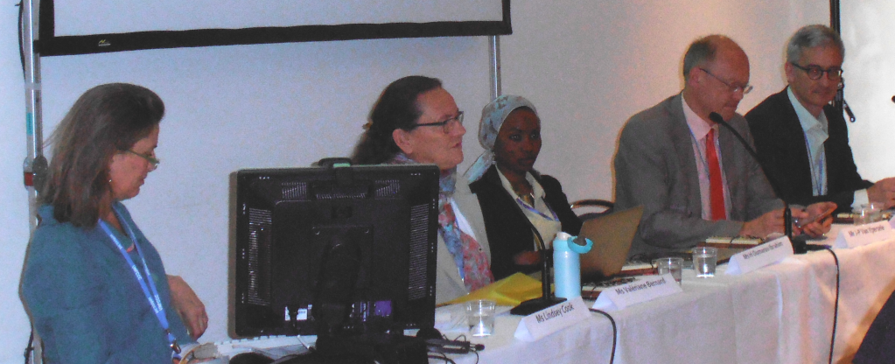
The speakers were : Maria Laura Vallejo, Colombia delegation; Jean-Pascal van Ypersele, co-writer of IPCC reports; Hindou Oumarou Ibrahim, Executive committee of Indigenous Peoples of Africa (IPACC); Jacob Werksman, Principal Adviser, Directorate-General for Climate Action; Valeriane Bernard, Brahma Kumaris; and it was moderated by Lindsey Cook, UN Representative Quaker;
Lindsey Cook from Quakers UN office started by reading the title the title and the description of the side event “ How is the role of ethics and human awareness critical to climate change solutions? A shift in awareness in needed to change behavior and lifestyles to foster low emissions and climate resilient sustainable development“ and asked the panelists How does this speak to you? She then added: The question is also: How do we want to live? Ethics is about a choice – about how we want to live. Let your life speak. She then explained that Quakers see Climate Change as a symptom of a greater challenge.
Valeriane Bernard from Brahma Kumaris reminded the audience that there are 2 major scientific UN organizations that have looked at climate change and ethics : The IPCC in chapter 3, and she sited “Ethics involves questions of justice and value. Justice is concerned with equity and fairness, and, in general, with the rights to which people are entitled” and UNESCO.
Climate Change is something that is totally related to the ethical choices we have made and go on making as a spicy. We all know that the current lifestyle of humanity is the internal motor of climate change crisis, and causes the carbon foot print to be is what it is. She then added that in order to create ethically appropriate choices we need to give ourselves healthy space to reflect and aline with our inner personal ethics and values… One needs to make time for one’s own awareness… Call it meditation or contemplation
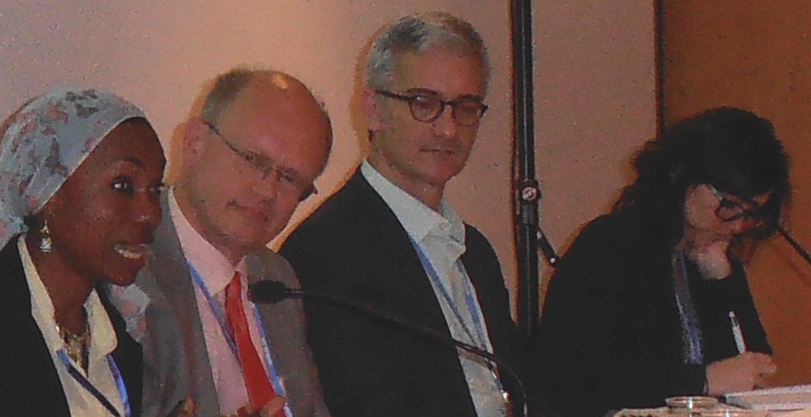
Oumarou Ibrahim (indigenous peoples of Africa): Climate Change for me coming from the village, UNFCCC and the processes here, looks like a machine. This panel/ event is the best one because it is on a human level, talking on rights for all For us indigenous peoples when something takes away the trees, animals, land, etc. for us it is like we are not existing anymore, because this is our home.
There is something wrong in the imaginations of countries... for us the social issues are what we are about – our life.
My realization when speaking in New York for the Presidential meeting was when sitting together with the “guy who were presidents”,and me being an indigenous women, having been given the chance to speak in New York, being not known to anyone,….but still sitting with all of them together, I realized we are all human beings….state representatives do not have three eyes or five hand, we are all the same….they had to prepare like I did before speaking to the people…
Van Yperdele: Started off his studies wanting to be an astronomer, then he told himself earth was also a planet and climate change was worth studying.
There is a double injustice, those who do not have much responsibility for climate change are the most affected by it, so taking this into account, climate equity is essential,
Jacob Werksman (UNFCCC): This event now, is an opportunity to speak as human beings and not as negotiators. What can we do as individuals, how urgently can we act, …how effectively? On a personal level, for example I´ve chosen not to own a car, not to eat meat, and to be a negotiator in this climate conferences. This personal choses are helping, but cannot have effect/ influence a larger group.
All the important things have been only included into the preamble, which reflects the thoughts behind it, the fact that it has not been gone into the text!
Maria Vallejo (Columbian delegation): I also am one of those who try to speak more in a human way I was completely shocked how simple conversations and decisions can be discussed in such a complicated way when I came to work here. What do ethics mean for me? What is it that is un- negotiable, and what is negotiable?
Being aware of what I do on a personal level, has an impact – somebody sometime notices what you do or say and starts to change his live.. Ethics is about caring – to understand how everything is connected and, so it is about being aware on your surroundingOne of the most important thing of the Paris agreement, is it is now very clear what the information is about,… how vulnerable some countries are etc. And it is then up to me/ us what we decide about what I´m doing with this information…
After each panelist shared his and her presentation, there was a few questions on human rights and climate change as well as question on climate change and traditional indigenous knowledge. And some conversation regarding ethics in the climate change conversation

