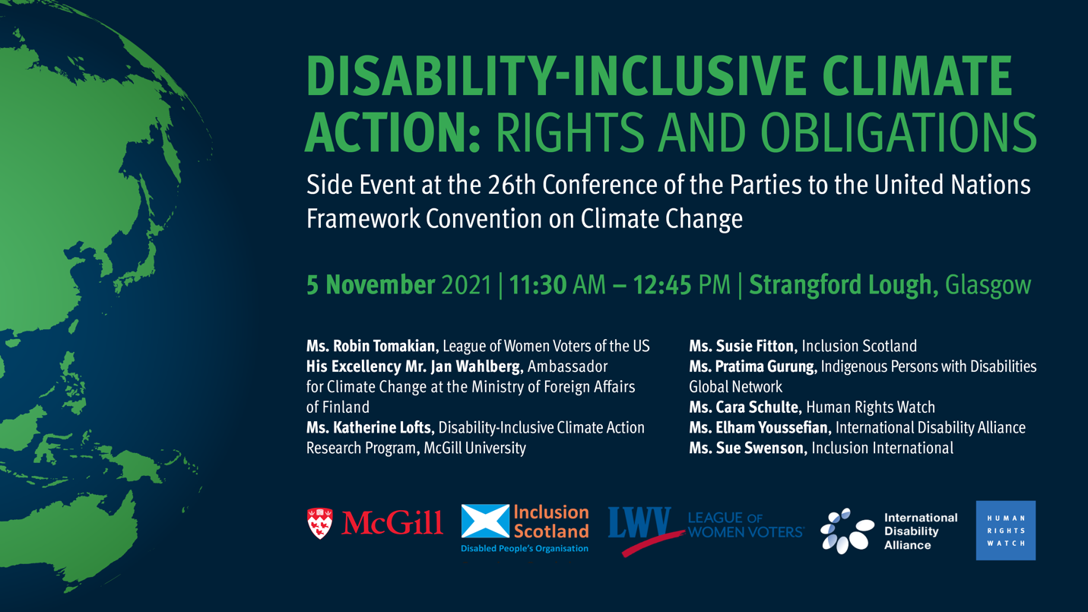

Title: Disability-Inclusive Climate Action: Rights and Obligations.
Description: Side Event at the 26th Conference of the Parties to the United Nations Framework Convention on Climate Change.
When? – 5 November 2021, from 11:30 AM through 12:45 PM, Greenwich Mean Time
Where? – Strangford Lough, Glasgow

Participants:
Ms. Robin Tomakian, League of Women Voters of the US
His Excellency Mr. Jan Wahlberg, Ambassador for Climate Change at the Ministry of Foreign Affairs of Finland
Ms. Katherine Lofts, Disability-Inclusive Climate Action Research Program, McGill University
Ms. Susie Fitton – Inclusion Scotland
Ms. Pratima Gurung – Indigenous Persons with Disabilities Global Network
Ms. Cara Schulte – Human Rights Watch
Ms. Elham Youssefian – International Disability Alliance
Ms. Sue Swenson – Inclusion International

Sponsor’s logos:
McGill University,
Inclusion Scotland,
League of Women Voters,
International Disability Alliance,
Human Rights Watch

