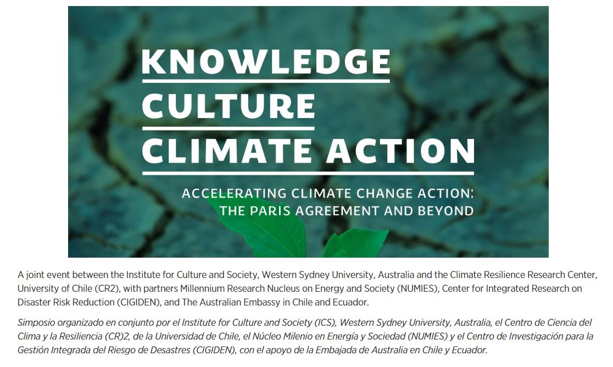
Date: 2-3 December, 2019
Venue: Enrique D’etigny Auditorium, Beaucheff 851 Building (Engineering Faculty). Universidad de Chile, Santiago.
Language: English and Spanish (simultaneous translation available)
Knowledge, Culture, Climate Action website
https://www.westernsydney.edu.au/ics/events/knowledge_culture_series/climate_action_2019
Live stream - Youtube
Monday 2nd December 2019
https://www.youtube.com/results?search_query=Acelerando+la+acci%C3%B3n+ante+el+cambio+clim%C3%A1tico%3A+M%C3%A1s+all%C3%A1+del+acuerdo+de+Paris
Tuesday 3rd December 2019
https://www.youtube.com/watch?v=Cw9Bi7Yl9Zk

