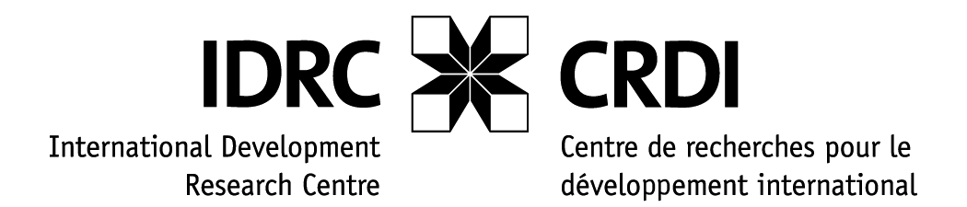**IDRC-START official COP 17 side event:**

**Building the knowledge base for African adaptation choices**

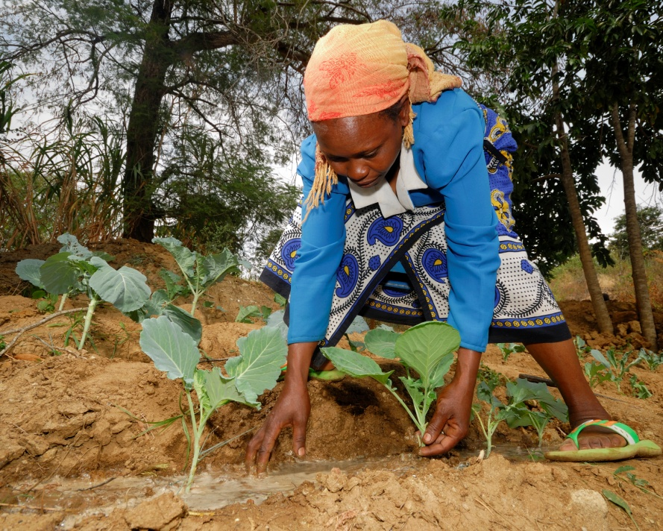Africa’s pressing adaptation needs demand evidence-based responses. Join us for lessons from the **Climate Change Adaptation in Africa** program**,** the **African Climate Change Fellowship Program**, **AfricaAdapt**, and some of our newest effortsas we share successes and challenges in linking adaptation research to decision-making.

Photo: IDRC/Thomas Omondi

**Please join us:**

***Thursday, December 1, 20:15 – 21:45, Levubu River Room, Durban Exhibition Centre***

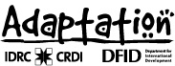 

**Background:**

Since its launch in 2006, the Climate Change Adaptation in Africa (CCAA) program[1] has supported 46 adaptation research and capacity building projects in 33 countries. These projects generated substantial new knowledge on options to reduce vulnerability in a range of contexts.

Among the additional layers of support the program provided for knowledge building and sharing were the African Climate Change Fellowship Program (ACCFP), led originally by START, and the AfricaAdapt network, led in its first phase by the Institute of Development Studies. As CCAA concludes, these two key initiatives have been extended for a second phase under African leadership. AfricaAdapt is now led by ENDA-Tiers Monde, and the ACCFP by the Institute of Resource Assessment at the University of Dar es Salaam. In 2010, the International Development Research Centre also announced funding for a new research-to-policy initiative to be led by the West and Central African Council for Agricultural Research and Development (WECARD/ CORAF).

In this panel, we present key lessons from early phases of the ACCFP and AfricaAdapt and their latest directions; we introduce WECARD’s plans for synthesizing and sharing research-based evidence on adaptation to inform decisions; and we welcome audience input on approaches to maximize the contribution of these latest efforts.

**Speakers:**

1. *Dr. Fatima Denton, Program Leader, Climate Change Adaptation in Africa, International Development Research Centre*

**CCAA contributions to building adaptive knowledge**

1. *Dr. Felix Olorunfemi, former ACCFP Policy Fellow Alumnus and Research Fellow from the Nigerian Institute of Social and Economic Research*

**Reflections from an African Climate Change Fellow**

1. *Dr Chipo Mubaya, Institute of Resource Assessment, Senior Program Officer for the ACCFP Secretariat and ACCFP Doctoral Fellow Alumna*

**Phase Two of the African Climate Change Fellowships Program**

1. *Moussa Na Abou Mamouda, ENDA – Tiers Monde, Network Coordinator, AfricaAdapt*

**Sharing knowledge through networking – Building on the AfricaAdapt experience**

1. *Dr. Abdulai Jalloh, West and Central African Council for Agricultural Research and Development*

**Introducing a new research-to-policy platform on adaptation and agriculture in Africa**

1. The Climate Change Adaptation in Africa (CCAA) research and capacity development program is jointly funded by IDRC and the United Kingdom’s Department for International Development (DFID).