***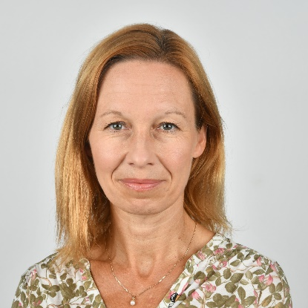*Participant Biographies**

***Moderator for the Event:* Ms. Megan Rowling** is a climate correspondent and editor for the Thomson Reuters Foundation (TRF), based in Barcelona but with an international beat. She runs a small team of reporters covering the ins and outs of securing a green and just transition to a decarbonised world, especially in developing countries. She has worked on topics ranging from finance to humanitarian news throughout her career as a journalist, with stints at Reuters and the BBC. She started TRF's climate change file more than 15 years ago and is always seeking ways to highlight the injustices of the climate crisis and solutions that leave no one behind.

***Opening Session:***

***UN Office for the Coordination of Humanitarian Affairs***

**Ms. Heli Uusikyla** is the Deputy Director in OCHA Operations and Advocacy Division in New York.  Over the last 23 years, she has held numerous management and leadership positions with UNRWA, UNDP and WFP in several countries including oPt/Gaza, Somalia/Kenya, Bangladesh, Syria, Jordan and Lebanon. Prior to her OCHA NY HQ assignment, she served as OCHA’s Head of Office in South Sudan, Pakistan and Syria. Heli is a Finnish national with post graduate degrees in Social Sciences from University of Turku and University of Helsinki, Finland.

***Food and Agriculture Organization***

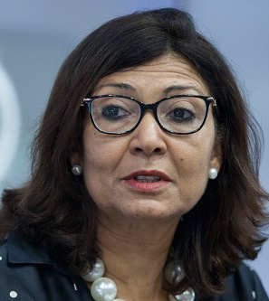**Ms. Maria Helena Semedo**, Deputy Director-General for the Food and Agriculture Organization, is an economist and politician from Cape Verde. A leading expert in global development issues, she has worked in public service for over thirty years. Over the last decade, FAO has helped shape a new global narrative where agriculture is prominently recognized as a solution in addressing increasingly complex emerging issues – from transforming food systems to dealing with climate change. As part of the FAO Core Leadership Team, Semedo works to develop impactful initiatives such as the FAO Green Cities Action Programme and the corporate strategy for mainstreaming biodiversity across agricultural sectors, fostering multi-stakeholder dialogues that optimize the Organization’s 75 years of technical expertise and experience, its global reach and innovative approaches, all contributing to achieve the Sustainable Development Goals. Before taking up her current duties in 2013, Ms Semedo gained valuable experience and insight in Africa, first as FAO Representative in Niger, then as Deputy Regional Representative for Africa and Sub-regional Coordinator for West Africa. Prior to her international career, she worked as an economist for the Cabo Verde Ministry of Planning and Cooperation before becoming Secretary of State for Fisheries, then in 1993 Minister for Fisheries, Agriculture and Rural Affairs – the first-ever woman Minister in her country. After serving as Minister for Tourism, Transportation and Marine Affairs from 1995-1998, she became Member of Parliament, a position she held until 2003.

***Panel of Government Partners***

***Government of Kenya***

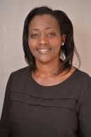H.E. the Honorable Roselinda Soipan Tuya, Cabinet Minister for Environment and Forestry. Roslinda Soipan Tuya is a Kenyan politician and former women representative for Narok county. He was recently nominated to be the new cabinet secretary for Environment and Forestry by President William Ruto.

She has worked in different capacities for various government and civil society organizations, including the United States Agency for International Development (USAID), Kituo cha Sheria and the former Ministry of Justice and Constitutional Affairs, as a United Nations Volunteer Specialist.

Hon. Soipan holds a Degree in Law from the University of Nairobi (2002) and later earned her Master of Law (LLM) in International Sustainable Development from the University of Washington, USA. In 2010.

***United Arab Emirates***

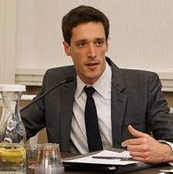**Mr. Dane McQueen** is the Director of Programs and Partnerships for COP28 UAE, in the Office of the Special Envoy for Climate Change. He has been with the UAE Ministry of Foreign Affairs and International Cooperation for a decade, establishing humanitarian and development partnerships in New York and setting up the ministry's energy and sustainability division and renewable energy development assistance programs in Abu Dhabi. Previously he worked at the OECD and in the hydrocarbon industry on project development. He studied at Cambridge, Berkeley, and Yale.

***African Development Bank***

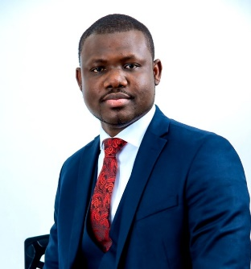**Dr. Olufunso Somorin** is a Regional Principal Officer at the African Development Bank. He leads the Bank’s work on climate change and green growth in the 13 countries of the Bank’s East African region. This includes supporting countries’ access to climate finance for implementing their climate actions, and mainstreaming climate change in all Bank policies and programs. He also leads policy dialogues with national/regional governments on developing policy frameworks for managing local/regional economic and social issues, climate change, renewable energy, resilience and inclusive growth.

Between 2013 and 2017, he coordinated the Bank’s work on addressing fragility and building resilience within the Horn of Africa. In the last 10 years, he has been directly involved in the design, appraisal, and supervision of more than 180 development projects worth about USD 16.4 billion. Somorin holds a PhD in International Environmental Policy from Wageningen University, the Netherlands. He is an alumnus of executive education from Bradford, Cambridge and Oxford Universities in the UK.

***Panel of Practitioners***

***International Centre for Climate Change and Development***

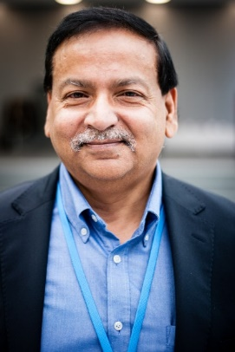**Prof. Saleemul Huq** is the Director of the International Centre for Climate Change and Development (ICCCAD) and Professor at the Independent University Bangladesh (IUB) as well as Associate of the International Institute on Environment and Development (IIED) in the United Kingdom as well as the Chair of the Expert Advisory Group for the Climate Vulnerable Forum (CVF) and also Senior Adviser on Locally Led Adaptation with Global Centre on Adaptation (GCA) headquartered in the Netherlands. He is an expert in adaptation to climate change in the most Vulnerable developing countries and has been a lead author of the third , fourth and fifth assessment reports of the Intergovernmental Panel on Climate Change (IPCC) and he also advises the Least Developed Countries (LDC) group in the United Nations Framework Convention on Climate Change (UNFCCC).

He has published hundreds of scientific as well as popular articles and was recognised as one of the top twenty global influencers on climate change policy in 2019 and top scientist from Bangladesh on climate change science.

***Intergovernmental Panel on Climate Change***

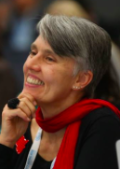**Prof. Debra Roberts is a co-chair of the IPCC Panel** and holds a PhD in urban biogeography and is currently head of the Sustainable and Resilient City Initiatives Unit in eThekwini Municipality (Durban, South Africa). She was a lead author of Chapter 8 (Urban Areas) and a contributing author to Chapter 12 (Africa) of Working Group II’s contribution to the Fifth Assessment Report of the Intergovernmental Panel on Climate Change (IPCC).

She was elected Co-Chair of Working Group II in 2015. Under her co-leadership Working Group II published the IPCC Special Report on Ocean and the Cryosphere in a Changing Climate (SROCC) in 2019 and contributed to the Special Reports on “Climate Change and Land” and “Global warming of 1.5°C in 2018. She was a member of the Scientific Steering Committee of the IPCC co-sponsored International Conference on Climate Change and Cities in 2018 and IPCC-IPBES co-sponsored workshop on “Biodiversity and Climate Change” in 2020. Prof Roberts co-led the Scientific Steering Committees of the IPCC-UNHabitat-GCom co-sponsored Innovate for Cities Conference and the IPCC-ICOMOS- UNESCO international co-sponsored meeting on Culture, Heritage and Climate Change, both held in 2021.

***Candlelight Somalia***

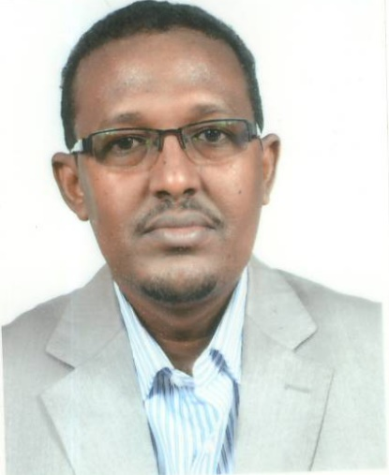**Mr. Abdirizak Bashir Libah** is the CEO of Candlelight Somalia and has served the organization for over 20 years.

Candlelight is a local humanitarian and development organization that operates across Somaliland, Somalia, Kenya, and Ethiopia.

He is currently preparing his second master’s degree in Environmental Planning and Management. Throughout his career, Mr. Libah has taken on different roles, working his way to becoming Chief Executive Officer. Throughout his time at Candlelight, he has managed, coordinated and implemented both humanitarian and development programming in Somalia.

***World Food Programme***

**Ms. Sibi Lawson-Marriott** is the Senior Regional Adviser and Team Leader for the Food Systems team at the World Food Programme’s Regional Bureau For the past twenty years, Sibi has been providing support to national governments and United Nations agencies in the areas of humanitarian and development action, innovative programme design and strategic partnerships. Currently, she is the Senior Regional Adviser and Team Leader for the Food Systems team of the World Food Programme’s Regional Bureau. In this capacity, she leads a team that covers issues of climate risk management, livelihood support, resilience-building, environmental sustainability and gender transformative programming in the eight countries that make up the region. Prior to this position, Sibi’s assignments included Head of Programme for the WFP Ethiopia Country Office, Adviser to UNICEF’s Emergency Operations Division and Deputy Country Director of the WFP Ghana Country Office. She spent several years working in the UN headquarters in New York, managing external relations for some of WFP’s most complex and challenging portfolios, including Sudan, the DRC and Somalia. Sibi is a national of Benin.

***UNICEF***

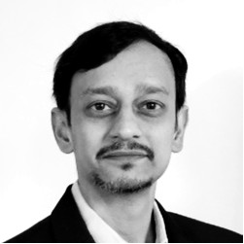**Mr. Gautam Narasimham** is the Global Lead for Climate Change, Energy, and the Environment at the United Nations Children’s Fund (UNICEF).  He works with a talented team to shape and advance UNICEF’s global agenda on these issues in the over 190 countries and territories where UNICEF works.  This involves the development of programmes and policies, providing guidance to country and regional offices, developing strategic partnerships, and representing UNICEF at the United Nations and other fora.  Gautam’s previous roles include environmental engineering, management, and financial due diligence in the United States and India, managing a global portfolio of climate change products for an energy company whilst based in London, and supporting governments in Afghanistan and the Republic of Georgia on energy policy. His academic background includes chemical and environmental engineering, public policy, and business administration.

**Closing Session:**

***UNHCR***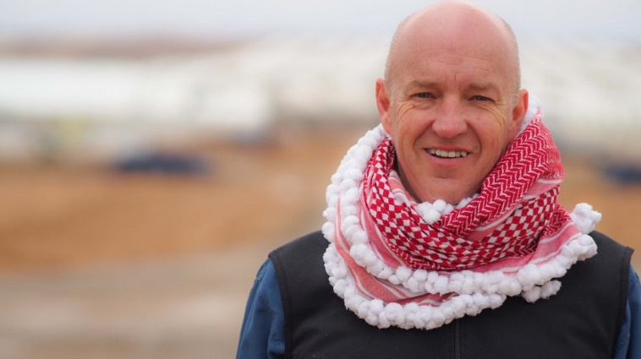

**Mr. Andrew Harper** is the Special Advisor on Climate Action to the United Nations High Commissioner for Refugees (UNHCR) in Geneva. He is responsible for providing strategic guidance, oversight and expertise to shape UNHCR's response to the climate emergency. Prior to his current tasks, he was the Director of the Division of Programme Support & Management (DPSM), where he oversaw programme policy, planning and management, as well as technical support to field operations.

Andrew has led the Innovation Service in UNHCR and was responsible for leading and coordinating the international response to the Syrian Crisis in Jordan. Some of the main achievements included responding to, at the time, the largest refugee crisis in the world, the establishment of the Zaatari and Azraq refugee camps, introducing biometric registration and linking that to the world’s largest biometric based refugee cash assistance programme.

Andrew also served as the Head of Desk for UNHCR, covering the Iraq Situation, as well as the Emergency Focal Point for the Middle East and North Africa region for the Libyan Crisis.

He has previously worked in various field locations with UNHCR, OCHA and the Australian Embassy, including Central and Southeast Asia, the Western Balkans, Islamic Republic of Iran and Ukraine.