**CASE STUDY:**

**EcoDriving:**

**American Programs and Results**

**December 2009**

_________________________________________________________________________________________

In 2008, Americans saw gas prices reach all time highs. Consumers reacted by driving less, purchasing more fuel efficient vehicles or even carpooling. And while automakers rushed to introduce more fuel efficient models, the reality was that for many purchasing a new vehicle or changing their driving habits wasn’t an option.

Research found that many consumers were unaware that simple maintenance and tips like properly inflating your tires, removing and practices like removing excess weight from your vehicle, driving the speed limit were just a few of the tips that could have a significant impact on virtually every vehicles’ fuel economy and greenhouse gas emissions. To help spread the word about these meaningful ways to both save money at the pump and reduce carbon dioxide emissions at the same time, automakers joined with California Governor Arnold Schwarzenegger and Colorado Governor Bill Ritter to launch EcoDrivingUSA.com.

EcoDriving is a public education and awareness initiative aimed at providing consumers with tips to show how regular vehicle maintenance combined with simple changes in driving habits can lead to significant improvements in fuel economy and reductions in automobile carbon dioxide emissions. EcoDriving is practiced in other parts of the world and is proven to provide fuel economy improvements as much as 15 to 20 percent.

By following a set of subtle and easy-to-use best practices for driving and vehicle maintenance, a typical EcoDriver can improve mileage by about 15 percent. Our goal was to teach consumers and policy makers that the more they knew about their auto, the more they could reduce fuel use and CO2 emissions.

EcoDriving produces the highest mileage from every single vehicle, regardless of vehicle size and age, so it offers an unmatched reach in addressing energy and climate issues by potentially affecting the nation’s entire fleet of 240 million automobiles. In the United States the program’s benefits are potentially huge:

• If just half of all drivers nationwide practiced moderate levels of EcoDriving, annual CO2 emissions could be reduced by about 100 million tons, or the equivalent of heating and powering 8.5 million households.

• If all Americans practiced EcoDriving, it would be equal to 450 billion miles traveled on our roadways without generating any CO2 emissions. That’s 1,500 CO2-free miles for every man, woman, and child in the United States each year.

Since its launch in August 2008 EcoDriving has been endorsed by Governors in 19 states including; California, Colorado, Kentucky, Mississippi, Michigan, Oklahoma, Utah, Virginia, West Virginia, Missouri, Maryland, Idaho, North Carolina, Georgia, Alabama, South Carolina, U.S. Virgin Islands, Puerto Rico.

**GreeNYC – TURN IT OFF**

**New York City Anti-Idling Campaign**

In April 2009 EcoDrivingUSA™ added another key supporter when New York City Mayor Michael Bloomberg endorsed the initiative, adding his name to a growing list of elected officials who support the program. NYC has good reason to join.

(LINK WILL BE NYC CASE STUDY TO BE POSTED ON OUR SITE)

[**http://www.nyc.gov/html/planyc2030/html/greenyc/greenyc.shtml**](http://www.nyc.gov/html/planyc2030/html/greenyc/greenyc.shtml)

* Every year, idling vehicles in New York City produce as much pollution as 9 million trucks driving from the Bronx to Staten Island, contributing to asthma, cancer, and heart disease.
* New York City vehicles waste approximately $28 million annually in fuel by idling, based on a $2.00 per gallon average gasoline price and a $2.50 per gallon average diesel price.
* The Mayor expanded the range of agencies can that could enforce New York’s already tough anti idling laws to take action, like issuing tickets. Three agencies joined the state’s Environmental Protection Agency:  NYPD's Traffic Enforcement Agents, the Department of Sanitation and the Department of Parks & Recreation.
* The penalty for idling in NYC, even if you are sitting in your vehicle waiting is $2,000. Mayor Bloomberg also signed a law limiting the time drivers can idle their engines while standing in school zones from three minutes to one minute.
* The program’s campaign advertises on print, radio, buses, and online. The bus tail advertising alone resulted in 133.4 million website impressions. 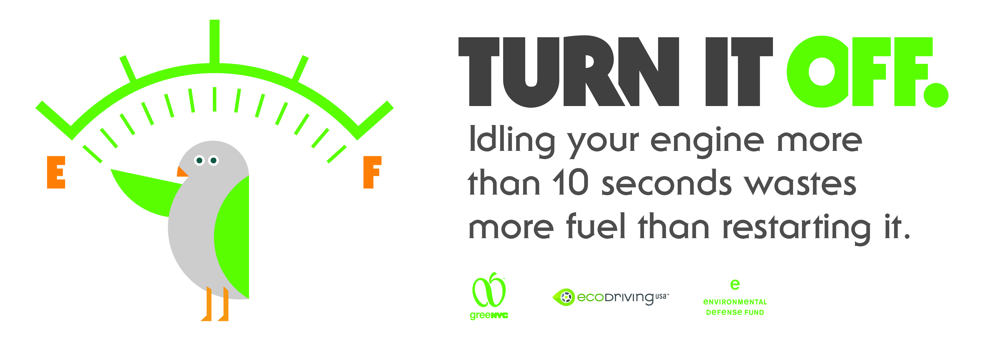
* New Yorkers are encouraged to call 311, their region’s non-emergency number, to report complaint, like anti-idling activity in the city. After the launch of the Turn It Off anti-idling program 311 calls related to idling increased by 111%.

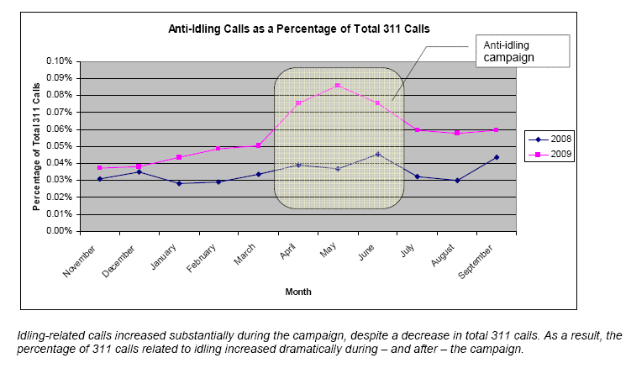

**Fleet Experiment - Department of Public Works**

**Milwaukee, Wisconsin**

The Milwaukee Department of Public Works in Milwaukee, Wisconsin is not only transitioning its fleet of vehicles to hybrids, its training workers to EcoDrive.

* In 2009 a group of 18 DPW employees completed an EcoDriving course, learning ways to boost fuel economy and save on fuel costs.
* After the training, the use of common-sense techniques like not speeding, driving smoothly and not idling has boosted gas mileage by at least 13%.
* In 2009 the city of Milwaukee purchased of the first of two new hybrid-electric aerial lift trucks for the DPW. The hybrid-electric truck relies on its battery - rather than its diesel engine - while the ladder is in use for crews to install and maintain street lights.

-- The hybrid cost $40,000 more than the same kind of rig with a diesel engine only - but even at today's fuel prices that will be paid off within seven years.

-- This single vehicle will save the city 1,500 gallons of diesel fuel a year. It also reduces noise and emissions from an idling diesel truck.

-- Another hybrid lift-truck is on order. The city will consider buying more each year, as it replaces about two trucks a year.

**Driving Change Reduces Vehicular CO2**

**Denver, Colorado**

In March 2008, the city and county of Denver launched a pilot test of green driving behavior among Denver city vehicles. The program’s services are powered by Eviance and Public Technology Institute  
[**www.drivingchange.org**](http://www.drivingchange.org)

[](https://www.drivingchange.org/home.aspx)

* 160 city vehicles participated in study.
* The group’s overall improvement in fuel efficiency was 15%.
* In 1993, the City created the first Green Fleet program in the nation.
* Denver’s fleet includes more than 140 hybrid-electric vehicles
* Denver was one of the first cities in the nation to acquire a hybrid-hydraulic trash truck, expected to produce a 25% to 50% increase in miles per gallon.
* Denver has also retrofitted on-road and off-road equipment with diesel oxidation catalysts and crank case ventilation systems to reduce emissions and clean the air in Denver neighborhoods.
* In addition, the City and County of Denver utilizes alternative fuels and operates more than 800 units on B20 biodiesel.

Denver’s program reinforced the conclusions that measurement improves performance, tracking driving behavior has a great impact, and driver education works.

**Ford EcoDriving for Life Performance Results**

With a mission to highlight the positive impact that green drivering can have on reducing GHG emissions Ford worked to educate drivers about EcoDriving techniques. The effort reached out to drivers around the world to promote EcoDriving.   
[**http://www.ford.com/microsites/sustainability-report-2008-09/issues-climate-progress-driver**](http://www.ford.com/microsites/sustainability-report-2008-09/issues-climate-progress-driver)

* In an experiment with Phoenix-based ProFormance, 48 drivers were tested on green driving behavior.

-- Results ranged from 6 percent fuel economy improvement to more than 50 percent, depending on their driving style and ability to master eco-driving behaviors.

-- Results showed that rivers who practice "eco-driving" can improve their fuel economy by an average of 24 percent.

* Beyond the US and Europe, Ford is working to teach EcoDriving to Asian regions as well.

-- In 2008 with a "train-the-trainers" workshop taught EcoDriving to instructors from Philippines, Vietnam, Thailand and Indonesia, in Bangkok.

-- To date, more than 5,000 people had participated in the training, including nearly 700 in Vietnam, over 1,000 in Thailand and more than 500 in Indonesia. The Philippines accounts for the remainder.

-- In 2009, the program will be expanded to Taiwan, China and India.

* Ford is also working to reach out to the dealer body to create EcoDriving awareness with car buyers and engaging policy makers about the possibility of integrating eco-driving techniques into driver education.
* Ford began work on the EcoDriving concept in 2000, when it was first offered an eco-driving program through German dealerships, in partnership with the German Federation of Driving Instructor Associations and the German Road Safety Council.

**5% Adds Up – FuelClinic.com**

FuelClinic.com helps EcoDrivers monitor their EcoDriving performance over time. FuelClinic.com, based in Orlando, Florida, took 2nd place in Global IBM-Sponsored Intelligent Transportation Society (ITS) ‘Congestion Challenge’ – Stockholm, in 2009.   
[**Www.FuelClinic.com**](http://Www.FuelClinic.com)

* According to FuelClinic.com, the average EcoDriver improves their efficiency by 5.3%. These are drivers who have had no formal instruction on green driving.
* Savings by drivers on FuelClinic are tallied. Thus far:
  + Money Saved = $41,142.49
  + Fuel Saved = 14,291 gals.
  + CO2 Reduced = 277,241 lbs.
* If everyone in the US improved their efficiency by just 5%, this would result in a XX reduction in CO2 emissions in the US. (2009 Wards Registered Vehicles # = 137,523,377). 