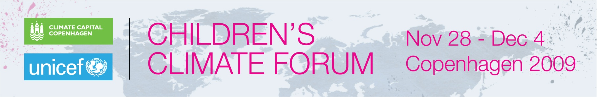

***UNICEF Young Spokespersons ***

**Bolivia: Darwin Peña, age 17**

Darwin hails from Beni, northern Bolivia, in the Amazon, a place marked by extreme weather conditions. Darwin says that torrential rains greatly disrupt the local communities, and threaten the natural habitat of the area, especially the flora and the fauna.

Darwin takes part in a group that promotes recycling and raises awareness around climate change. They work together with elders in the community, and join forces to preserve this beautiful part of the Amazon.

Darwin attended the Children’s Climate Forum, a seven-day event that ended 4 December 2009 when all of the 164 participants, aged 14 to 17, from 44 countries were named Climate Ambassadors. This designation formalized the commitments embodied in the young people’s outcome document, the Climate Declaration. including to commit to personal life style changes for the “common good”; to educate themselves and their communities to mitigate the changing climate; to engage with all generations and governments to combat climate change.

Their commitment is for one year.

To learn more about the network they have formed, the full Declaration and the extensive reporting that youth journalists carried out during the Forum can be viewed at: [www.uniteforclimate.org](http://www.uniteforclimate.org)