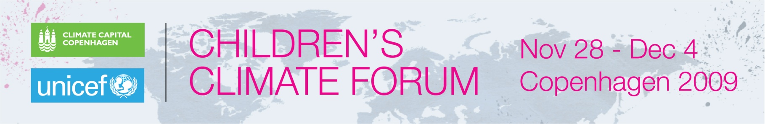

***UNICEF Young Spokespersons ***

**Bangladesh: Torqul Momen, 16**

Climate Ambassador Torqul, lives in southern coastal area of Bangladesh, in the area of Bhula.  Tarikul is a young journalist, and organizes radio and television programmes that address environmental issues.

He says that his area is heavily affected by climate change. Sea levels are rising at an alarming rate, and food shortages are common.  “Our livelihood is affected, and our [lives] are at stake.”  He says that the world’s leaders should address climate change now to protect the world’s children.

Torqul attended the Children’s Climate Forum, a seven-day event that ended 4 December 2009 when all of the 164 participants, aged 14 to 17, from 44 countries were named Climate Ambassadors. This designation formalized the commitments embodied in the young people’s outcome document, the Climate Declaration. including to commit to personal life style changes for the “common good”; to educate themselves and their communities to mitigate the changing climate; to engage with all generations and governments to combat climate change.

Their commitment is for one year.

To learn more about the network they have formed, the full Declaration and the extensive reporting that youth journalists carried out during the Forum can be viewed at: [www.uniteforclimate.org](http://www.uniteforclimate.org)