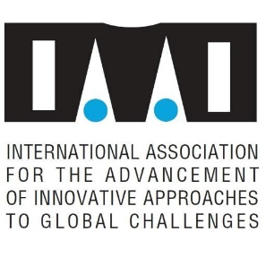

Official Side Event to the
UN Bonn Climate Change Conference June 2019 (SB 50)
Thursday 27 June 2019, 11.30-13.00
World Conference Center Bonn, Kaminzimmer

Getting everyone engaged in climate action
with culture, social innovation, value change & technology

The climate crisis requires a new mindset with everyone taking climate action. Unprecedented youth and civil society engagement is needed. The side event will gather different stakeholders joining forces on mass mobilization, low carbon lifestyle promotion and climate action empowerment.

Speakers:
- Miroslav Polzer, IAAI GloCha
- Jerrica Rai Whitlock & Saffran Mihnar, ActionNow Campaign
- Timothy Damon, Education, Communiction & Outreach Stakeholders Community (ECOS)
- Golo Pilz, advisor to Brahma Kumaris on Renewable Energy and the Head of India-One Solar project
- Dorothy Nalubega (Green Economics Institute Uganda)
- Miriam Kennet, Green Economics Institute (video message) and GEI Climate

Moderation:
Carolin Fraude, Institute for Advanced Sustainability Studies e.V. (IASS)

Contact :
Miroslav Polzer, IAAI, polzer@glocha.info, +436644203648

