**UNFCCC Side event COP29**

**Designing for Quality and Equity in Clean Cooking Carbon Projects**

**Time:** Tuesday 12 Nov 18.30 – 20.00h

**Location:** Side Event Room 2

**Organisers:** [SNV Netherlands Development Organisation](https://snv.org/), [Cleaner Cooking Coalition](https://www.cleanercooking.org/), Indian Network on Ethics and Climate Change

**Theme:** Universal access to cleaner cooking is critical to the energy transition. Implementers, governments, developers, and investors discuss challenges and opportunities to enhance quality and credibility of cooking-focused carbon projects, covering technicalities, safeguards, co-benefits, sustainability.

SNV works together with partners to deliver quality clean cooking market development work. Cleaner Cooking Coalition promotes responsible carbon finance to make sustainable cooking energy accessible for all - leaving no-one behind. At COP 26 in Glasgow in 2021, Government of Malawi signed the Cleaner Cooking Pledge and in late 2023 became one of the first countries to authorise Gold Standard credits from a cleaner cooking programme to be used as ITMOs under Paris Agreement’s Article 6. Climate Impact Exchange and ACT Commodities ensure quality in carbon trading.

**Objectives of the session:**

* Emphasise the importance of quality and equity in clean cooking-focused carbon projects.
* Exchange learnings on and opportunities for responsible carbon finance in accelerating the global transition to cleaner cooking, looking at examples of how organisations are trying to ensure quality and equity in clean cooking carbon projects.
* Discuss how to warrant rigour and quality of carbon projects whilst ensuring carbon finance for clean cooking becomes accessible and feasible for all.
* Explore collaborative approaches between governments, private sector, and civil society to enhance the impact of cleaner cooking initiatives using carbon financing.

**Outline:**

**Welcome:** Moderator: Simon O’Connell, CEO, SNV Netherlands Development Organisation

**Opening remarks:** Hon Minister of State Union Affairs and Environment, Tanzania, Dr Ashatu Kijaji

**Keynote:** Vice President & Minister of Natural Resources and Climate Change, Malawi, Honourable Michael Usi

**Panellists:**

* Margaret Kim, CEO, Gold Standard
* Paul Muthaura, CEO, Africa Carbon Markets Initiative
* Dr Priyadarshini Karve, Director of the Cleaner Cooking Coalition
* Daniel de Vries, ACT Group
* Molly Brown, Burn Manufacturing

**Closing remarks** (by moderator)

**Speaker Biographies**

With over 25 years’ experience working for social change in a wide array of different countries and contexts, **Simon O’Connell** is an experienced and entrepreneurial leader. Passionate about promoting equitable access to opportunity and catalysing positive, inclusive and lasting change, Simon’s main areas of expertise are in setting strategy, leading teams and fostering partnerships.A person in a suit

Since late 2020 Simon has been the Chief Executive Officer of SNV, Netherlands Development Organisation, leading a team of almost 1,300 people and ongoing programmes in approximately 25 countries. With overall responsibility for SNV, Simon oversees a global portfolio focused on the Agriculture, Energy and Water sectors and systems interventions that contribute to sustainable, transformational change.

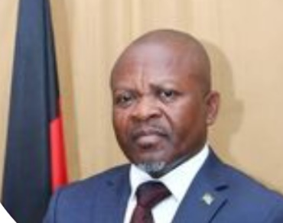

**Hon.** **Michael Bizwick Usi** is Vice President of the Republic of Malawi and Minister for Natural Resources and Climate Change. He previously served as the Minister of Tourism, Culture & Wildlife. Hon Usi is also a movie actor, playwright, and musician.

**Margaret Kim** is the CEO of Gold Standard, a leading standard that allows climate and development initiatives to quantify, certify and maximize their impact towards climate security and sustainable development.

Margaret has over 15 years of experience in international management roles including at the Global Green Growth Institute (GGGI) where she held various posts including the Head of Green Climate Fund liaison and Head of Strategy and Integration.

Prior to this role, she occupied leadership roles in the private sector in business development and corporate strategy at a leading biotechnology company.

**Paul Muthaura** Paul Muthaura is the CEO of the Africa Carbon Markets Initiative (ACMI). He was previously the CEO of ICEA LION General Insurance Kenya and Capital Markets Authority of Kenya .

He is an independent board member of the International Ethics Standards Board for Accountants; British American Tobacco (BAT) Kenya; ICEA LION Asset Management; and the Financial Sector Deepening Trust, Kenya.

In a career spanning more than 20 years, **Dr. Priyadarshini Karve** invented a number of improved biomass burning cooking devices, to reduce smoke in the kitchen and dependence on firewood for domestic cooking in rural areas. In 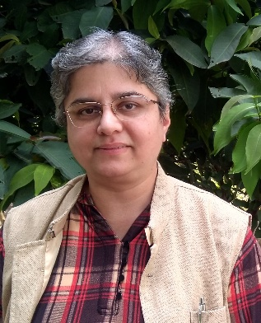2005, she started Samuchit Enviro Tech, a social enterprise that has been selling a wide range of biomass energy, renewable energy, and energy efficient household energy devices since its inception. Her work has been honoured by several national and international awards, including World Technology Award 2005 (by World Technology Network, New York), Sahyadri Hirkani Award 2011 (by Mumbai Doordarshan, India), Pune’s Pride Award for Innovation 2013 (by Residency Club, Pune), etc. She has also been featured in a number of national and international periodicals, publications and radio and television programmes.

**Daniel de Vries - ACT Group**

As Global Manager - Tech-based climate projects, Daniel oversees ACT's climate action partnerships and the pipeline of project development from design to the delivery of the carbon credits. His team developed the world's first Article 6.2 authorized cookstove activity under an implementing agreement between partnering countries. He maintains close contact with the public and private sectors to operationalise various mitigation activity types, in particular under the Paris Agreement's Article 6.2.

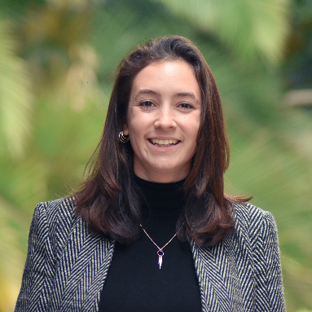Since joining BURN as Head of Carbon Strategy, **Molly Brown** has led our partnership engagement to support the improvement of carbon credit quality across the cookstove sector. This has included engaging the Project Developer Forum to coordinate cookstove industry responses to key events, working closely with ratings agencies to improve their scoring metrics, and supporting methodology development. In addition, she leads our carbon policy work across the continent, including supporting carbon regulation development, building partnerships with governments, and developing new Article 6 projects. Her background is in social business, monitoring and evaluation, gender, and poverty. She is based at BURN’s HQ in Kenya.