A CALL FOR CLIMATE JUSTICE AND IMMEDIATE ACTION A Message from Women for Climate Justice to the Global Climate Action Summit Steering Committee,Government Representatives and Participants.

The 2018 'Call For Climate Justice and Immediate Action', released and presented during the Global Climate Action Summit in California contains key background and analysis on WECAN International's position on the state of international climate action and has been signed by over 40 international organizations.

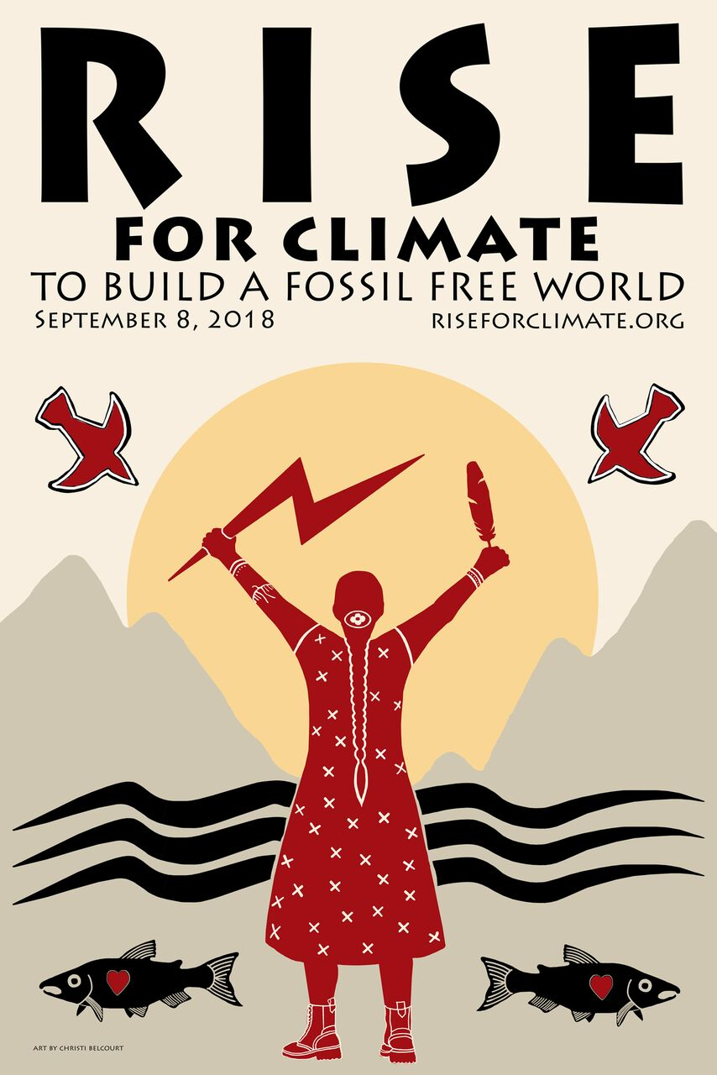

**A CALL FOR CLIMATE JUSTICE AND IMMEDIATE ACTION**

***A Message from Women for Climate Justice***

***to the Global Climate Action Summit Steering Committee,***

***Government Representatives and Participants***

San Francisco, California

September 11, 2018

Dear GCAS Steering Committee and Government Representatives,

We are speaking out on behalf of a growing movement of diverse women for global climate justice.

We are speaking out in recognition of the sacred interdependence of all life on Earth, and with respect for the Rights of Nature, and with the knowledge that business-as-usual economic models predicated on fossil fuel extraction have ushered in an era of unprecedented planetary distress, in which life as we know it is dangerously threatened.

**We call on elected officials to steadfastly commit to keep global warming below 1.5°Celsius, as stated in the Paris Climate Accord, via policies that simultaneously prioritize social, racial and economic justice for all.**

In order to do this, we are calling for a transformation of how we relate to the natural world and to one another. We must transition from an extractivist, colonial paradigm of “exploit and extract” to a sustainable, globally-conscious one of “respect, restore and replenish.” We must rapidly halt the extraction and burning of coal, oil and gas, while simultaneously building a new economy predicated on community-led solutions and women’s rights, Indigenous rights, the rights of nature and the rights of future generations.

This starts with policies to promote energy democracy, in which women, Indigenous people, communities of color, low-income communities, municipalities and small businesses are empowered to own and manage our energy resources. We must recognize the inalienable rights and invaluable traditional knowledge of Indigenous Peoples, and follow their environmental justice leadership in climate solutions. Such a plan must also prioritize and advance women’s leadership, as women are disproportionately harmed by climate change while possessing unique knowledge and skills to drive innovative solutions. Finally, we must protect biodiversity, seed sovereignty, and food security, and respect the rights of nature for the forests, oceans, rivers and lands upon which all life depends.

Crucially, we must do everything we can to ensure justice is respected in the transition to 100% renewable energy. Any solution that does not safeguard the dignity and flourishing of people and the planet must be rejected. False solutions, such as dangerous nuclear power plants; increased natural gas extraction; mega-dams that cause irreversible damage to biodiversity, food sovereignty and livelihoods; geo-engineering; bioenergy; carbon trading schemes; and carbon capture and storage have no place in the Just Transition.

Finally, we call on all governments to respect the right to freedom of expression and peaceful protest, and to immediately halt the criminalization of land defenders, whose efforts are central to a climate-just world.

**List of Global Demands**

**1. Leave Fossil Fuels in the Ground: No New Fossil Fuel Infrastructure.**

*We must limit global warming to below 1.5° Celsius in order to ensure a livable future for humanity. Accordingly, we must develop assertive plans to leave all remaining fossil fuel reserves in the ground, including gas that could be extracted via fracking.*

* Commit to a firm and binding international-reductions plan that limits global temperature rise to below 1.5°C and transitions the global economy to 100% renewable energy by 2035.
* In line with the Lofoten Declaration, use the principle of “common but differentiated responsibilities” to support developing nations with financial allocations from countries that benefited from fossil fuel exploitation.
* Divest from fossil fuel companies, end all governmental fossil fuel subsidies, and institute a strict regime of global carbon fees immediately.
* Implement a Financial Transaction Tax to fund the research and adoption of regenerative energy technology, and to help vulnerable communities adapt to the real-time effects of climate change.
* Reject greenhouse gas emissions reduction schemes that come from high-risk technologies that create irreversible damage to human and planetary health including tar sands, shale gas, nuclear energy, and geo-engineering.

**2. Promote Women’s Leadership and Gender Equity**

*Due to inequitable gender norms, women are disproportionately impacted by climate change while playing a central role in mitigating climate injustice. As women are most often responsible for providing food, water and energy for their families, climate change-related natural disasters, resource scarcity, and decreased biodiversity hit their livelihoods first and hardest. Furthermore, in many communities on the frontlines of fossil fuel extraction and mining, women bear the brunt of gendered and sexual violence. At the same time, women are crucial leaders in the transition to a just, renewable future. From the halls of the United Nations and of national governments, to primary resource-dependent communities, study after study has shown that when women hold positions of leadership, entire communities benefit.*

* Require and mainstream climate policy implementation that is rooted in grassroots feminism at the international negotiation table and at national and local levels.
* Acknowledge the unique and essential roles, responsibilities, solutions, needs, and desires of women in development and climate-change mitigation efforts.
* Acknowledge women’s traditional knowledge as central to climate solutions.
* Honor women’s rights to self-determination in all contexts.
* Ensure women’s full and equal participation in all aspects of climate policy, actions, and sustainable solutions, including decision-making power over financial investments at every level, from local communities to the international arena.
* Realize the principles embedded in the Paris Agreement ensuring that all climate actions respect and fulfill human rights, including the promotion of gender equality and women’s empowerment. Use the UNFCCC Gender Action Plan to guide activities that support gender equality.
* Ensure that women can implement safe, sustainable and low carbon development projects at every level.
* Recognize that women are half the world’s stakeholders, key advocates for the care of the Earth and all future generations.
* Developed countries must urgently mobilize new, additional and ambitious climate finance of at least 100 billion dollars per year by 2020, in line with obligations of the Paris Agreement. Make this priority a litmus test for climate leadership from elected officials. Ensure there is gender equity in the distribution of funds.

**3. Protect and Implement the Rights of Indigenous Peoples.**

*Indigenous Peoples make up about 5% of the world’s population, but 80% of biodiversity on Earth lies within Indigenous lands. This is not coincidental: the holistic relationship that Indigenous Peoples hold with their lands are founded on a deep understanding of fundamental interdependence between people and the natural world. Their traditional knowledge of agriculture, seeds, biodiversity, natural resource stewardship and conservation are indispensable, even as these communities are disproportionately under attack by fossil fuel development, mining and climate impacts.*

* Respect all governmental treaties with Indigenous Peoples and defend their right to continue to inhabit traditional lands, undisturbed by industrial projects and extractive industries.
* Respect and implement the United Nations Declaration on the Rights of Indigenous Peoples and in particular, Free, Prior and Informed Consent.
* Honor and implement Indigenous knowledge and prioritize the conservation and veneration of Indigenous Peoples’ decision-making power at the national and international levels, and ensure that Indigenous Peoples have an equal seat of power at the decision-making table.
* Empower communities to take increasing ownership and direction of their local agricultural cultivation and nutrition; support such agro-economies.
* Honor Indigenous Peoples’ unique relationship with the most biodiverse regions of our Earth; invest in Indigenous People’s global leadership to protect and promote healthy relationships with life-sustaining ecosystems.

**4. Promote Energy Democracy.**

*We will have lost the fight for climate justice if we further entrench inequalities in power and wealth while transitioning from fossil fuels to renewable energy. Rather, we must transform extractive, unjust, status quo economics into new, socially just and environmentally sustainable economics.*

* Transition to a regenerative energy economy based on 100% renewable sources by 2035. Decentralize and democratize ownership of this new energy economy.
* Develop a just transition plan that protects people, whose livelihoods are affected by the economic shift, including coal communities and natural gas workers.
* Adopt a true-cost economic model to drive industry toward sustainable activities and thus internalize the external costs of fossil fuel usage.
* Pass laws that hold industries, corporations, and individuals responsible for any and all costs and negative externalities their economic activities impose on others.
* Implement campaign finance reform to reduce the disproportionate power of capital-holders to direct political outcomes for their personal gain at the expense of the common good.

**5. Protect the Rights of Nature.**

*The Rights of Nature is a groundbreaking legal framework that recognizes natural systems, such as rivers, forests, mountain ranges and water bodies, as rights-bearing entities with an inviolable claim to protection and preservation. A growing global movement for the recognition of the Rights of Nature is gaining momentum, from Ecuador, Nepal, Colombia and New Zealand to communities across the USA.*

* Recognize the Rights of Nature in law and practice. It is time to stop treating nature as property, but rather as a rights-bearing entity.
* End the commodification, ownership, and exploitation of all ecosystems such as forests, grasslands, deltas, rivers, and wildlife preserves.
* End market-based mechanisms that purport to protect ecosystems such as forests and jungles but in reality promote the industrial and monocultural destruction of biodiverse regions and hotspots.
* Reduce consumption and invest in sustainable production and consumption, prioritizing safe and just circular economies and regenerative systems.
* Promote biodiversity renewal and restore 30% of lost forests and other essential bioregions by 2030. Prevent any industrial logging of forests. Protect old-growth forests.
* Outlaw water privatization and oceanic colonization. Recognize the human right to water and ocean access.
* Protect a minimum of 30% of vulnerable and threatened fisheries and coral reefs in marine sanctuaries (Marine Protected Areas) by 2020.

**6. Protect and Promote Biodiversity and Seed Sovereignty.**

*Globally, the stewardship of biodiversity and Indigenous species of seeds lies heavily in the hands of women. We must promote the health, holistic management of our food system and agriculture resources in order to mitigate localized climate impacts and promote food security.*

* Make it illegal for international trade agreements to determine seed “ownership” and “use.” Outlaw the global patenting of seeds.
* Support educational programs that encourage reconnecting with, and understanding, the natural world.
* Promote localized systems of agricultural production that support decentralized, “people-run” economies; natural, non-genetically modified foods; and cyclical and sustainable agro-ecological farming practices.
* Organize campaigns and trainings to empower communities to take increasing ownership and direction of their local agricultural cultivation and nutrition; support such agro-economies.

**A Final Note**

Though this call to action lays out the framework for a global Just Transition, we recognize the unique potential of the Global Climate Action Summit to drive change in the United States, the country with the largest emissions per capita in the world and with disproportionate geopolitical power and privilege. Therefore, we urge leaders in the United States, especially Governor Jerry Brown and Michael Bloomberg, to rapidly advance the above agenda at the state and federal level. We are calling on our elected officials to demonstrate **true** climate leadership: banning all new fossil fuel leases and development, from offshore oil extraction to natural gas build-out countrywide (and in California through the [Browns’ Last Chance](http://brownslastchance.org/) campaign); prioritizing and respecting the rights and self-determination of Indigenous Peoples in North America, from the resistance at Standing Rock to the Bayou Bridge and Line 3 pipelines; refusing contributions from the fossil fuel industry by signing the [No Fossil Fuel Money](http://nofossilfuelmoney.org/pledge-signers/) pledge; and advancing visionary climate justice policies such as [Green New Deal](https://qz.com/1316082/alexandria-ocasio-cortezs-green-new-deal-could-make-the-us-a-climate-change-leader/) and a [Federal Jobs and Green Infrastructure Guarantee.](https://thenextsystem.org/learn/stories/shovel-ready-green-jobs-job-guarantee-and-climate-resiliency)

Requests for further information can be directed to osprey@wecaninternational.org

For the Earth and Future Generations,

Women’s Earth and Climate Action Network (WECAN) International, USA

Honor the Earth, USA

Divest, Invest, Protect Campaign, USA

Urgent Action Fund for Women's Human Rights, International

Idle No More SF Bay, USA

Indigenous Women of the Americas Defending Mother Earth Treaty, USA

Global Grassroots Justice Alliance, USA

World March of Women - US chapter, USA

Women’s Environment and Development Organization (WEDO), USA

TierrActiva, Peru

Lead Tchad (Leadership For Environnement and Développement), Chad

Reaccion Climatica, Bolivia

Campaña Salvemos al Madidi, Bolivia

Las nietas de los Andes, Bolivia

Movement Rights, USA

Climate Mama, USA

Jena & Michael King Foundation, USA

Women In Solar Energy (WISE), USA

Climate Justice Alliance, USA

Climate Compassion, USA

Terra-1530, Republic of Moldova/Romania

Central Asia and Afghanistan Women and Water Association, Central Asia, Afghanistan

Amazon Watch, USA

Indigenous Climate Action, Canada

Adéquations, France

Support for Women in Agriculture and Environment (SWAGEN), Uganda

Association Femmes Leadership et Développement Durable Women Leadership& Sustainability, Mali

Earth Law Center, USA

Australian Earth Laws Alliance, Australia

Indigenous Environmental Network, USA

Global Forest Coalition, Paraguay and The Netherlands

Pachamama Alliance, USA

Voice of Women, Maldives

Green Divas, USA

Traditional Women's Society Ponca, USA

Ponca Pa Tha Tah, USA

Ponca Nation of Oklahoma, USA

World Pulse, USA

Earth Guardians, USA

FRIDA, USA, Canada

The Green Education and Legal Fund, USA

350NYC, USA

Tree Sisters, USA