

**ORGANIZERS**

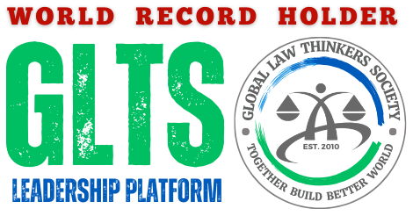

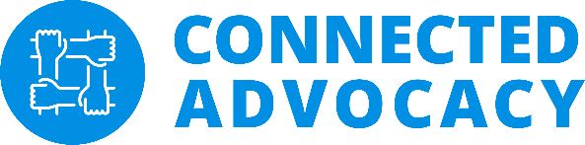

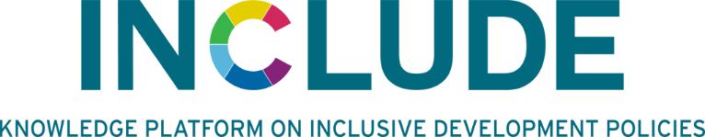

**INDEX**

1. **Key Concept: EcoCash Global Trade Hub - Towards Sustainable Living Community; Page: 2-3**
2. **Key Concept: Decent Jobs for Youth and Women in Low-Carbon Transition, Insights from Nigeria, Ghana and Uganda; Page: 4**
3. **Key Concept: Bridging the Financial Transition Gap: An Imperative Issue for Locally Impacted Communities; Page 5**
4. **Speakers; Page 5**

**EcoCash Global Trade Hub - Towards Sustainable Living Community**

**Key Concept**

The EcoCash Global Trade Hub is a pioneering initiative designed to support the growth and development of eco-conscious businesses and sustainable living practices through a comprehensive ecosystem of resources, partnerships, and opportunities. The Hub facilitates the connection between eco-entrepreneurs, green businesses, and conscious consumers to promote a resilient and sustainable green economy in Bangladesh and beyond.

Through this initiative, GLTS aims to bridge the gap between eco-businesses and global markets, foster financial literacy, provide funding opportunities, and support eco-friendly innovation. The Hub’s mission is to build a community of environmentally responsible enterprises that drive sustainable practices and support the global transition to a low-carbon economy.

**Direction for Project Implementation**

1. **Develop a Collaborative Platform**Create an online and offline marketplace where green businesses can showcase their products and services, connect with consumers, and attract potential investors.
2. **Host Global Eco Trade Fairs**Organize quarterly virtual and physical trade fairs, providing eco-entrepreneurs with a global audience for product exhibitions, business pitches, and networking opportunities.
3. **Empower Through Literacy and Training Programs**Implement training modules focused on financial, business, and trade literacy, covering key areas such as sustainable business models, budgeting, eco-investments, global trading practices, and legal compliance.
4. **Facilitate Funding and Investment Access**Provide funding avenues like pitch competitions, crowdfunding, low-interest loans, and grant opportunities for sustainable enterprises, supporting their growth and scalability.
5. **Establish Eco-Innovation Hubs**Set up collaborative physical and virtual spaces where eco-entrepreneurs can innovate, access resources, and engage in knowledge-sharing to develop sustainable business solutions.
6. **Create Networking and Partnerships**Build an online platform and organize regional meet-ups for eco-businesses, consumers, investors, and NGOs to foster community and sustainable practices.
7. **Track Progress and Long-Term Impact**Regularly assess the impact of the Hub on green trade, eco-business growth, and sustainable practices in Bangladesh, using data-driven metrics to refine and scale the initiative for maximum impact.

**Long-Term Vision**

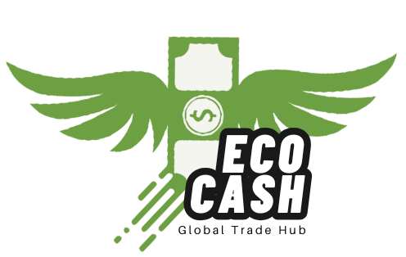EcoCash Global Trade Hub envisions a world where sustainable living and green businesses drive economic growth. By fostering an environment where eco-friendly practices thrive and encouraging partnerships for low-carbon development, the Hub aims to become a global model for sustainable trade, ultimately supporting Bangladesh’s climate resilience and contributing to a global shift towards sustainable economies.

|  |  |  |
| --- | --- | --- |
| **Contact Information**  **Raoman Smita** 📞 +8801755991488 📧globallawthinkers@gmail.com 🌐 [www.globallawthinkers.org](http://www.globallawthinkers.org)  <https://ecocashhub.com/> | **Scan to Explore the Full Concept:** | **JOIN SOCIAL** [**MARKET PLACE**](https://www.facebook.com/groups/ecocashglobaltradehub) **>>** |

**Key Concept: Decent Jobs for Youth and Women in Low-Carbon Transition, Insights from Nigeria, Ghana and Uganda**

**1. Diverse Stakeholder Perspectives in Africa's Low-Carbon Transition**

Stakeholders in Africa’s low-carbon transition hold varied perspectives shaped by their specific mandates and interests, similar to the "blind men and the elephant" parable. Communities, industries, policymakers, and environmental groups each focus on areas like community well-being, decarbonization, job security, and livelihoods. While these priorities aim toward a common goal of low-carbon development, they often lead to fragmented or conflicting approaches due to limited understanding of the broader transition picture.

**2. The Need for Balanced and Inclusive Policies**

Current energy policies in many African countries primarily emphasize conservation and decarbonization, often neglecting labor-based incentives crucial for youth and women. This oversight places job creation for these groups on the periphery, creating disparities that undermine the concept of a “just transition.” Existing fossil fuel structures tend to reinforce inequalities, limiting opportunities for marginalized communities to participate in renewable energy jobs. Addressing this requires policies that balance environmental objectives with employment-centered initiatives to prevent young people from becoming unintended victims of the transition.

**3. Recommendations for a Just and Inclusive Transition**

To achieve a fair low-carbon transition, African countries must adopt policies that resonate with youth, provide currency hedging mechanisms to stabilize investments, incentivize youth and women employment, and support low-carbon entrepreneurship. Additional strategies include promoting import-substitution initiatives, raising awareness to expand the total addressable market, and addressing infrastructure deficits. Region-specific opportunities across Africa in renewable energy, sustainable agriculture, and circular economy initiatives further highlight how localized approaches can foster inclusive growth and contribute to a balanced low-carbon transition across the continent.

INCLUDE Knowledge Platform

Witte Singel 27A

2311 BG   
Leiden, The Netherlands  
+31(0)71 527 6602 [www.includeplatform.net](http://www.includeplatform.net) / info@includeplatform.net

**Key Concept: Bridging the Financial Transition Gap: An Imperative Issue for Locally Impacted Communities.**

As we envisions a world without exclusion, strengthening collaboration, coordination and implementation that accelerates local action which in turn supports mitigation, adaptation and finances climate change investment at the grassroots.

Let us work together to make a difference in the Following:

* Accelerating subnational emission reduction (NetZero) strategy;
* Promoting Access for Local communities renewable energy democracy;
* Providing Climate and environmental advocacy;
* Championing Indigenous knowledge exchange to tackle climate crisis;
* Youth Green Jobs & Technology transfer for impacted community.

**Contact: Connected Advocacy for Empowerment and Youth Development initiative**

<www.connectedadvocacy.org.ng>

<info@connectedadvocacy.org.ng>

+2348064871447

**SPEAKERS:**

**1. Raoman Smita,** Climate Finance, Justice & Legal Expert, Founder of Global Law Thinkers Society

**2. Israel Prince Orekha**, Executive Director, Connected Advocacy for Empowerment & Youth Development Initiative

**3. Samiha Khan,** Academician, Daffodil International University

**4. Morgana Sythove,** General Secretary, URI Netherlands

**5. Victoria Manya,** Doctoral researcher at Leiden University and knowledge manager INCLUDE Knowledge Platform

**6. Basu Gautam,** Founder, Lumbini World Peace Forum

**MODERATOR**

**Dr. Anika Altaf,** Executive Director, INCLUDE (Moderator)

**Read the Full Concept:** [https://www.globallawthinkers.org/cop29-climate-conference-at-baku-azarbaizan/](https://www.globallawthinkers.org/cop29-climate-conference-at-baku-azarbaizan/%20)