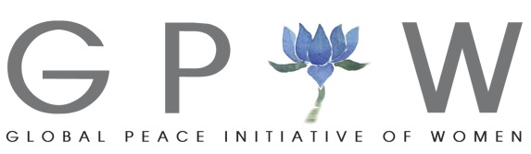

**Inner Dimensions of Climate Change**

* *an educational program for —*

**Emerging Environmental Professionals**

**Overview**

In 2016 The Global Peace Initiative of Women (GPIW) launched a series of global dialogues between emerging young leaders working in the environmental field and spiritual mentors on the theme of the Inner Dimensions of Climate Change.

GPIW has also been attending the past COP meetings since Copenhagen COP15. We have aimed to bring delegations of young ecologists as well as thought leaders and leaders of the faith and indigenous communities.

Over the past two years we have been holding dialogues with young leaders on climate change.

With the support and partnership of **Dharma Drum Mountain Buddhist Association (DDMBA), an American based NGO with UN ECOSOC status,** and with the collaboration of **Earth Charter International**, this series of global gatherings is designed to enable young leaders and environmental professionals to see the climate/ecological crisis through a spiritual lens, to explore the broader implications of the serious changes we are causing for the earth community. Our hope is that through these gatherings these young people will come more deeply into the recognition of the sacredness of the world around us, and awaken from within a love for the natural world.  This, we hope, will inspire and guide their work going forward.

**Thematic topics covered and questions explored during the workshop and dialogue:**

* How can we raise awareness of the interlinkages between human conflict and the violence inflicted on the Earth?
* Regenerative Agriculture: the importance of shifting from large scale industrial agriculture to ecological forms of agriculture.
* Rebuilding Right Relationship with the Commons: Cultivating holistic behaviors to equitably share the Earth’s resources: water, air, land
* Biodiversity: How do we contribute to restoring balance to the Earth’s natural rhythms and rebuild the integrity of soils on which we depend for nutrient rich food?
* What is the role of the wisdom traditions of the world in directing humanity toward a new relationship with the Earth and her resources?
* Lifestyle Transformation: Deemphasizing consumerism and materialism toward a greater focus on the well-being of others and the Earth’s diverse living inhabitants and systems.

**Program Schedule**

**Morocco – November 2016**

*Inner Dimensions for the Africa Region*

GPIW brought 22 young ecologists from 14 countries in Africa to Marrakech for participation in the civil society/NGO portion of COP22, a teambuilding nature trek in the Atlas Mountains of Morocco, as well as 3 days of focused dialogue.

**Costa Rica – January 2017**

*Inner Dimensions for the Americas & Caribbean*

GPIW hosted 25 young environmental leaders from government, NGO’s, academia and other civil society sectors from 15 countries from North America, Latin America, and the Caribbean to The Earth Charter International headquarters, the UN University for Peace and three days of focused dialogue and workshops at an eco-lodge. The program included site visits to eco projects in Costa Rica.

**Bonn, Germany – November 10-15, 2017**

*Inner Dimensions for Europe*

GPIW to host approximately 25 young environmental leaders from throughout Western and Eastern Europe to Bonn for participation in the civil society/NGO portion of UNFCCC COP 23, along with an educational river excursion on the Rhine to learn more about the importance of fresh water bodies, as well as 3 days of focused dialogue.

**Thailand – February 8-12, 2018**

*Inner Dimensions for Asia & Pacific*

GPIW will hosted 25 young environmental professionals from throughout Asia for a five day program and workshop in Bangkok that take place at Sathira Dhammasathan as well as a half-day session at UNESCAP with special guest speakers from the international community as well as from Thailand.

**Cyprus – October 20-25, 2018**

*Inner Dimensions for the Mediterranean & Middle East*

**Africa Region** **North America, Latin America & Caribbean** 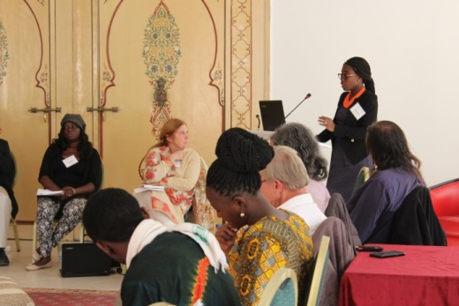 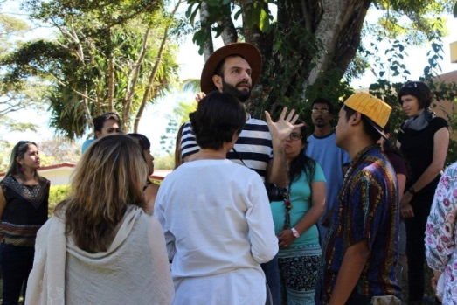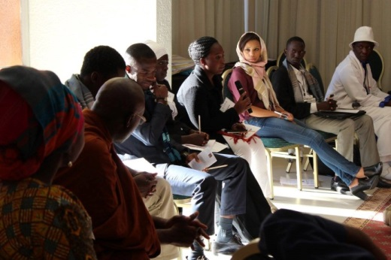 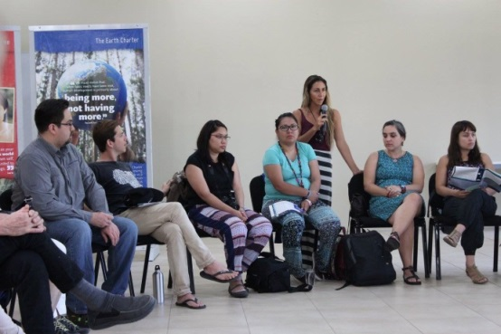

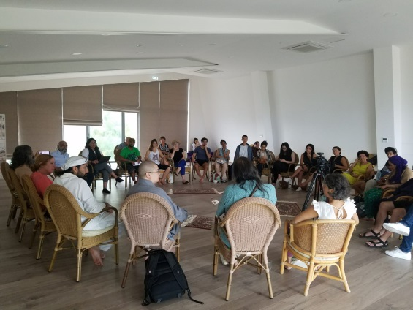 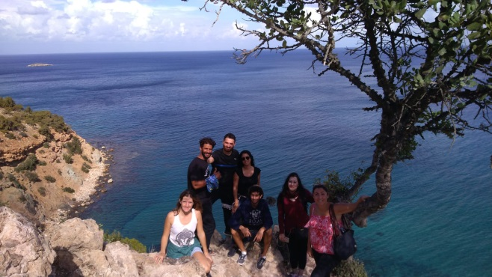

**About the Organizers and Program Partners**

**Global Peace Initiative of Women**

The basis of GPIW’s work is the dynamic expression of unity, emerging from the heart of wisdom of the world’s spiritual traditions, and our own hearts, into a new story for the human community. This new narrative can help animate social and economic structures and systems that better reflect our natural evolution toward greater wholeness. An essential part of this shift is the coming into a sacred relationship with the earth and all the living forces of the universe. Feminine wisdom and the power of love can serve as the fulcrum for this inner and outer transformation. The Global Peace Initiative of Women was founded in 2002 at the Palais des Nations when more than 700 women from government, business and the faith traditions met with the support of H.E. Kofi Annan to expand the role for women on issues of critical global concern. Since that time the network of GPIW has grown globally with over 100 major gatherings around the globe, engaging thousands of men and women leaders from all sectors of society.

**Dharma Drum Mountain Buddhist Association**

Dharma Drum Mountain Buddhist Association (DDMBA) is a U.S. based non-profit organization with UN ECOSOC status committed to serving humanity by working to relieve human suffering – physical, emotional and spiritual. Its founder and spiritual leader is the renowned teacher of Chan Buddhism, Master Sheng Yen.

**Earth Charter International**

Earth Charter International (ECI) is comprised of the ECI Secretariat and the ECI Council. The ECI Secretariat, which is based at the United Nations-mandated University for Peace in Costa Rica, endeavours to promote the mission, vision, strategies, and policies adopted by the ECI Council. It supports the work of the Council, assists with strategic planning, and coordinates many Earth Charter activities. The Secretariat guides and liaises with efforts to bring the Earth Charter to the fields of education, youth, business, and religion, manages communications with the larger Earth Charter network, and promotes the use of the Earth Charter as an international soft law document.

GPIW Contact:

The Global Peace Initiative of Women

Dena Merriam, Founder and Convener - [merriamd@gpiw.org](mailto:merriamd@gpiw.org)

Marianne Marstrand, Executive Director - marstrandm@gpiw.org

301 East 57th Street, 4th Floor

New York, New York 10022

USA

[www.gpiw.org](http://www.gpiw.org)

+1 212 593-5877