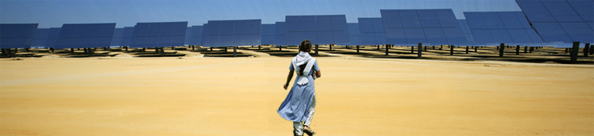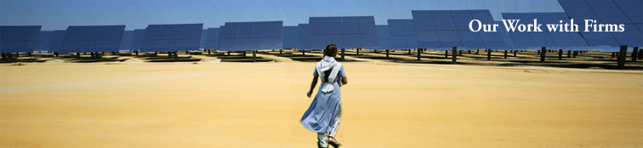 **Friendly Development**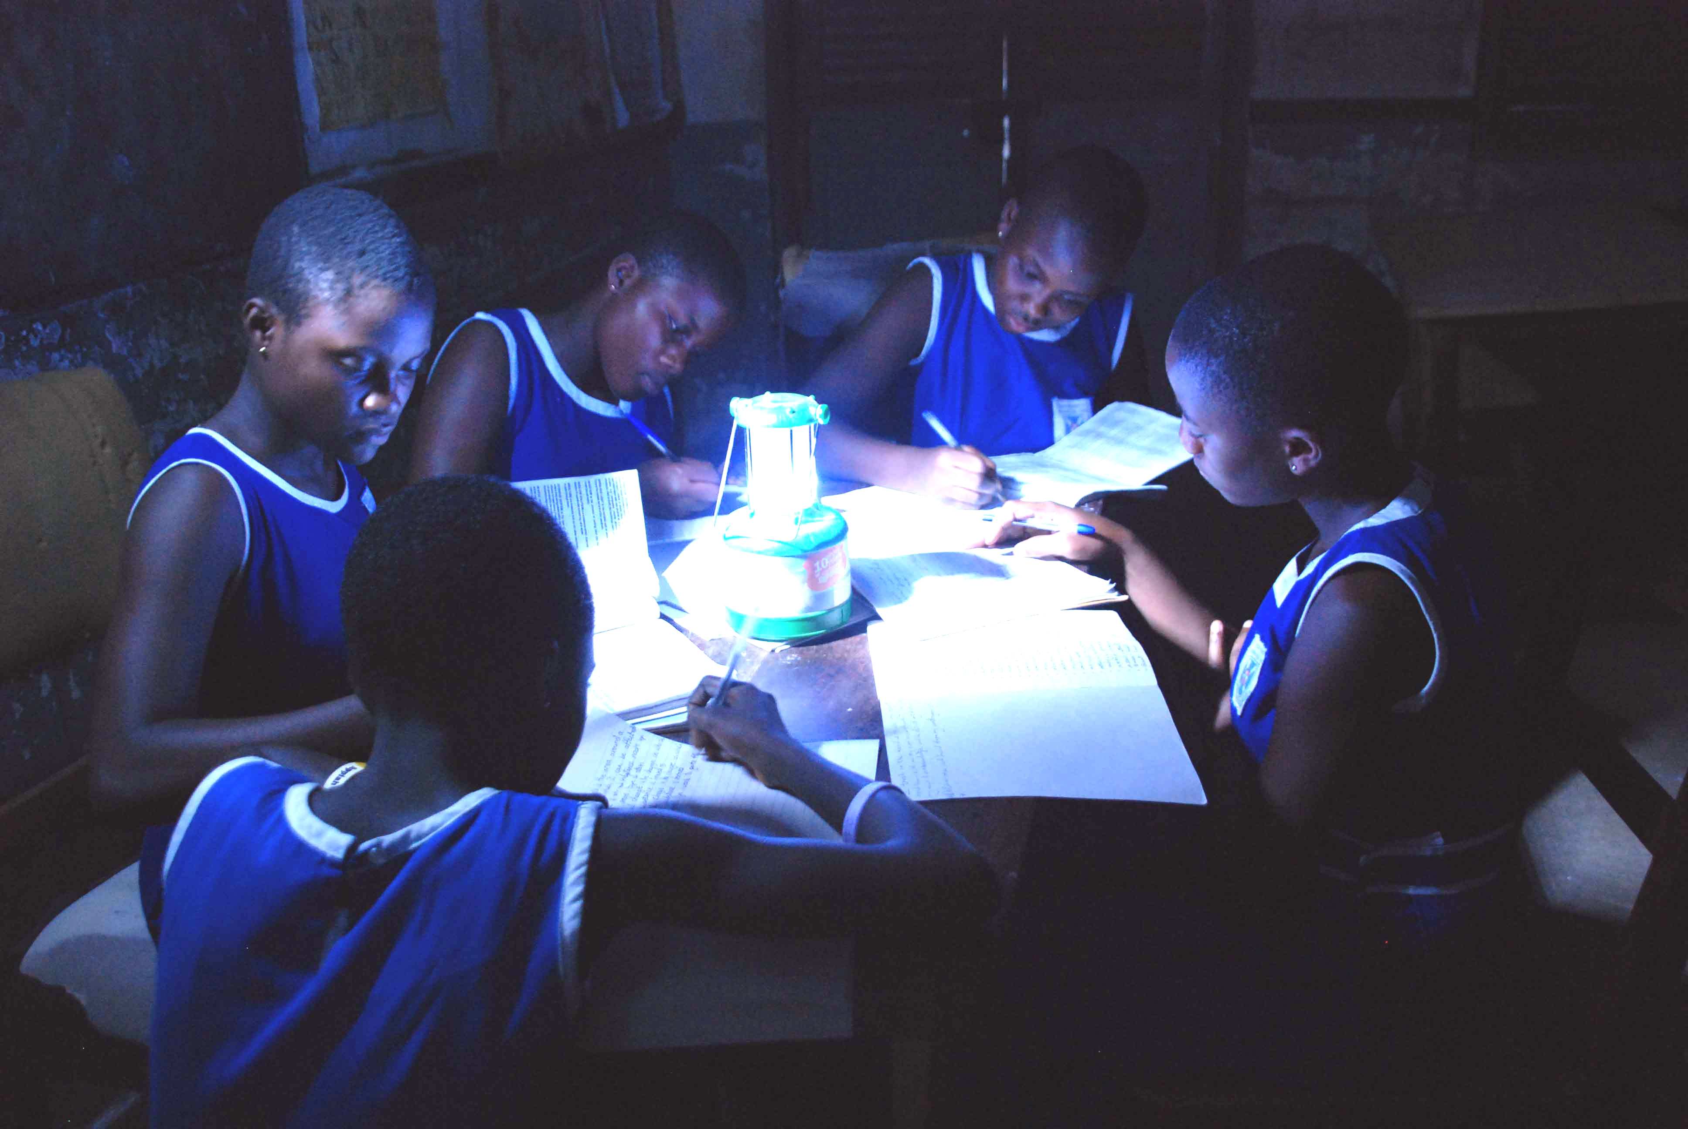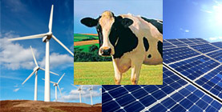

How does IFC work with firms on Climate Business?

IFC helps industry build capacity to deliver grid-tied solutions, as well as focusing on the needs of the underserved. These initiatives (such as Lighting Africa and Lighting India) operate on the edges of commercial markets. They leverage IFC and other commercial financing to reach scale.

**Climate risk assessments:** In 2008, IFC initiated several assessments with clients. Findings on risk and mitigation options for clients in hydro power, agribusiness, infrastructure and manufacturing, and also implications for financial institutions, have now been published. Further assessments and then the elaboration of analytical tools to help clients plan for adaptation will follow.

**GHG accounting:** In 2009, the IFC began GHG accounting for its direct investments. In 2011, IFC defined several methodologies to estimate GHG reductions. IFC is now developing similar approaches for its financial intermediary and advisory portfolios.

**Standard setting:** IFC has updated its Environmental and Social Performance Standards (which are widely applied by commercial banks via the Equator Principles) to include climate considerations. IFC is a member of a multi-stakeholder steering committee to define standards for “green” bonds and, on the equity side, IFC and Standard & Poor’s launched the world's first carbon-efficient index for emerging markets.

**Collaboration with other institutions**

IFC is proud to partner with the following change-agents: World Business Council for Sustainable Development; the Equator Banks; the Critical Mass Initiative; the Carbon Disclosure Project; the Water Resources Group; the World Economic Forum; the EBRD, AfDB, ADB, IADB, and several large institutional investors, among others.

**Carbon Finance**

In June 2011, IFC established the **Post-2012 Carbon Facility** to forward purchase credits produced until 2020 by IFC clients and by clients of IFC partner banks. This €150 millionFacility helps to address post-2012 carbon market uncertainty faced by projects by creating a pathway to market. IFC also offers **innovative debt finance** for projects with bankable carbon off-take contracts, and develops **new innovative climate finance products** that increase flows of climate-friendly investment in emerging markets. IFC also advises partner banks interested in accessing carbon finance markets.

**Concessional Finance**

IFC currently manages about $700 million from climate donors. In addition to advisory work, IFC provides concessional funding to overcome the higher costs or perceived risks that inhibit fully commercial financing of some projects. Donor funding has allowed IFC to catalyze innovative financing structures, such as risk sharing facilities with banks, and demonstration projects.

**Advisory Services, Analytics and Standards**

**Resource efficiency / cleaner production advice:** IFC helps clients optimize project/process designs and identify retrofit opportunities to achieve greater efficiency in energy, water and other resources. In addition to working at the firm level, IFC also undertakes sector-wide studies, and provides regulatory and policy support (including for specific public private partnership projects), end-user information and education, market aggregation initiatives, and support for more effective vendor networks.

**Clean energy scale-up and energy access initiatives:** IFC supports scale-up of grid-tied and off-grid clean energy by regulatory advice, improving access to finance, and addressing informational barriers to market development.

**For more information, contact Maureen Shields Lorenzetti**

[mlorenzetti@ifc.org](mailto:mlorenzetti@ifc.org) Tel. 1-202-473-8131

**www.ifc.org/ClimateBusiness**

**IFC thanks the following donors** **for their on-going support**: the Global Environment Facility, the Climate Investment Funds, Canada, Austria, Denmark, Finland, Iceland, Ireland, Italy, Japan, Luxembourg, the Netherlands, New Zealand, Norway, Saxony, Spain, the Trust Fund for Environmentally and Socially Sustainable Development, the United Kingdom, and the United States.

Climate Business at IFC

An overview of IFC’s climate change activities

**Promoting climate friendly investments using commercial funds.** IFC along with the World Bank pledged to grow its energy efficiency and new renewable energy lending by an *average* 20 percent per year beginning in FY05. This target has been met *and exceeded*. IFC clean energy lending grew at an annual average of 51% per fiscal year over the last fourfiscal years-- from $221 million in FY05 to $1,034 million in FY09. IFC investments in clean energy often open new markets by introducing first of their kind technologies or financial products, e.g., a “merchant” wind power project in Chile in which power is sold on the spot market without price guarantees.

**Cleaner production.** IFC offers existing and new clients a combined package of cleaner production audits and financing to implement recommendations for improving energy and resource efficiency through low cost, high return measures. Programs are under implementation or being developed in Eastern Europe, South Asia, Latin America and Africa. Following a successful pilot program, a $125 million facility is now available with a streamlined process for approving related loans.

**Clean technology.**After a successful initial experiment with donor funds, IFC is now investing for its own account in early stage clean tech companies and private equity funds. Investments in early stage climate friendly technologies are centrally coordinated with overall targets, across all sectors and industries, through IFC’s Information and Communication Technology Department. Examples include a high efficiency turbine manufacturer in India and a Chinese company with dehumidification technology to improve energy efficiency in blast furnaces.

**Solar strategy**.As solar energy applications have become increasingly commercial and equipment markets global, IFC has responded with an investment strategy across the solar value chain investing in materials, manufacturing, solar applications, and power generation. Investments have included a supplier of materials for solar cell manufacture and two solar cell makers.

**Innovative concessional financing.** Funding from the Global Environment Facility (GEF) and more recently the Clean Technology Fund (CTF) has allowed IFC to pilot many pre-commercial sustainable energy projects. The Clean Technology Fund will support an innovative wind project in Mexico. Some earlier projects undertaken with GEF support, such as a clean energy financing program, have established successful models for mainstream investments. The GEF supported Earth Fund allows for streamlined approval cycles and the management of such projects on a portfolio basis. Other projects, such as the *Lighting Africa* program (www.lightingafrica.org) develop markets for new technologies and help meet the needs of the poor.