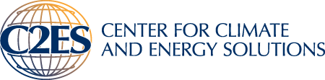
Learning from UNFCCC Transparency Experience: Perspectives of Parties and Expert Reviewers
The Paris Agreement calls for an “enhanced transparency framework” building on experiences with existing transparency mechanisms of the U.N. Framework Convention on Climate Change (UNFCCC). This side event, organized by the Center for Climate and Energy Solutions (C2ES), will present perspectives from developed and developing countries, and from expert reviewers, on lessons learned that can help inform the design of an enhanced transparency framework.
May 23, 2016
16:45 – 18:15
Room Berlin (112)
Panelists:
Laurence Ahoussou
Environment and Climate Change Canada
Ana Maria Danila
European Commission – DG Climate Action
Brian Mantlana
Department of Environmental Affairs, South Africa
Helen Plume
Ministry for the Environment, New Zealand
(Expert Reviewer)

Marcelo Rocha
Ministry of the Environment, Brazil
(Expert Reviewer)

Jennifer Huang
C2ES

Moderator:

Elliot Diringer
C2ES

